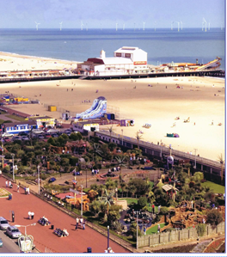
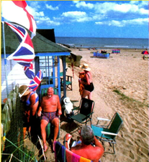

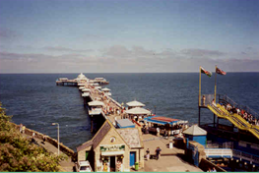

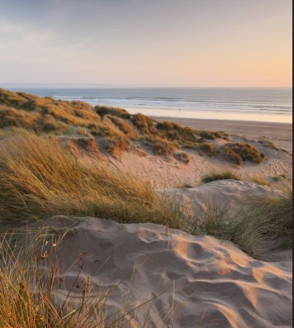

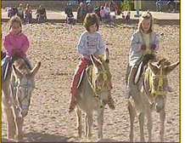

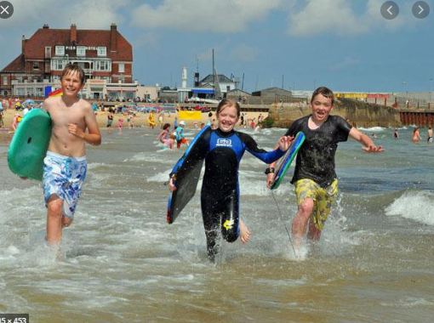
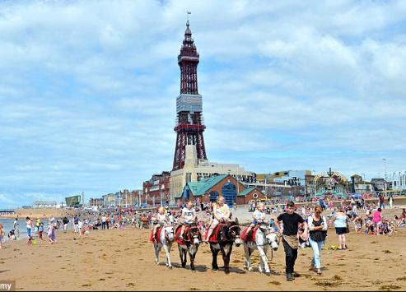

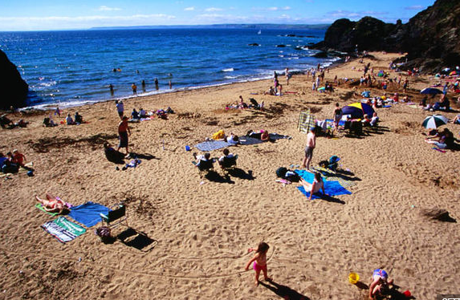
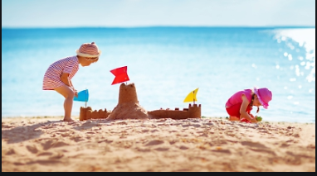

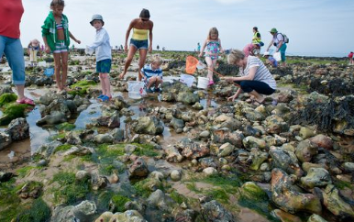

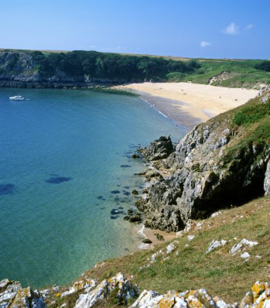

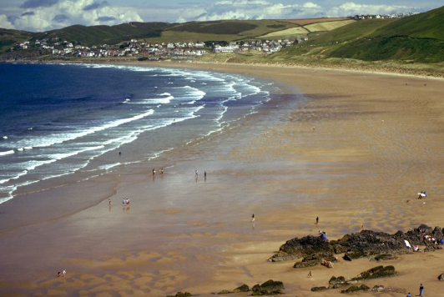

Ask your child to think about a time when they have been at the seaside:
Red hat: How did you feel when you were playing on the seaside?
__________________________________________________
Yellow hat: What do you like about the seaside? ______________
___________________________________________________
Black hat: What don’t you like about the seaside? _____________
___________________________________________________

Can you describe some of the clothes worn on the beach?
________________________________________________________________________________________
____________________________________________
Describe some activities on the beach ________________
____________________________________________
____________________________________________
What transport do people use to get to the beach? ______
____________________________________________
____________________________________________

Draw your own summer holiday picture and label using some of the words in the textbox, below.

