Activity 1 Watch clip on BBC https://www.bbc.co.uk/bitesize/clips/zv2qxnb
- Look at the pictures of the bean plant. You can cut them up and re-order.
- Can you write or talk about what is happening in each picture?
- What are the main things that a plant needs in order to grow?
2.

_________________________________
1

_________________________________

3.

______________________________
______________________________

4

_______________________________

Cut the pictures and stick in the right order over page or click on the images and move into the text boxes over page. Can you write about what is happening?
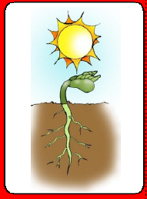
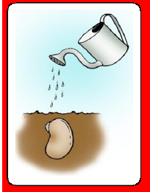

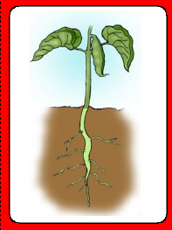
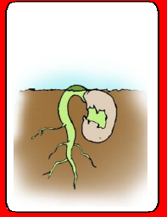

Activity 2 This is much more challenging!
Look at the powerpoint and watch this video to learn about this lifecycle.
https://www.youtube.com/watch?v=OQsfedMrjs8 animation about the lifecycle of a dandelion.
Look at the powerpoint on the lifecycle of a plant. The plant needs pollinators (insects) to help it make new plants as well as a way of moving its seeds away.
https://www.youtube.com/watch?v=UQ_QqtXoyQw Watch the dandelion flower turn into a seed head.
Read ‘The Tiny Seed by Eric Carle’ https://www.youtube.com/watch?v=ls6wTeT2cKA&t=158s
Can you draw the lifecycle of a plant over page or use the pictures and stick them (or move the text boxes) into the right order?

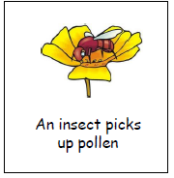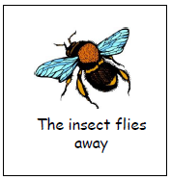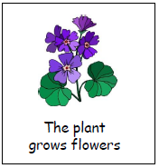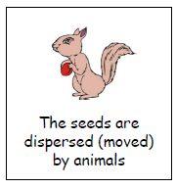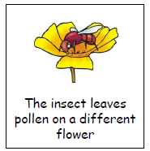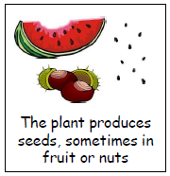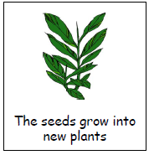

Place the pictures in a cycle.

