Look closely at a host of household appliances below:
- iron
- washing machine
- dishwasher
- hair dryer
- microwave
- vacuum cleaner
- kettle
- microwave
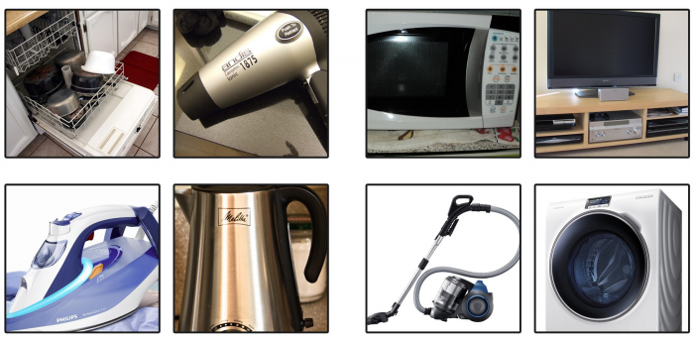Think about these questions:
- What purpose does each of these appliances have?
  - E.g. a washing machine washes our clothes.
- Why are these appliances important?
  - E.g. it is important to keep our clothes clean and tidy so that they are free from germs and also so that we look neat and tidy.
- How would our lives be different without them?
  - E.g. we would have to wash our clothes by hand like they used to do years ago which would take a lot longer.

Order these appliances from most important to least important. Please give reasons for you ordering.
1 | _______________________________________________________________________  _____________________________________________________________________________________________________________________________________________________________________________________________________________________
2 | _______________________________________________________________________  _____________________________________________________________________________________________________________________________________________________________________________________________________________________
3 | _______________________________________________________________________  _____________________________________________________________________________________________________________________________________________________________________________________________________________________
4 | _______________________________________________________________________  _____________________________________________________________________________________________________________________________________________________________________________________________________________________
5 | _______________________________________________________________________  _____________________________________________________________________________________________________________________________________________________________________________________________________________________
6 | _______________________________________________________________________  _____________________________________________________________________________________________________________________________________________________________________________________________________________________
7 | _______________________________________________________________________  _____________________________________________________________________________________________________________________________________________________________________________________________________________________
8 | _______________________________________________________________________  _____________________________________________________________________________________________________________________________________________________________________________________________________________________

