African big five facts for kids
Kids Encyclopedia Facts
The phrase African big five or Big Five game was coined by hunters and refers to the five most difficult animals in Africa to hunt on foot. The term is still used in most tourist and wildlife guides that discuss African wildlife safaris.
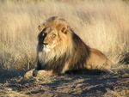  Lion | 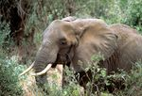  African Elephant | 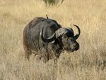  African Buffalo | 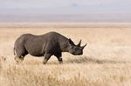  Black Rhinoceros | 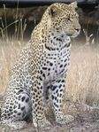  Leopard
The collection consists of the lion, the African elephant, the African Buffalo, the leopard and the rhinoceros, either the black rhinoceros or the white rhinoceros. The members of the big five were chosen for the difficulty in hunting them and not their size, which is why the leopard is on the list and the enormous hippopotamus is not.
The big five are among the most dangerous mammals:
- The Lion is a large carnivorous feline of Africa and northwest India, having a short tawny coat, a tufted tail, and, in the male, a heavy mane around the neck and shoulders.
- The African elephant is a very large herbivore having thick, almost hairless skin, a long, flexible, prehensile trunk, upper incisors forming long curved tusks of ivory, and large, fan-shaped ears. There are two distinct species of African elephant: African Forest Elephant and the African Bush Elephant (Loxodonta africana).
- The African Buffalo or Cape Buffalo (Syncerus caffer) is a large horned bovid. It is the most dangerous of the Big Five, reportedly causing the most hunter deaths.
- The Leopard is a large, carnivorous feline having either tawny fur with dark rosette-like markings or black fur. Leopards are the most difficult to acquire hunting licenses for and are often difficult to hunt due to their behavior and their nocturnal feeding habits. Leopard hunting usually overlaps several weeks of baiting.
- The Rhinoceros is a large, thick-skinned, herbivore having one or two upright horns on the snout. In Africa, there are two distinct species of rhinoceros; the Black Rhinoceros and the White Rhinoceros. Both of these species have two upright horns on the snout.
Countries where the big five can all be found include South Africa, Kenya, Tanzania and Botswana. According to recent studies it is difficult to spot the Rhinoceros in Botswana.

Conservation status
If the white rather than black rhinoceros is chosen, the Big Five do not include any endangered species. However, the lion and African bush elephant are classified as vulnerable (the African forest elephant is not yet evaluated as of 2008); African buffalo are conservation dependent. The leopard and white rhinoceros are of less concern.

