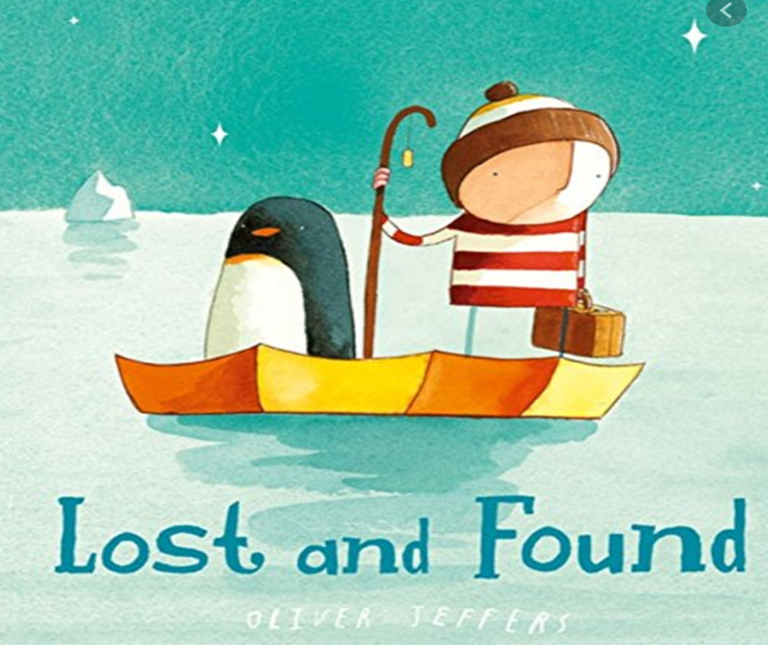

**What can I see?**

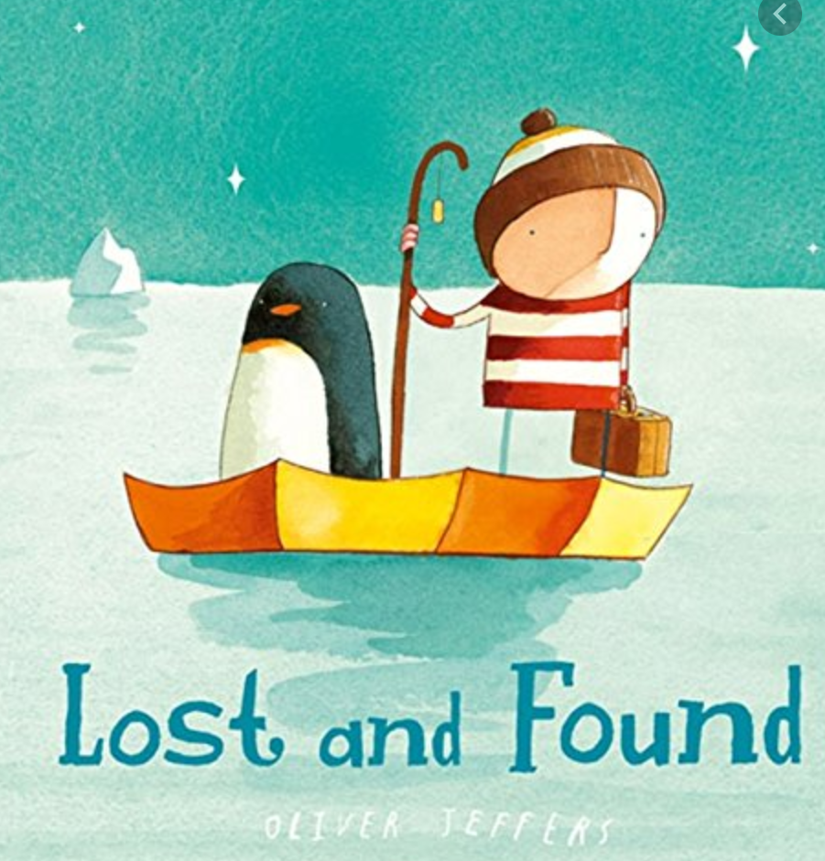

**What can I infer (guess) from this photo?**

**What questions could I ask to further my knowledge or understanding?**