St Mary’s Catholic Primary School

Ruby Class Summer Term Newsletter 2020

Week 1 and 2: 20th April-1st May

Dear Children and Parents,

We hope you’ve had a lovely Easter and everyone is staying safe and healthy. We really miss you all. We are sure you are all working hard at home and the children are trying hard to help around the house.

Please find below information of all the lessons we were due to complete over the next 2 weeks. Please spread these activities out and have a look at the suggested timetable. Work through as many activities as you can we know you are all trying your best to do what you can during these uncertain times. There are some resources available to assist you on our class page also.

Religious Education:
This term in R.E. our topic is From Easter to Pentecost.

Over the course of the term children will learn:
- To recall key events of Holy Week.
- To retell the resurrection of Jesus according to Matthew 28 (1-10)
- To retell the events of the Holy Spirit appearing to the disciples. (Please note Matthew’s Gospel does not have a story of the coming of the Holy Spirit: we find it in Luke’s writing. Read Acts 2:1-4)
- To understand how Pope Francis lives the spirit of Pentecost.

RE activities for the next 2 weeks:
Week 1:
- Lesson 1:
  - Learning objectives:
    - To recall key events of Holy Week
Activity:
Task 1: Create an information leaflet about the key events during Holy Week.
    - To recognise the characters in the story of the resurrection of Jesus based on Matthew 28:1-10.
Activity:
Task 2: Write down the characters from the story and a short description about each character.
- Lesson 2:
  - Learning Objective:
    - To retell the resurrection of Jesus according to Matthew 28 (1-10).
Activities:
Children can listen to the story and then try to act it out recalling key characters, setting and events in order.
You can role play the story and write a short description about what you did or you could create a story scene/box to help you to retell the story.
Week 2:
- Lesson 3:
  - Learning Objective:
    - To retell the story of the resurrection of Jesus according to Matthew 28 (1-10).
Activity:
To retell the story in the form of a letter from Mary Magdalene to a friend.
- Lesson 4:
  - Learning Objective:
    - Today I am learning to retell the events of the Holy Spirit appearing to the disciples.
Activity:
Children to draw a storyboard of the story and add words/sentences.

- Please go to the website to the Ruby Class page where you will find a PowerPoint detailing lessons 1-4.
- Also, on the RE section of our class page you will find a range of additional activities to complete linking to Holy Week. http://stmarysenfield.co.uk/Ruby
- Twinkl also have some nice resources you can use to support teaching these topics if you have created a free account (details below on how to do this).

Literacy
This term we will continue to look at fiction and non-fiction styles of writing. This term we are looking at quest stories exploring their structure and language choice.
Week 1: Lessons 1-5
  - Lesson 1:
Introduce quest stories are stories about a journey with a goal, which requires the characters to overcome obstacles. Share and discuss Lost and Found (you can find this on story on Youtube https://www.youtube.com/watch?v=cRAAQ8EWzig), exploring key events from the beginning, middle and end of the story.
Activities:
Task 1: Inference grid (to complete before reading the story!)
Task 2: After reading the story discuss and order the story. Then create a story map putting the story in the correct order and adding words/sentences to your images.

  - Lesson 2:
Remind children that quest stories include a journey. Reread the journey in Lost and Found. Note the illustrations, descriptive language and past tense verb forms. Discuss possible alternative journeys to cheer the penguin up. Where might they go? How would they get there? What would they see on the way?
Activity:
Give children a starter sentence and get them to describe one of the journeys discussed. Remember to include: how they travelled; at least 3 things they saw on the way; and end with arriving at the destination. Children check and edit their work by rereading their writing aloud.

  - Lesson 3:
Look at illustrations in Lost and Found. Briefly revise verbs; past and present verb forms. Introduce/revise past and present tenses.
Activity:
Write sample sentences about the images. When sentences are written go back and underline the verbs, noting whether they are past or present tense verbs.

  - Lesson 4:
Look back at Lost and Found and discuss how the penguin could have delayed the boy’s preparations to journey to the South Pole. Children discuss and act out what penguin might have done.
Activity:
Children write an imagined scene where the penguin was sabotaging the journey. They can then draw an image of the event.

  - Lesson 5:
Discuss the features of a newspaper report. Have a look online at different newspapers and how they are laid out.
Activity:
Task 1: Create a poster about the features of a newspaper report.
    - Title (you can create one or use the name of a newspaper you know)
    - An interesting headline.
    - Subtitles
    - An introductory paragraph
    - Information in chronological order
    - Pictures with captions
Task 2: Children to create a newspaper report about the story Lost and Found. Remember to include the key features of a newspaper report on your poster.

Week 2 Lessons 1-5:
  - Lesson 1:
Introduce The Way Back Home and recap on quest stories. Read and display the first few pages then pose questions and make predictions. Discuss the sentence types and punctuation for the questions and predictions (statements). https://www.youtube.com/watch?v=RbyUrb0X5iU
Activity:
Imagine you are a news reporter. Write three questions you want answered about the story, with a prediction for each. Make sure you punctuate your sentences correctly and then read your questions and predictions to someone.
  - Lesson 2:
Recap on statements and questions from Day 1. Discuss the difference between a question and a statement. Today discuss exclamation and command sentences. Discuss the rules and examples of commands and exclamations.
Activity:
Children create the 4 types of sentences for The Way back Home. They use the rules and examples recorded in the main teaching to support them.
  - Lesson 3:
Recap on quest features. Today children will plan their own quest story using a story map. Children use the boy from Lost and Found as their main character, deciding where his journey will lead, what obstacles he will meet and what his goal will be.

Activity:
Children decide on goal, destination and obstacles. They plan their story in the form of a story map.
  - Lesson 4:
Think about how you want your story to begin: introduce characters and setting. Look back at Lost and Found and note how it uses a question to draw the reader in. Children think of questions to intrigue their readers. Briefly recap other forms of sentence and model writing.
Activity:
Children think about the question that their quest is going to answer to incorporate into their opening. Encourage the use of all four sentence types, reminding children of the associated punctuation. Children write opening then reread to check that it meets the agreed criteria.
  - Lesson 5:
Think about the middle section of the story: a series of increasing obstacles, which must be overcome. Model writing an obstacle, making mistakes with tenses. Can children spot the error and correct it?
Now think about the ending. Think back to Lost and Found. How would children feel if the story stopped when the boy and penguin parted at the South Pole? Explain that stories are disappointing when they stop abruptly and are boring when they go on too long.
Activity:
Children to write their middle and ending of their story (Remember to look at you plan). They then reread their writing aloud, checking for sense and overall effect. Encourage children to edit to improve writing, referring to criteria agreed across the unit.

Spelling:
Please continue to learn your common exception words. You need to able to read all these words and spell them. If you know al of your year 2 common exception words, then you can move onto the Year 3 and 4 words. If you google Year 2 or Year 3 and 4 common exception words you can see the list.

Here is a nice website you can use to practice your spellings with a variety of different games:
https://www.spellingcity.com/spelling-games-vocabulary-games.html

Reading
Please continue to read daily with your child asking a range of questions, making predictions, sequencing the story etc. Here are some examples of questions you could ask:
- Look at the front cover. What could the book be about? Do you think it is a fiction/non-fiction book?
- Who is the author?
- Who is the illustrator? What do they do?
- What does that word mean? (you could make a list somewhere of all the new words you have learnt and a definition for each)
- How can you read unfamiliar words? (sound them out)
- Who are the main characters?
- What do you think will happen next? (prediction)
- How do you think the character feels? Why do you think this? How do you think you would feel if you were the character?
- Can you predict how the book will end?
- Who is your favourite character? Why?
- Is there a hidden message in the story? What is it?
- Can you retell the story in your own words?
- Did you like how the story ended? Can you create a different ending to the story?

There are some websites that have free access to a range of eBooks. Some examples are:
- Sooperbooks https://sooperbooks.com/bedtime-stories/
- Twinkl https://www.twinkl.co.uk/
Numeracy
Please continue to revise basic numeracy topics regularly:
- Odds and evens
- Doubling and halving
- Reading and writing numbers to 100 (also to spell numbers one-one hundred)
- Place Value (hundreds, tens and ones)
- 2, 5 and 10 times tables (some children have moved onto the 3 and 4 times tables). You need to know these in sequence, mixed up and related division facts.
- The four operations: addition, subtraction, multiplication and division:
  - Please create some word problems for your child to solve.
  - Provide your child with a range of number sentences to solve (23 + 45=, 43 – 29= etc)
- Fractions (1/2, 1/4 , 2/4, ¾, 1/3) Remember to use your bar model to help:
  - ½ of 6
6

Numeracy lessons for Weeks 1 and 2
Week 1:
Hamilton Trust
Learning at Home Packs for Maths-Year 2-Week 1
https://www.hamilton-trust.org.uk/blog/learning-home-packs/
Week 2:
Hamilton Trust
Learning at Home Packs for Maths-Year 2-Week 2
https://www.hamilton-trust.org.uk/blog/learning-home-packs/

Some useful websites to support the above learning:
- Twinkl https://www.twinkl.co.uk/
- Topmarks https://www.topmarks.co.uk/Search.aspx?Subject=16&AgeGroup=2

Science
Our topic this term is ‘Animals including Humans’
- Lesson 1:
- Notice that animals, including humans, have offspring which grow into adults
- Activity:
  - Research different animals and create a list of animals and their offspring and note whether they are a mammal, amphibian, reptile…
  - Discuss how animals grow and complete some life cycles for different animals (egg-chick-hen, spawn-tadpole-frog)

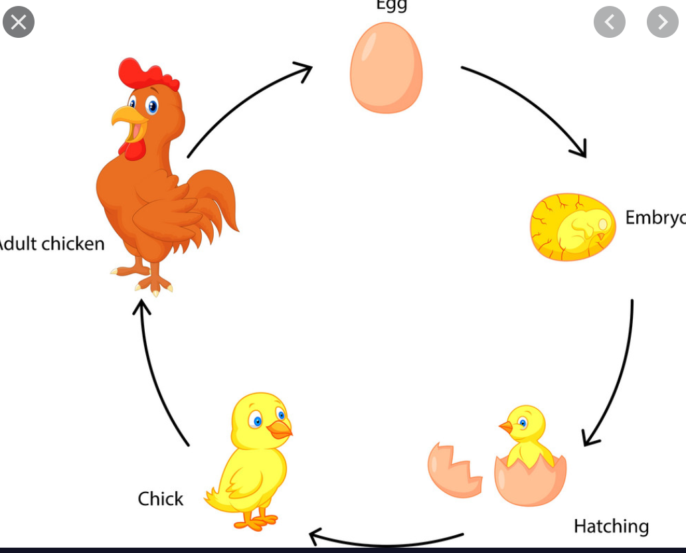
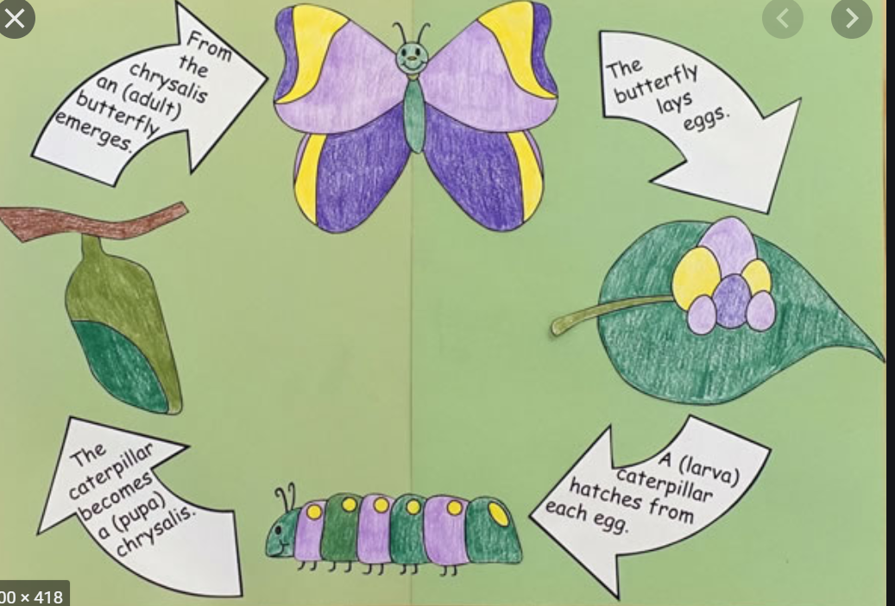
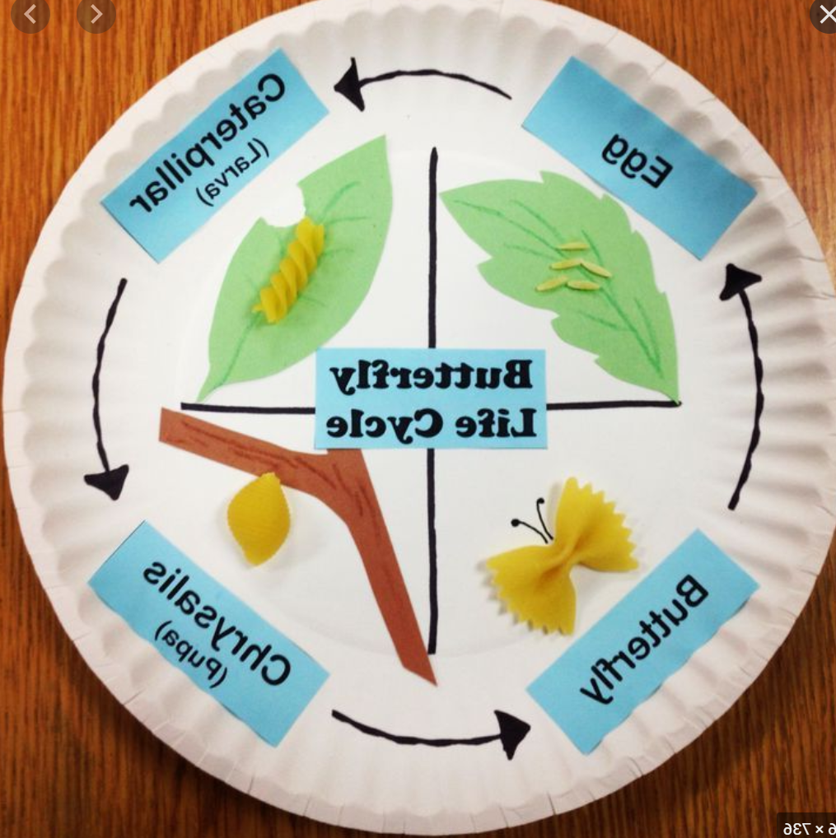
- Lesson 2:
- Notice that animals, including humans, have offspring which grow into adults
Activities:
- Create a poster detailing the life stages of a human describing each stage:
Baby- They need a grown up to help them. A grown up needs to feed the baby. They also need to wash the baby.

Some useful websites to support the above learning:
- Twinkl https://www.twinkl.co.uk/
- Explorify https://explorify.wellcome.ac.uk/ (please note this will require you to create a free account)

P.E.
Joe Wicks puts on a workout session every morning at 9 am on YouTube.
Please also see the PE and Sport page on the school website for a range of activities. (http://stmarysenfield.co.uk/PE-and-Sport)

Music:
Out of the Ark are producing a free song for every day we are at home! If you’d like to join in click on the following link https://www.outoftheark.co.uk/ootam-at-home/?utm_source=homepage&utm_campaign=ootamathome2&utm_medium=banner

History
This term we were due to research and learn about significant events in our local area. The event we were going to focus on was WW1 and WW2 and the impacts it had on the people and places of Enfield. The Dugdale Centre have a range of information about this including pictures and PowerPoints https://www.dugdalecentre.co.uk/page/enfield-local-history-factsheets/.

- Week 1 and 2:
Have a look at the WW1 presentation on the Dugdale website https://www.dugdalecentre.co.uk/media/Enfield%20WW1%20Presentation.pdf
After completing your research please choose an activity below each week (e.g. week 1-a poster, week 2-a diary entry):
- Create a poster about what you have learnt.
- Write a letter to a family member detailing what you have learnt about WW1 in Enfield.
- Create a diary entry as a child living during that time.

Art / Design Technology
This term we had planned to study the artist Georges Seurat. George Seurat was a French painter who created a new painting technique called ‘pointillism.’ Pointillism is a technique of painting in which small, distinct dots of color are applied in patterns to form an image.

Lesson 1:
Carry out some research about Georges Seurat and create a fact file about him.
https://www.nationalgallery.org.uk/artists/georges-seurat
https://www.ducksters.com/biography/artists/georges_seurat.php
Lesson 2:
Try to replicate one of his paintings.

Useful information:

In order to sign up to twinkl for free please follow the below instructions:
- How do I sign up for the free month?
  - Step 1: Go to www.twinkl.co.uk/offer
  - Step 2: Enter the code you have received, or CVDTWINKLHELPS if you have not yet been given a code
  - Step 3: Share the offer code and website link with anyone who could benefit

If you have any questions at all, please feel free to email us and we will get back to you as soon as possible. Hopefully we will see you all again soon. Until then stay safe and well.

Miss Treacy and Miss Beckles

