Lesson 2:
https://www.theschoolrun.com/homework-help/roman-empire
LO: To understand some of the reasons why the second Roman invasion was a success
This lesson will look at the areas of land the Romans conquered as well as some reasons a to why they were successful in claiming this land.
You should be able to answer the following questions after completing lesson 1:
WHITE HAT
What information did we learn about the Romans?
GREEN HAT
What reasons did the Romans have to invade Britain?

Key information:
The Romans had a large Empire and wanted to expand (make bigger) that Empire.
In particular, the Romans wanted to take over places that could give them something which was useful to them.
The ancient Romans were based in Rome in Italy, but they ruled over land that stretched far beyond the borders of Rome. This was called the Roman Empire, and it covered large parts of land all around the Mediterranean Sea – and even part of Great Britain.
The Romans got this land mostly by fighting battles with other groups of people, like the Celts in Britain – when the Romans won, they’d get more territory to add to the Empire. This meant that Roman culture had a huge influence on other cultures, and it’s why finding Roman artefacts (like coins), and ruins of Roman walls and buildings (like Hadrian’s Wall) is so common in the British Isles today
Look at the map of where the Roman Empire spread to:
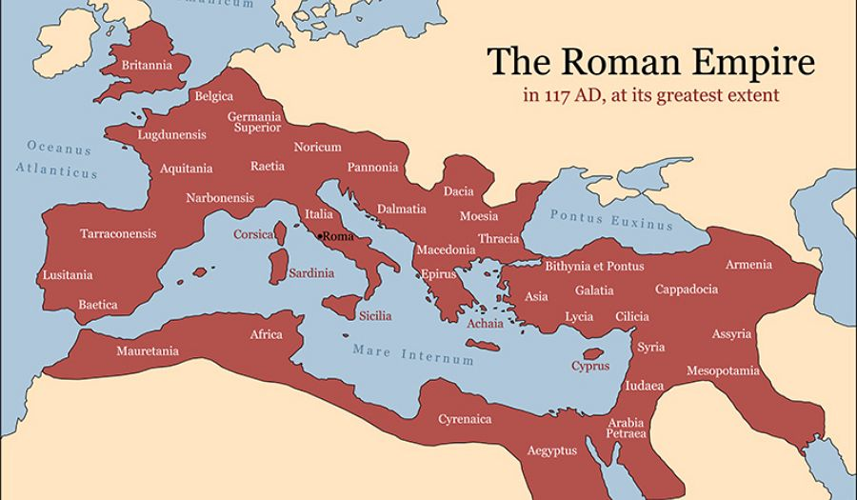
Can you identify any of the countries taken over?
Look at and compare images of Roman and Celt soldiers. Why do you think the Roman soldiers were successful with their invasion?
The Romans had:
• Better armour
• Better discipline and tactics
• Better inventions and weapons e.g. the Spear
• Divide and rule techniques
• Build forts to protect themselves.
Draw and label diagram of a Roman Soldier. https://www.bbc.co.uk/bitesize/topics/zqtf34j/articles/z9j4kqt http://www.primaryhomeworkhelp.co.uk/romans/soldiers.html

Task: Write an explanation to the question below.
WHITE HAT
Why were the Romans victorious over the Celts?
Think and discuss:
GREEN HAT
Do you think the Celts could have done anything to beat the Romans?

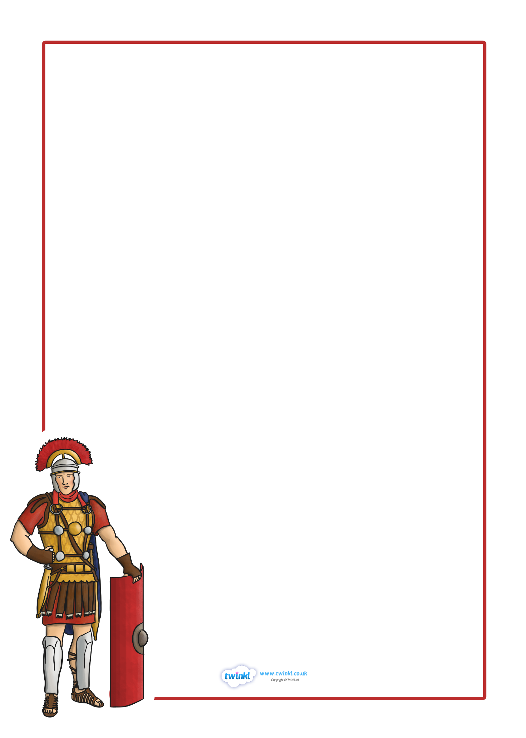
A Timeline of the Roman Era
Name:
753 BC

