**Science Lesson 2:**

**LO: To understand what reflection is.**

**To identify materials which can reflect light and understand how these can keep us safe.**

<https://www.bbc.co.uk/bitesize/topics/zbssgk7/articles/zqdxb82>

**EXPLORE:**

Begin by looking at the slide Seeing things in the dark and talk about what it shows.

Discuss the different ways in which objects in the slide below make it easier for things to be seen.

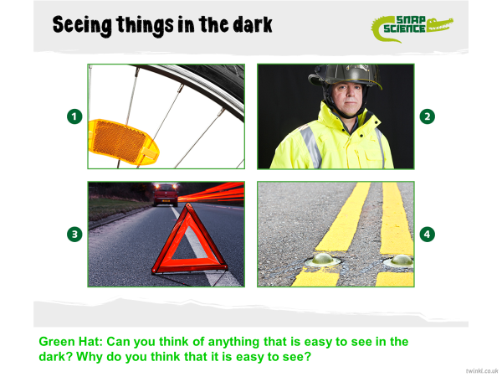

**Key Information:**

We can see things because materials reﬂect light.

**Reflection**

When light from an object is reflected by a surface, it changes direction. It bounces off the surface at the same angle as it hits it.

Smooth, shiny surfaces such as mirrors and polished metals reflect light well. Dull and dark surfaces such as dark fabrics do not reflect light well.

**Watch this clip carefully:**

<https://www.bbc.co.uk/bitesize/topics/zbssgk7/articles/zqdxb82>

**Answer the following questions:**

What is reflection?

How is light reflected?

**Key Information:**

Light travels in a straight line.

When light hits an object, it is reflected (bounces off).

If the reflected light hits our eyes, we can see the object.

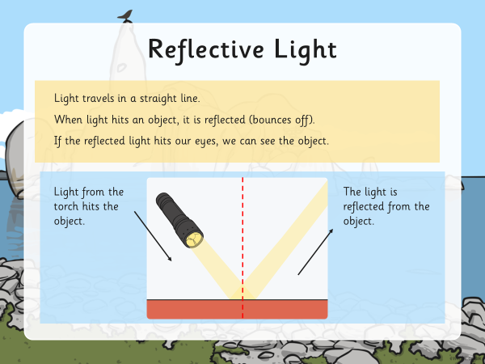

Some surfaces and materials reflect light well. Other materials do not reflect light well.

Watch this **‘The use of reflective materials for safety’** short film. It is all about materials that reflect light.

<http://www.bbc.co.uk/education/clips/ztcg9j6>

**While you are watching, think about:**

What does it look like if a material reflects light well?

Which colours do you think reflect most light?

What are reflective materials useful for?

**Reflective surfaces and materials can be very useful:**

Reflective strips on coats or bags mean you can be seen at night. They are also useful for fire-fighters or builders who may work in a dark and dangerous environment.

'Cat's Eyes' help drivers see the road by reflecting light from headlamps.

Mirrors let us see ourselves, and are also useful in cars, to allow drivers to see behind them.

Retro-reflectors are used for road signs so that drivers can see the signs from their car.

**Can you think of any other uses?**

**Task: Design a poster to explain why/how wearing reﬂective clothing makes it safer to be out in the dark.**

**Possible investigation activity: Design a reﬂective strip**

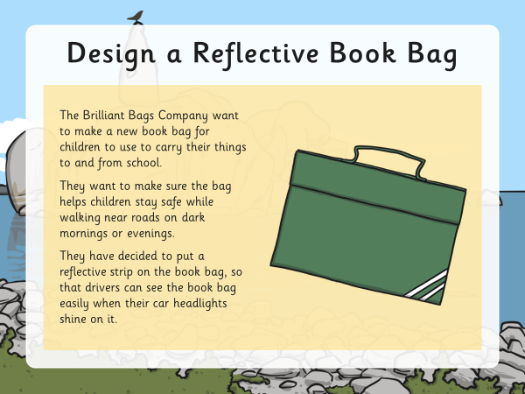

Choose a range of reﬂective materials to test.

Look at the different materials. Which material do you think will be best for the bag? Write your prediction.

You will need to test the different materials to see how reflective they are. Think about how you could do this?

**In order to test the materials, you can make a reflection tester.**

Attach a piece of white card to a torch:

1. Cut a hole in the centre of the card and push the torch through so that the card fits snugly around the torch without you having to hold it.
2. Shine the torch at the material you are testing.

If the material reflects light well, you will see the reflected light shine through the white card and light it up.

Order your materials from most reflective to least reflective on your Testing Reflective Materials Activity Sheet.

Choose the most reflective material from the ones you tested.

Draw your chosen material on the book bag in the place you think it should go, and label it.

**Write an explanation to the Brilliant Bag Company so they know why you have chosen this material.**

**Challenge: How are all reflective surfaces similar? Think about how they look and feel.**

