Science-
Forces and Magnets

Some useful links:
https://www.bbc.co.uk/bitesize/topics/znmmn39
https://www.bbc.co.uk/bitesize/topics/zyttyrd
https://www.theschoolrun.com/homework-help/magnets

Lesson 10:
LO: To measure the strength of a magnet in different ways
You will need a magnet again for this lesson.
Green Hat: Can you think of some items at home that has a magnet? What are they?
Magnets attract magnetic materials so they can be used to separate metals that are magnetic and those that are not at a recycling plant. A magnet can also be used to pick up heavy objects such as cars at scarp yards, as they are made of magnetic materials.
Investigation: Magic Magnets
Try this trick to make a paper clip hover:
- Tie a length of cotton thread to a paper clip.
- Tape the end of the thread to the table.
- Hold a magnet above the paper clip.
- Can you make the paper clip hover above the table?

As you move the magnet away from the paper clip, it will fall back to the table.
The magnetic force pulling the paper clip up to the magnet is not as strong.
By seeing how many paper clips are attracted to a magnet, you can measure the strength of the magnet’s force.

There are lots of different types of magnets:
Bar magnet | 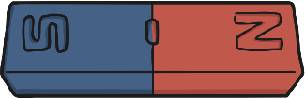
Cylindrical magnet | 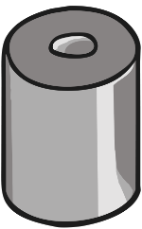
Horseshoe magnet | 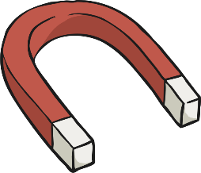
Button magnet
Ring magnet | 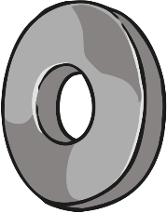
Square magnet | 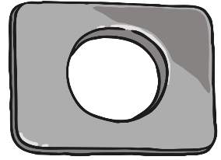
Arc/ crescent magnet | 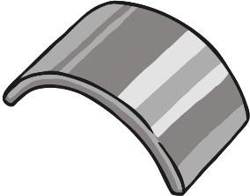

Which do you predict would be the strongest? __________________________________________________________________________________
Why do you think this? ______________________________________________________________________________________________________________________________________________________________________________________________________________________________________________________

We would have completed this investigation in school, I know you will not have access to all of these magnets at home but have a read through of the method:
- To measure the strength of each magnet, you will hold a paper clip to a magnet so that it is attracted to it.
- You will then hold another paper clip to the first one to see if it is also attracted to the magnet, through the first paper clip.
- Keep adding paper clips in a chain, until no other paper clips are attracted in the chain.
- Keep a record of how many paper clips were in the chains for each magnet.
- The magnet with the longest chain of paper clips is the strongest, as its magnetic force can pull the paper clips over the longest distance.

What steps would we need to take to ensure this was kept a fair test? What would we be changing? What would we keep the same? ______________________________________________________________________________________________________________________________________________________________________________________________________________________________________________________________________________________________________________________________________________________________________________________________________________________________________________________________________________________________________________________________________________________________________________________________________________________________________________________________________________________________________________________________________________________________________________________________________________________________________________________________________________________________________________________________________

Here is a short clip of some students completing the paperclip test:
https://www.youtube.com/watch?v=MsU1GHhkJqs
Can you identify which types of magnet are being used in the clip?

Another video of the experiment:
https://www.youtube.com/watch?v=RsIOVGhruTE

https://www.theschoolrun.com/homework-help/magnets

Task: Draw a neat and clearly labelled diagram of how this investigation would be carried out.

