History – The Romans:
Lesson 11: History
LO: To understand what religious beliefs the Romans had and know about some of the gods and goddesses that they worshipped
http://www.primaryhomeworkhelp.co.uk/romans/gods.htm
Roman Religion
In the earlier Roman times, the Roman people believed in many different gods and goddesses whom they believed controlled different aspects of their lives.
They did not have a central belief system of their own as such, but rather borrowed gods, rituals and superstitions from a number of sources and adapted them to suit their own needs. The Romans believed in good and bad omens and they performed many rituals in the hope of receiving good luck. Prayer and sacrifice was important and the Romans held festivals every month to honour the gods. They would worship their gods and goddesses at temples.
Elements of Religion
In the earlier Roman times, the Roman people believed in many different Gods and Goddesses whom they believed controlled different aspects of their lives. They did not have a central belief system of their own as such, but rather borrowed gods, rituals and superstitions from a number of sources and adapted them to suit their own needs. The Romans believed in good and bad omens and they performed many rituals in the hope of receiving good luck. Prayer and sacrifice were important and the Romans held festivals every month to honour the gods. They would also worship their gods and goddesses at temples.

Task 1: Discuss the words highlighted in the text above and work out what they mean. You can use dictionaries to help you complete the table below.
Word | What it means | Why the Romans did it/ believed it
Ritual
Superstition
Omen
Prayer
Sacrifice
Worship

Roman Gods and Goddesses
The Romans had lots of gods and goddesses. Many of their gods and goddesses are the same as the Greek gods, but with different names. They make things very confusing! We are going to look at some of the more popular Roman gods and goddesses. If they sound familiar, the table on the following slide might help you to recognise the Greek gods and goddesses of the same name.
Comparing Gods
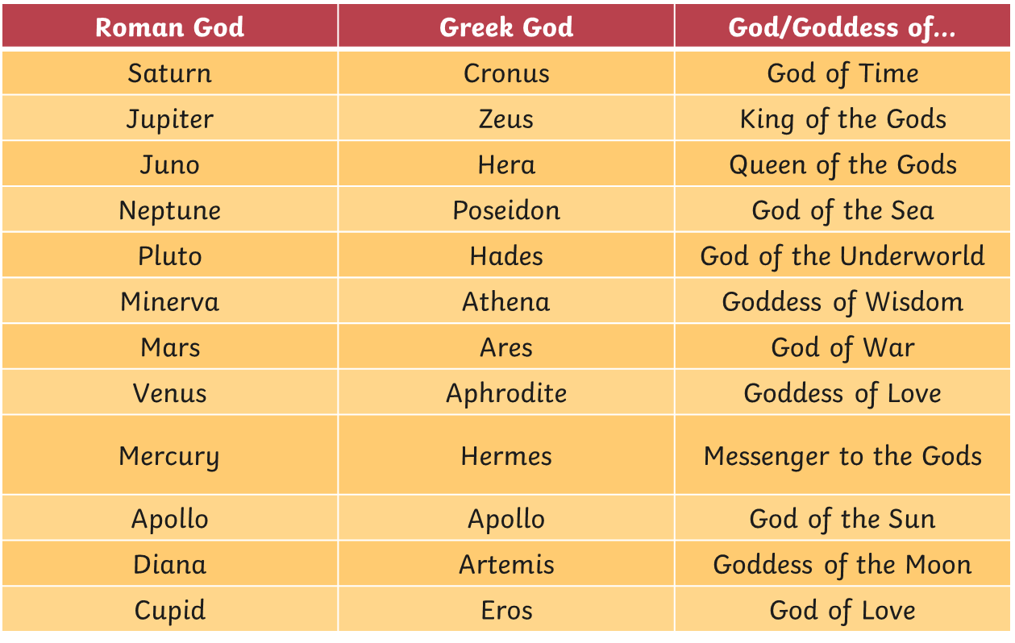

A God Family Tree
Most of the gods and goddesses were related to each other. Have a look at this family tree to see how our twelve gods and goddesses were linked
Now let’s have a closer look at some of the Roman gods:
Saturn: God of Time
Father of Jupiter, Pluto, Neptune, Juno, Ceres and Vesta.
Married to Ops, Mother Goddess.
The Saturnalia festival lasted seven days and was similar to our Christmas today.
Jupiter: King of the Gods and Heavens
Son of Saturn. Brother of Pluto and Neptune.
Married to Juno, who was also his sister.
Jupiter could shape-shift (make his body look like something else, e.g. an animal) and throw his voice.
Juno: Queen of the Gods
Married to Jupiter.
Mother of Mars, Natio, Juventa and Vulcan
There was a festival every year on the 1st March to honour Juno.
Neptune: God of the Seas
Brother of Jupiter and Pluto
Neptune was also the god of earthquakes, known as the Earth-Shaker.
Pluto: God of the Underworld
Brother of Jupiter and Neptune.
He had a three-headed dog called Cerberus.
Venus: Goddess of Love and Beauty
Her sign was a rose.

Use the internet to help you research more Roman Gods and information.
Task 2: Choose a Roman god and create a fact file or poster about them.
Details to include:
- Name
- Where they fit in the family tree above
- Any powers/weapons/skills
- Why they were important to the Romans
- How they were celebrated

