RE- The Kingdom of God
Lesson 11:
LO: To be able to explain how my beliefs are linked to my behaviour and how this will me achieve the Kingdom of God in my life.

HOM: Thinking about Thinking.

Complete a BUBBLE MAP with your ideas of how you can create the Kingdom of God here on earth in your life today.

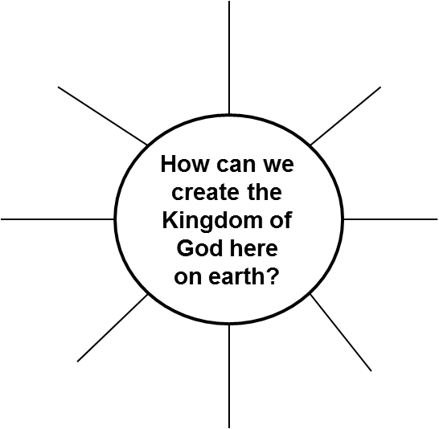

Answer the Thinking Hats questions in full sentences:

Yellow Hat: What would be the benefits of being a worker for God’s kingdom?

Red Hat: What would that be like to be a worker for God’s kingdom?

Green Hat: What rewards would we gain from having God’s Kingdom here on Earth?

Black Hat: What problems may you find when trying to create God’s Kingdom here on Earth?

Complete a MULTI FLOW MAP to show how a person’s behaviour can have an effect on their life and their relationship with God.

Effect
Cause

Task

This is an example to help you structure your diary entry:

