Science-
Forces and Magnets

Some useful links:
https://www.bbc.co.uk/bitesize/topics/znmmn39
https://www.bbc.co.uk/bitesize/topics/zyttyrd
https://www.theschoolrun.com/homework-help/magnets

Lesson 11:
LO: To identify the two poles on a magnet and investigate how magnets attract or repel each other

Look at this bar magnet.

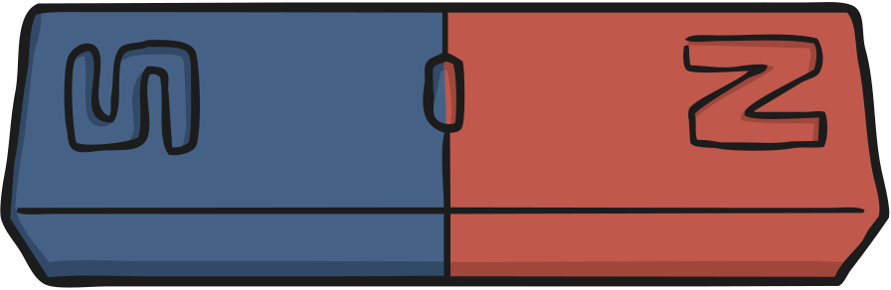
It has two different sections, which are often coloured red and blue.
But what are these sections?
https://www.bbc.co.uk/bitesize/clips/zk9rkqt
While you are watching, listen for the answers to these questions:
Which three metals are attracted to magnets?
What happens when two magnets repel each other?
What are the different parts of a magnet called?
Which way will a compass always point?
Watch the clips demonstrating the poles of a magnet:
https://www.youtube.com/watch?v=Mp0Bu75MSj8
https://www.youtube.com/watch?v=f1zGie-_IHY

What did you find out?
The three metals that are attracted to magnets are iron, cobalt and nickel.
When two magnets repel each other, they push away from each other.
The different parts of a magnet are called the poles. There is a north pole and a south pole.
A compass always points north-south.

Attract and Repel Investigation
Explore the poles of two magnets and feel them repel and attract.
Take two magnets and place them so the two north poles are facing each other. Try to make them touch. What do you feel?
Try this with the two south poles. What do you feel this time?
You should feel the two magnets pushing away from each other – they are repelling each other.
Now try to make the north pole of one magnet touch the south pole of another magnet. What do you observe this time?
Did the two magnets stick together? They are attracted to each other.
Remember: Like poles repel, opposite poles attract.

Task: The north pole of a magnet will always attract to the south pole of another magnet. If two north poles or two south poles are put together they will repel each other. When this happens the magnets will move away from each other. Write whether you think the magnets shown below will attract or repel each other.

Task 2: Draw a neat, labelled diagram of a magnet.
You will need to:
- Label each pole
- Explain how the poles work.

