ART- Roman Art

Lesson 3:
LO: To understand how to design a Roman mosaic.
HOM: Creating, Imagining, Innovating
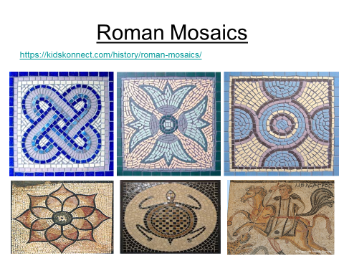
White Hat: What are Roman mosaics?
Green Hat: What different images can be used?
Green Hat: What were some of the reasons why these mosaics were used?
Yellow Hat: What were the benefits of using tiles for the mosaics?
Use the web link to find out the history of Roman mosaics. See if you can find out about any Roman mosaics which have been discovered in England since the Roman invasion.
TASK- Use the outlines of the Roman mosaics provided below to colour the tiles. Think about the pattern which you are trying to create and the choice of colours.
Extra Challenge- create your own design for a Roman Mosaic using the examples given.

