History – The Romans:
In this topic children will learn about the life of the Romans and how they invaded Britain. They will be exploring ways which Boudicca helped to invade Britain. The children will be making comparisons between the Celts and the Romans. The children will be learning about how the Gladiators fought and the ways that the Romans entertained themselves.
Useful Links:
https://www.bbc.co.uk/bitesize/topics/zwmpfg8
https://www.youtube.com/watch?v=b9bcohqsTGk
http://www.primaryhomeworkhelp.co.uk/Romans.html
https://central.espresso.co.uk/espresso/primary_uk/subject/module/frontscreen/item991656/grade2/index.html?source=subject-History-KS2-History-Resource%20types
https://www.twinkl.co.uk/search?term=the+romans
http://www.primaryresources.co.uk/history/history5.htm
Lesson 3: History /ICT
LO: To select and record information about the Celtic and Roman way of life.
To make comparisons between lifestyles and aspects of life in Roman and Celtic Britain.
In school this lesson would have been covered through one in class session and then a separate research session in the ICT suite.
Begin by reminding yourself of the following:
WHITE HAT
Who were the Romans?
Who were the Celts?
GREEN HAT
What reasons did the Romans have to invade Britain?
WHITE HAT
Why were the Romans able to so easily defeat the Celts during the invasion?
Key information: The way of life of the Romans and the Celts were extremely different. This means that the Celts must have been forced to change some of their ways of life when the Romans invaded.
https://romansandcelticsociety.weebly.com/similarities-and-differences.html
Watch the Youtube clips of the roman and Celtic way of life and make some notes.
https://www.youtube.com/watch?v=D-VmbxpEFAA
https://www.youtube.com/watch?v=XS7OmcX3uRA
http://www.bbc.co.uk/education/clips/zcfygk7
http://www.bbc.co.uk/guides/ztqg4wx
Task: Draw your own double bubble map like we use in class to compare some similarities and differences between the life of Celts and the life of Romans.

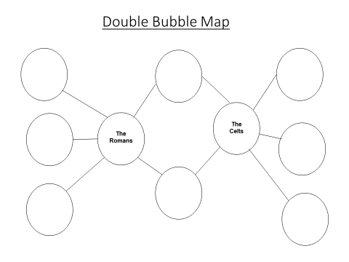
Part 2:
Independent research task: Research the way of life for the Celts and Romans. Choose an area of life for the Romans and the Celts e.g. houses, clothes, beliefs, towns, art, technology and language. Make notes on what you find out.
Written Task: Create information page or leaflet comparing the two using what you have learnt.

