Lesson 4:
LO: To understand that sources about Boudicca contradict each other.
To make a comparison of these accounts which give different viewpoints.

Read the Roman description below and think about who or what it could be describing?
“In stature she was very tall, in appearance most terrifying, in the glance of her eye most fierce, and her voice was harsh; a great mass of the tawniest hair fell to her hips; around her neck was a large golden necklace; and she wore a tunic of divers colours over which a thick mantle was fastened with a brooch. This was her invariable attire . She clutched a spear when she spoke to her people.”
WHITE HAT: What words could we use used to describe the person who we have just heard about?
Can you draw a sketch of what you are picturing in your mind after reading this description?
Now read the Celtic description below and again think about who it could be describing?
It is reported that she was tall, had beautiful long red hair down to her knees and usually wore a multi-coloured tunic. It is also believed that she wore a heavy golden necklace and a silken blue cloak secured by a brooch. She was said to have carried a spear and looked beautiful.
WHITE HAT: What words could we use used to describe the person who we have just heard about?
Can you draw a sketch of what you are picturing in your mind after reading this description?
Looking at both of your pictures can you answer the following?
GREEN HAT
What similarities and differences can you see between your pictures?
Both of the accounts you read were describing the same person. Her name was Queen Boudicca.
Learn more about her by reading the information on these links and watching the clips below.
https://www.ks2history.com/boudica-info-guide
https://www.youtube.com/watch?v=9G01vm9MVa4#
https://www.youtube.com/watch?v=eC7ONgTJGKw
https://www.theschoolrun.com/homework-help/boudica

Task: Complete the double bubble map to compare the two descriptions of Boudicca
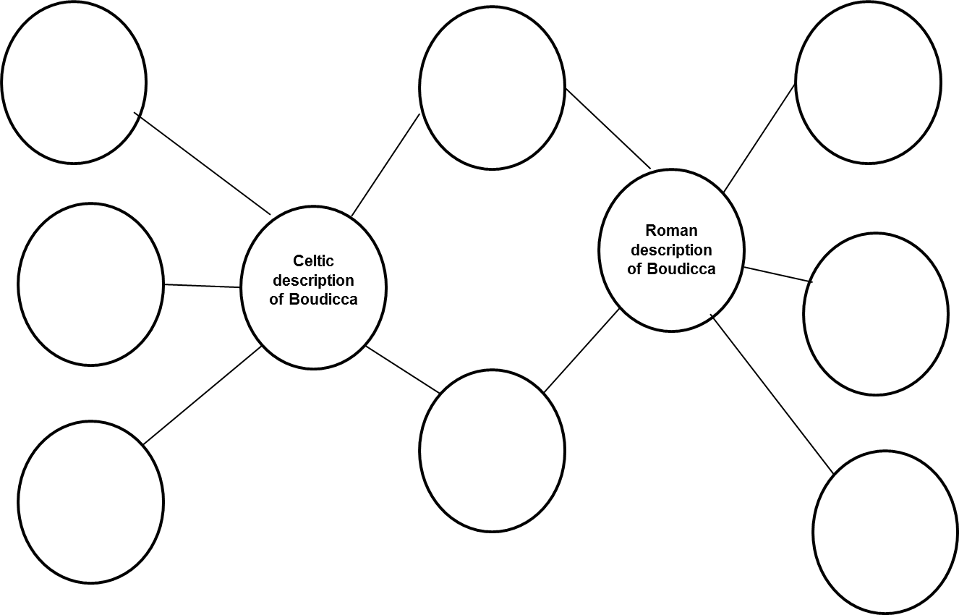

Questions to discuss and answer:
GREEN HAT
Why do you think the images differ?
WHITE HAT
Who do you think might be telling the truth?
Why do we not know who is telling the truth?
What can you tell about what the Romans thought of Boudicca from their account?
What can you tell about what the Celts thought of Boudicca from their account?
GREEN HAT
Whose side do you think Boudicca might have been on? Why?
Task: To write a balanced argument explaining what Boudicca was like from both points of view, one from the Roman point of view of Boudicca and another from a Celtic point of view. Ensure that you have included clear descriptions of what Boudicca was like giving examples.

Look at the example structure given below to give you some help of what to include. .
Challenge: Can you explain why there are two different views of Boudicca?
