RE- From Easter to Pentecost

Lesson 4:
LO: To recognise a commercial representation of Easter and explain how this could be dangerous for Christians.
HOM: Thinking and communicating with clarity and precision.

The Church uses liturgical colours as they represent new life which reminds us of the resurrection of Jesus on Easter Sunday.

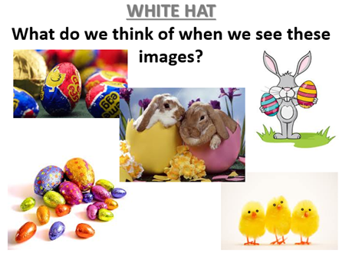

TASK- Write an explanation as to how these pictures do represent Easter and how they are not accurate representations of Easter. Explain why the symbol of a rabbit and an Easter egg is not a good enough representation for Christians the events and season of Easter

