Science-
Light:

https://www.bbc.co.uk/bitesize/topics/zbssgk7
Lesson 4:
LO: To identify how shadows are formed.
To start:
White Hat: What is a shadow?
Green Hat: What words would you use when you talk about shadows?
https://www.youtube.com/watch?v=ibctn5G-_dg (You can watch the whole story or skip to around the 5.00 minute mark)
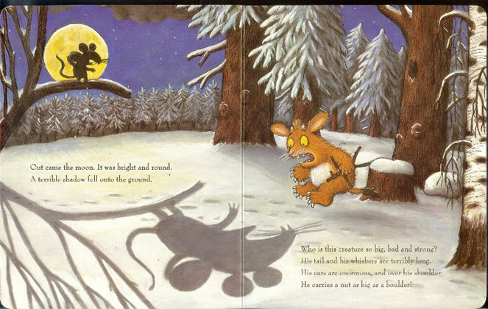
Yellow Hat: How was the mouse’s shadow useful?

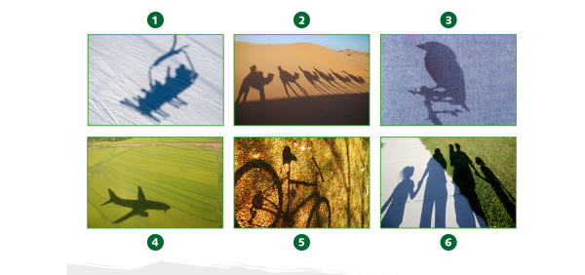
Can you identify what these are shadows of?
Key Vocabulary:
Opaque- Blocks the light from passing through
Transparent- Lets nearly all the light falling on it to pass through
Translucent- Blocks some of the light passing through it
Can you think of some examples of objects for each of the above terms?

What is a shadow?
https://www.youtube.com/watch?v=YuUJCNzfoBw
https://www.bbc.co.uk/bitesize/clips/z6fnvcw
Key Information:
Shadows are created when a source of light shines on an object but the light is blocked and does not pass through it.

Task 1: Sort the objects
Transparent | Opaque | Translucent

Paper Ice cubes Window
Pencil Sandwich bag Glass bottle
Sticky tape Chair Tin can
Task 2: Look at the items below and decide which type of material would be best for each one. Try to explain your reasons:
Bathroom window
Sun Hat
Living room curtains
Car windscreen
A window
Shower curtain
Explain your reasons for your choices.

Task 3: Complete the paragraph below:

Task 4: To Investigate: How can you make a really good shadow?
Use a torch to investigate how different types of shadows can be made. Test out some opaque, transparent and translucent objects you can find around your house.
Can you try to make a long, stretched shadow or a shorter shadow? How?
Remember to record all of your findings.

