History – The Romans:
In this topic children will learn about the life of the Romans and how they invaded Britain. They will be exploring ways which Boudicca helped to invade Britain. The children will be making comparisons between the Celts and the Romans. The children will be learning about how the Gladiators fought and the ways that the Romans entertained themselves.
Useful Links:
https://www.bbc.co.uk/bitesize/topics/zwmpfg8
https://www.youtube.com/watch?v=b9bcohqsTGk
http://www.primaryhomeworkhelp.co.uk/Romans.html
https://central.espresso.co.uk/espresso/primary_uk/subject/module/frontscreen/item991656/grade2/index.html?source=subject-History-KS2-History-Resource%20types
https://www.twinkl.co.uk/search?term=the+romans
http://www.primaryresources.co.uk/history/history5.htm
Lesson 5: History 22nd May 2020
LO: To understand the role played by Boudicca in the invasion of Britain.
To write a biography of Boudicca describing what she is really like.

Can you tell someone at home what you now know about Boudicca from your previous lesson?
https://www.bbc.co.uk/teach/class-clips-video/story-of-britain-boudica-and-the-roman-invasion/zmyhf4j
https://www.youtube.com/watch?v=eC7ONgTJGKw
https://www.youtube.com/watch?v=zhcm6z5PT04
Task: Fill in the (or draw your own) bubble map with what you know about Boudicca.

To think about:
White Hat: Why was Boudicca described in two different ways?
Who did Boudicca probably fight for?
How do we know?
Green Hat: What can we learn about Boudicca from the way she was described?
Key Point: Boudicca fought for the Celts –against the Romans- during the invasion.
Read through some more facts about Boudicca below, then complete the task at the end:

Facts about Queen Boudicca
Here are some facts about Queen Boudicca:
- Boudicca lived in Norfolk and was part of the Iceni tribe
- The Romans, who invaded England in 43 AD, and the Iceni tribe were on good terms, to begin with.
- Boudicca married King Prasutagus and they had two daughters together.
- Due to Roman law, Boudicca had no right to inherit her husband's property because she was a woman.
- When the Roman's came to take the property Boudicca tried to defy the Romans. They beat her and her daughters.
- Boudicca and her family attacked Roman Colchester, destroying the temple and killing everyone.
- Then, they burned down London and St Albans, mercifully killing the town's population.
- Boudicca and her rebels were eventually defeated in 61 AD by the Roman commander Gaius Seutonius Paulinus.

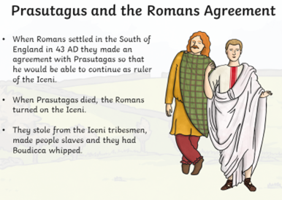
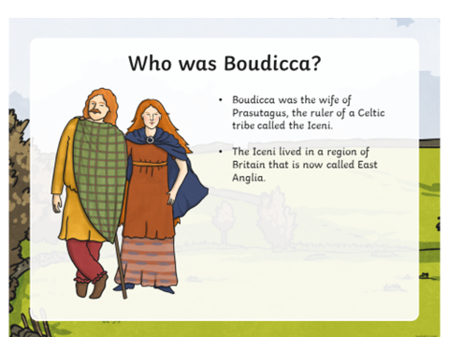
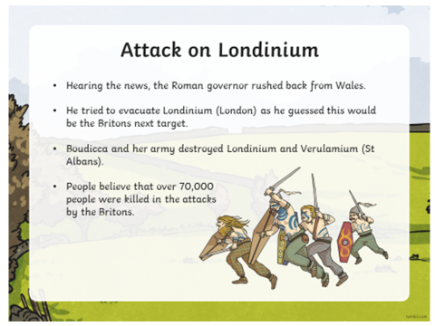
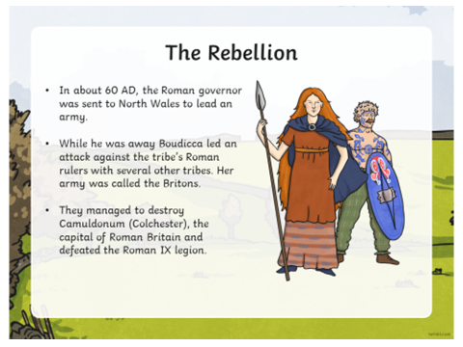
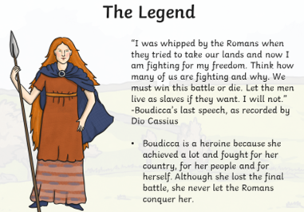
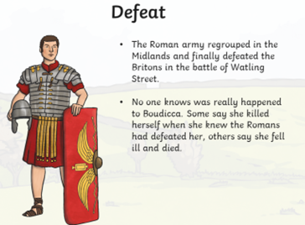
Task: Using the information you’ve learnt, create a biography page for Boudicca. You will need to include clear historical facts to describe what she did in her life.

