Science-
Light:

https://www.bbc.co.uk/bitesize/topics/zbssgk7
Lesson 5: 18TH May 2020
LO: To investigate how to change the size of a shadow
Last time we looked at how shadows are formed. You should be able to explain this in your own words now. Today we are going to look at how we can change the appearance of shadows by carrying out some investigations.
Starter:
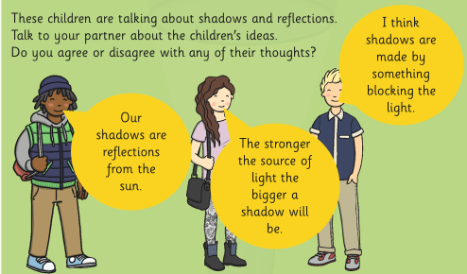
Answer the questions below:
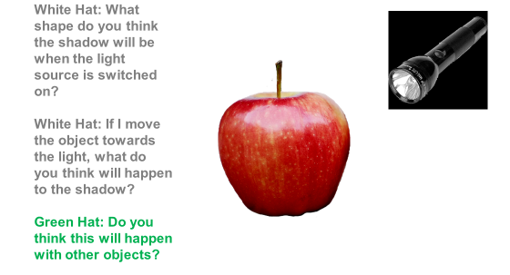

Investigation Question: How shadows change when the distance between the light source and object changes.
You will need: a torch, a ruler/ metre stick/ measuring tape, and an opaque object.
Method: You will measure the shadow of the object at different distances from the torch (the light source).
Think about what you will do to answer the question, and what you think you will find out.
Task 1:
Prediction:
I predict that as the object moves closer to the light source the shadow will get . . .
I predict that as the object moves further away from the light source the shadow will get . . .
Task 2:
Planning:
Equipment: What will you need to carry out your investigation? | Step 1: How are you going to make a shadow using your equipment? | Step 2: How are you going to measure the distance of the object from the light source and the size of the shadow?
Step 3: How will you measure what happens to the shadow when you move the object away from the light source? | Step 4: How will you record your results? | Draw a small diagram of your investigation.

Task 3:
Investigate:
Use the table to help you record your results:
Distance between the light source and object | Size of the shadow
10cm

Look at your results carefully, what do you notice? Has the size of the shadow changed when the distance changed?
Explain in your own words what you notice: ________________________________________________________________________________________________________________________________________________________________________________________________________________________________________________________________________________________________________________________________________
Can you write a conclusion summarising what your investigation has shown you?
__________________________________________________________________________________________________________________________________________________________________________________________________________________________________________________________________________________________________________________________________________________________________________________________________________________________

Why Do Shadows Change Size?
You should have noticed that the smaller the distance between the light source and the object, the bigger the object's shadow is.

Why do you think this this happens?

Key information: The closer an object is to the light source, the more light it blocks. This means the shadow created is bigger. But if an object is far away from the light source, it does not block out much light, so the shadow is smaller.

Task: Be the teacher!
Can you explain (in your own words) how shadows change size to someone at home?

