ART- Roman Art

Lesson 6:
LO: To design a Roman soldier’s shield.
HOM: To use past knowledge.

Roman soldiers were well prepared for battle and one of the things which made them so successful was their well-designed armour.

Look at the examples of the Roman soldier’s shields.

White Hat: What do all the shields have in common?

Green Hat: What is different about the shields?

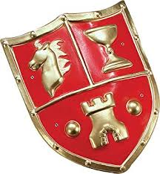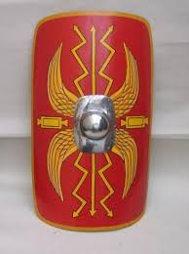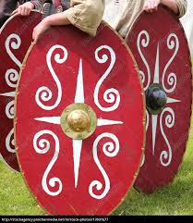

TASK 1- Use colours to design this Roman soldier’s shield

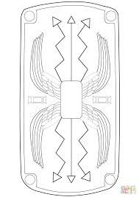

TASK 2- Draw your own shield on the blank paper provided and design it in your own way. Think about any patterns needed or any special symbols which could be relevant.

