RE- Islam

Lesson 6: (This may take more than one session to complete)
LO: To look at people who are inspirational and special to you.
To learn about who Muhammad was and why he is important to Muslims.
HOM: Remain open to continuous learning.

Complete the Circle Map and include information about what you already know about the Islamic faith.

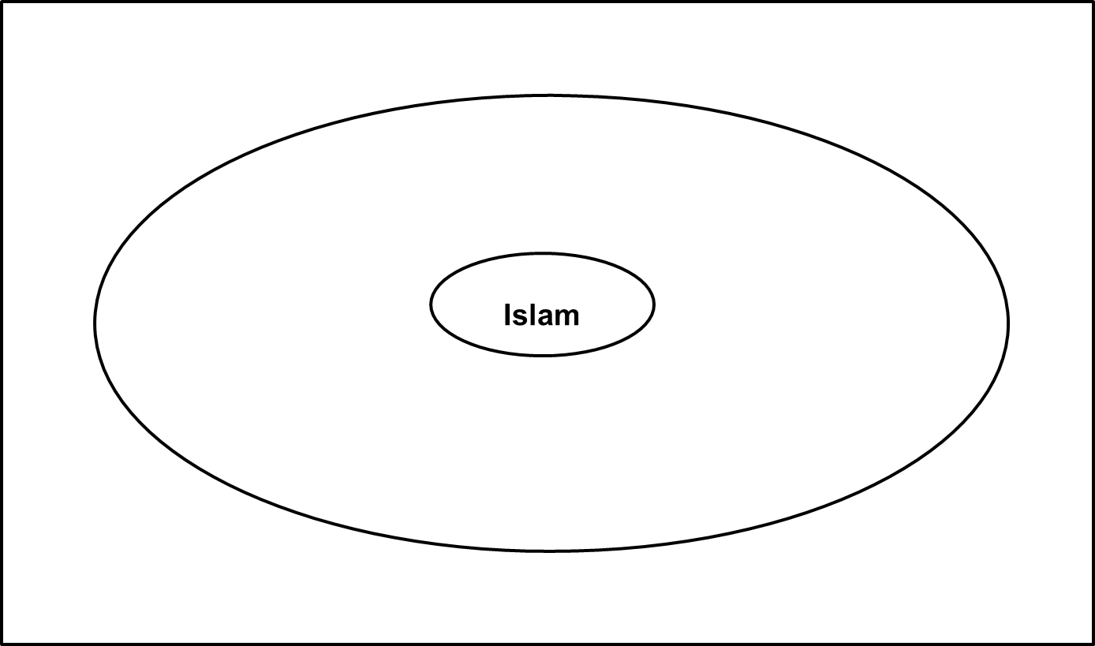

Discuss and answer the Thinking Hats questions
WHITE HAT
Which people do you know who are special? What makes them special?
What did they do to inspire others?
How these special people inspired others and became famous for it.

Introduce who Muhammad was.
Read together information about the life of Muhammad.

Discuss and answer these questions:

WHITE HAT
What was Muhammad like?
What did Muhammad not like about people at the time?
What did Muhammad want the people to be like?
What did the Angel Gabriel tell Muhammad?
What made Muhammad special?
RED HAT: Why was he unhappy if everything in his life was good?
GREEN HAT: How did he inspire others?
YELLOW HAT: Why is Muhammad important to the Muslim people?
BLACK HAT: what difficulties did Muhammad face in his life?

TASK 1: You will use the information sheet about Muhammad to create a fact file about Muhammad’s life and why he is important to the Muslim people on the next page. Either print this off and write it on, or complete the work on the Word document.

You can use the link below to find out additional information about Muhammad.
http://espresso/espresso/modules/t2_faiths/islam/index.html

