Science- 8th June 2020
We should be starting a new topic this half-term:
Forces and Magnets
What the children will be learning:
- To explore how a force is required to make something start to move.
- To explore how air can make things move
- To explore how objects move on different materials
- To explore which materials are magnetic
- To measure the strength of a magnet in different ways
- To carry out an investigation comparing the strength of different magnets
- To identify the two poles on a magnet and investigate how magnets attract or repel each other

Working Scientifically:
- Identifying differences, similarities or changes related to simple scientiﬁc ideas and processes
- Setting up simple practical enquiries, comparative and fair tests
- Using results to draw simple conclusions, make predictions for new values, suggest improvements and raise further questions
- Gathering, recording, classifying and presenting data in a variety of ways to help in answering questions
- Recording ﬁndings using simple scientiﬁc language, drawings, labelled diagrams, keys, bar charts and tables
- Reporting on ﬁndings from enquiries, including oral and written explanations, displays or presentations of results and conclusions
- Making systematic and careful observations

Some useful links:
https://www.bbc.co.uk/bitesize/topics/znmmn39
https://www.bbc.co.uk/bitesize/topics/zyttyrd
https://www.theschoolrun.com/homework-help/magnets

Lesson 7:
LO: To explore how a force is required to make something start to move.

Success Criteria:
- MUST- be able to understand that pushes, pulls and twists can make objects move.
- SHOULD- be able to draw and label a diagram to show the force that makes an object start to move.
- COULD- be able to explain how to make an object start, change direction and stop.

Complete a circle map on what you know about magnets and springs:
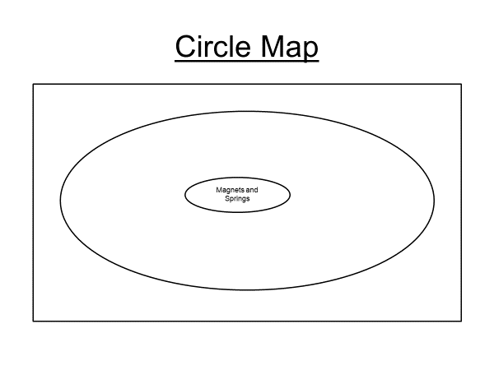

Watch the video clip at the link below, as you watch keep note of the objects that move and think about how they are moving/ what is making them move.
https://www.bbc.co.uk/bitesize/clips/zf84d2p https://www.bbc.co.uk/bitesize/clips/zf84d2p
White Hat: What caused the object(s) to start moving?
Key Information: What Is a Force?
A force is a push or pull acting on an object as a result of the object's interaction with another object.
Forces can make objects stop or start moving.
Watch the clip showing the effects of forces on different objects. While you are watching, note down any examples of pushes or pulls that you see.
http://www.bbc.co.uk/education/clips/zkw8q6f
Did you spot these examples of pulling forces?
- The rower pulls the oar.
- The tug of war teams pull the rope.
- A catapult is pulled back.
- The string of the bow is pulled back.
- Pulling the sledge.
- The bell ringers pull the ropes.

Did you notice these examples of pushing forces?
- The runner's feet push off the ground.
- A person pushes the piano keys down.
- The hockey stick pushes the ball.
- The golf club pushes the golf ball.
- The bat pushes the ball.
- The woman pushes the pram.
Task: Forces in Action
Think of an action that shows how forces move objects. You could choose an action from the clips you watched earlier or think of your own.
Create a freeze frame of the action you have chosen.
Show your freeze frames to someone at home. Can they decide if you are demonstrating a pushing force or a pulling force?
OR
Have an adult take a picture of your action.
Then,
Draw a diagram of the action, explaining where the push or pull force takes place and what the result is when the force is applied.
e.g. When I kick the ball with my foot, the ball moves forward because I have applied a pushing force.
Investigation:
The challenge is to make objects move in different ways using only certain resources. You will need to think of different ways to use the resources to make an object move. Some combinations of objects are listed below. Test out as many as you can.
• table tennis ball and a drinking straw
• table tennis ball and a piece of card
• cotton wool and a rubber band
• spinning tops
• clockwork toys
Explore how to make the objects start moving, change direction and stop. Draw a series of diagrams to show how you achieved each using arrows to show where the force was applied.

