Science- 15th June 2020
Forces and Magnets

Some useful links:
https://www.bbc.co.uk/bitesize/topics/znmmn39
https://www.bbc.co.uk/bitesize/topics/zyttyrd
https://www.theschoolrun.com/homework-help/magnets

Lesson 8:
LO: To explore how objects move on different materials
Success Criteria:
By the end of the lesson I:
- MUST- be able to understand how to carry out a comparative test.
- SHOULD- be able to compare how an object moves on different surfaces.
- COULD- be able to explain how the surface affects the movement of the object.

Think about a slide you would find in a playground. What type of material is it usually made out of? What does the surface feel like? Smooth, rough, hard, soft?
How do you go down a slide?
White Hat: Why do you slow down so quickly at the bottom of a slide?
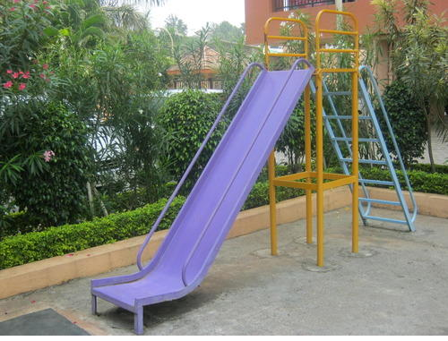
Becomes horizontal (flat, no longer sloping downwards)
Steep slope
The slide is now horizontal and there is a change in surface (the ground).
Key Information: Making Things Move
Forces make things move. Whenever an object starts to move or moves faster, it is a force making this happen. Forces can also make things stop moving or slow down.
But what is a force?
- Forces are pushes and pulls.
- These pushes or pulls will always change the motion of an object. They will either make it start to move or speed up, slow it down or even make it stop.
Talk to someone at home about examples of forces changing the motion of different objects.
Cycling
By pushing the pedals harder or faster, a cyclist can change the motion of the bicycle. It will speed up.
When the cyclist pulls on the brakes, the brake pads will push on the wheels, changing the bicycle's motion. It will slow down, and eventually stop.
Cyclists sometimes travel over different surfaces.
How do the different surfaces affect the motion of the bicycle?
Which would be easier/ harder to cycle on? Why do you think this?
Key information: These surfaces all exert a force on the bicycle. This force is called friction. Friction is a force that holds back the movement of an object. Friction acts in the opposite direction to the movement of the object.
Different surfaces create different amounts of friction. The amount of friction created by an object moving over a surface depends on the roughness of the surface and the object, and the force between them.
Investigation:
You will need:
A toy car
A board/ramp
Different materials to cover your board
A ruler or measuring tape
Method:
- Place the car at the end of one of the boards.
- Place the ruler at the side of the board, so you can measure the height of the board as you lift the end.
- Lift the end of the board that the car is on 1 cm at a time.
- Watch the car carefully, and notice at what height it starts to move.
- Try this with each of the boards covered with different surfaces.

As you lift the ramp, gravity will pull the car down. Friction will be pushing opposite to this. Surfaces that create a lot of friction will need to be lifted higher for gravity to overcome the friction and pull the car down the ramp. Surfaces that don't create much friction will not need to be lifted much, as it will be easier for gravity to pull the car down.
Use the sheet attached below to help you complete your investigation.

If you cannot complete the investigation for any reason, complete the below activity instead:
St. Marys are looking to create a new playground slide for its students and need your help!
- Draw a diagram of the ultimate slide.
Make sure you include labels of the following
- The height and slope of your slide.
- The surface/ material your slide will be made from.
- The bottom of your slide, how do you come to a stop?
- A landing area for your slide.
2. Write a proposal to go with your slide.
Things to include:
- Why this will be the best slide.
- Explain each of the choices you made above.

Which surfaces will you test?

Which surface do you predict will create the most friction for the toy car?
____________________________________________________________________________________________________________________________________________________________________

Measure how high the ramp needs to be for the car to start to move over each surface. Record your results below:
Surface | Height of Ramp When the Car Started Moving

Which surface created the most friction for the toy car?
__________________________________________________________________________________
Which surface created the least friction?
__________________________________________________________________________________
Was your prediction accurate?
__________________________________________________________________________________
Challenge: Can you explain your findings? Why did the different surfaces create different amounts of friction?
________________________________________________________________________________________________________________________________________________________________________________________________________________________________________________________________________________________________________________________________________

The Ultimate Slide

My Proposal:
________________________________________________________________________________________________________________________________________________________________________________________________________________________________________________________________________________________________________________________________________________________________________________________________________________________________________________________________________________________________________________________________________________________________________________________________________________________________________________________________________________________________________________________________________________________________________________________________________________________________________________________________________________________________________________________________________________________________________________________________________________________________________________
________________________________________________________________________________________________________________________________________________________________________________________________________________________________________________________________________________________________________________________________________________________________________________________________________________________________________________________________________________________________________________________
________________________________________________________________________________________________________________________________________________________________________________________________________________________________

