ART/ D&T- A ROMAN BOAT

Lesson 9:
LO: To create a model of a Roman boat.
HOM: To use past knowledge.

Look at some of the images of Roma boats:
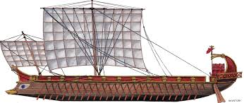

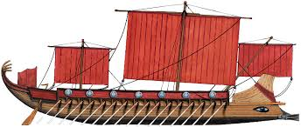

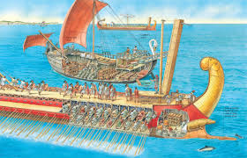

The Romans used these boats in order to travel to different parts of the world which helped them to invade different countries.

Complete the Circle Map:

Complete the designing and generating ideas page:

Complete the Final Design page:

TASK:

Choose one of these templates to make a Roman style boat (you can use card if you have some), then you can decorate and colour it in.

