History Lesson 10

LO: To understand what Roman baths were and know about the different amenities they contained.

https://www.bbc.co.uk/bitesize/clips/z8grkqt
http://www.primaryhomeworkhelp.co.uk/romans/baths.html
https://www.romanbaths.co.uk/childrens-pages-roman-bathing
Roman Baths
The Romans loved to keep clean and bathing was a sociable experience that the Roman people enjoyed sharing together.
The Romans also built their baths in the countries they conquered and re-established under Roman rule. There are many fine examples of Roman bathhouses in Britain.
This picture shows the Roman baths at Bath, Somerset.
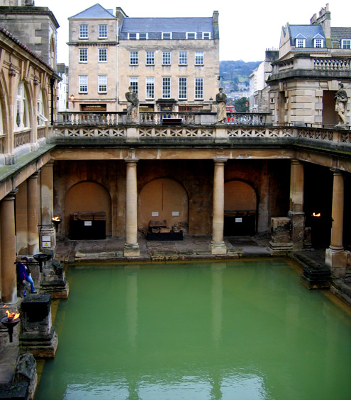

The Romans are well known for their innovative engineering and design skills and building a bathhouse really showcased their talents!
Water was heated by furnaces (fires) which were maintained by slaves and the hypocaust system used hot air under the floor to distribute the heat to where it was needed.
The baths were often elaborately decorated with statues and fine mosaics. There were mirrors on the walls, beautiful glass ceilings and smooth marble-lined pools.
If water was not available from natural springs at the site, it had to be brought in using an aqueduct system which the Romans developed to transfer water from one place to another.
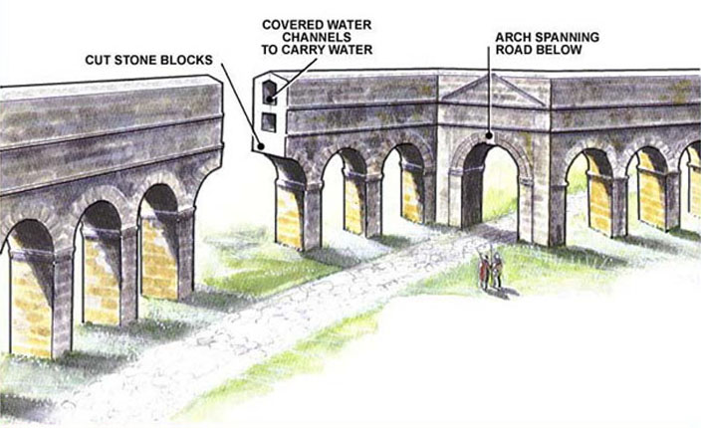

A Roman bath was not just a bath! Roman baths were based on three main bathing experiences. First, the bathers would relax in a warm room called the tepidarium. After that, they would enter the caldarium, which was a hot room designed to make them sweat out dirt. In the caldarium, a tool called the strigil was used to scrape dirt off the skin.
The final frigidarium bath was cold and big enough to swim in.
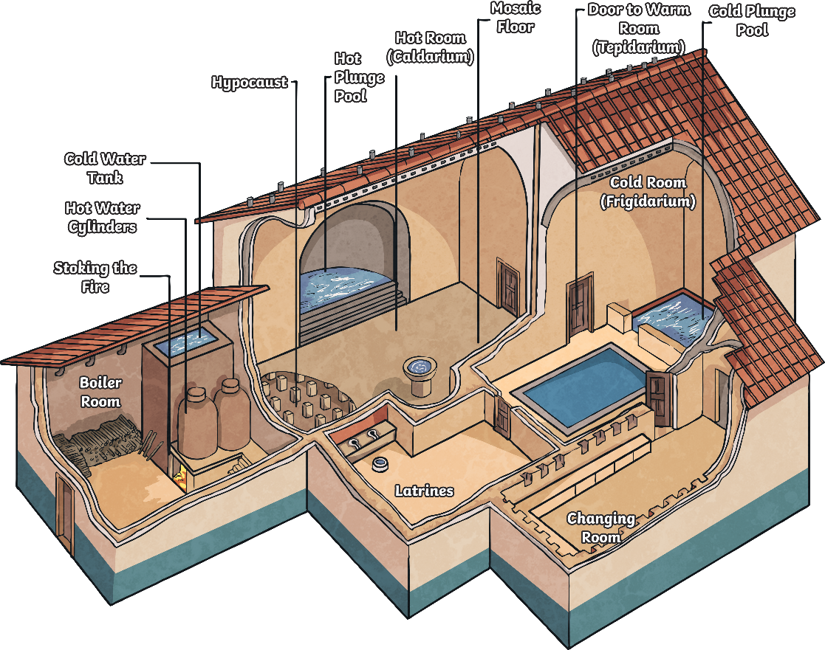

Many Roman baths offered other services too, making a visit to the bathhouse a total spa experience!
There was a gymnasium where people could exercise and get fit.
Masseurs were employed to give massages and help soothe aching muscles. They would also rub oil into the skin.
Vendors sold food and drink at many stalls.
Some baths had separate plunge pools, steam rooms and saunas.
Entertainment was often provided for people relaxing before and after bathing.
Some of the bigger baths had more than one of each type of room.
There were changing rooms where people could get dressed and undressed. Bathers might bring their slaves to guard their clothes and carry their towels or they could pay an attendant a fee to look after their property instead.
Task 1: Can you answer the following questions?
- How was water brought to the baths?
- How did the Romans heat the water?
- What were the names of the three main bathing experiences?
- What was the name of the tool used to scrape dirt off the skin?
- List three other things that visitors could do in the baths.

Task 2: Imagine you are a rich Roman who has just opened a new bathhouse. Design a guide or information leaflet giving details of your bathhouse and its features. You may wish to draw and include a labelled floor plan.
Things to consider:
- What is the bathhouse for?
- Who can use it?
- What features/ rooms does it have?

