ART LESSON 2
LO: To be able use lines and shadings for effect.
HOM: Remaining open to continuous learning.
TASK
In today’s lesson you are going to use the skill of drawing lines and then incorporating shading using different colours to create an optical illusion.
White hat? What is an optical illusion?
Optical Illusions can use colour, light and patterns to create images that can be deceptive or misleading to our brains. The information gathered by the eye is processed by the brain, creating a perception that in reality, does not match the true image. Perception refers to the interpretation of what we take in through our eyes. Optical illusions occur because our brain is trying to interpret what we see and make sense of the world around us. Optical illusions simply trick our brains into seeing things which may or may not be real.
Taken from https://www.optics4kids.org/illusions
Here is an example of an image taken from the website above.
How many figures can you see in the image below.
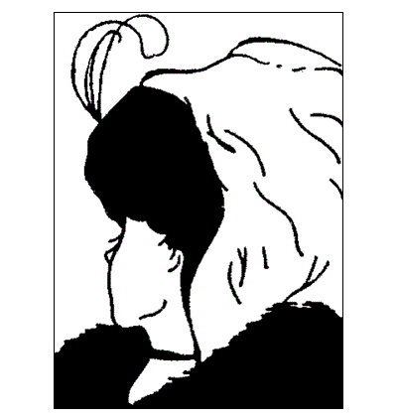

Your art task today is to create a simple optical illusion.
You can easily follow the simple task below o the left, which requires little instruction, or you can follow the instructions given to create the illusion on the right.

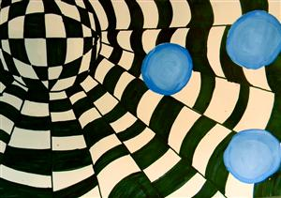
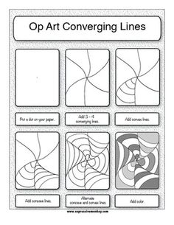
WHAT YOU WILL NEED:
A4 White paper (blank)
Pencil
Ruler
2p coin
Round shape like the top of a small tin or jar
Black felt tip pen or black colouring pencil

INSTRUCTIONS
- Lay your paper flat in a landscape position.
- Using your small tin or lid, draw around it in the upper left corner or your paper but a small part to the round shape needs to come off the paper, so that you are not drawing around it in its totally. Look closely at the example above.
- Now, using your ruler draw 8 straight lines about 2 to 3 centimetres apart. Depending on how you draw them you may get more or less lines that you will need to shade in. Tip: Place dots around the circle to help you with the spacing out of your lines.
- Place your 2p coin in 3 places on your paper. Draw round them, then choose a different colour to colour them in.
- Go back to your 8 lines. In each line, draw a series of lines carefully spaced out from the edge of the circle to the end of the paper. Do this for all your lines drawn. These will be the spaces that you will colour in alternately using your black colour.
- Feeling confident. Colour in each alternate shape, so that you mirror the example shown above.
- Once this is completed you can now concentrate on your circle. Look very carefully at the example above. The two centre lines that have been created go vertically from the top of the paper, almost in an oval shape. Can you draw these first? This is your guide
- Keep referring back to the example to be able to draw the rest of the lines in both vertical and horizontal positions. Keep going.
- Your next and final task is to shade in alternate lines within the circle shape.
- YOU HAVE SUCCESSFULLY COMPLETED YOUR TASK.

