SCIENCE LESSON 1.
LO: To identify the different types of teeth in humans and their simple functions.
HOM:
Before you start: Watch this video clip http://kidshealth.org/en/kids/teeth-movie.html
KEY VOCABULARY
teeth, incisors, molars, canines, jaw, evidence, digestion, chew, saliva.
Task
- First find a mirror in your home
- Open your mouth and look very closely at the teeth you have in your bottom set of teeth. Can you name them?
- Can you see your upper set? How many teeth do you have there? Can you name them? You might need an adult to help you with this first part.
Complete the chart below by colouring in the teeth that you do have.

Now watch the video clip that we started with again and label the diagram below, using the key vocabulary given.
When you have completed this task move on to the extension task. You will need to do your own research. BE COMPUTER SAFE!
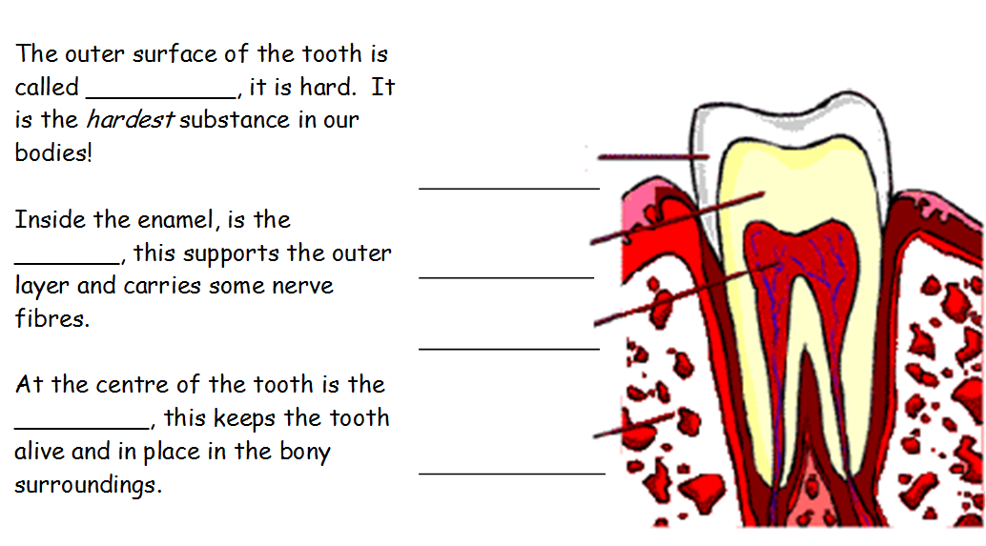
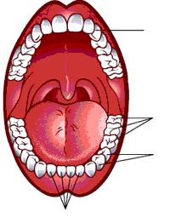
Teeth are particularly important for the life process of ______________.
It is our mouth and teeth which meet food first.
We have four types of teeth:
- Incisors
- Canines
- Premolars
- Molars
Label them on the diagram.

Now complete the extension task below.

