TOPIC LESSON 1

L.O – To recognise the main events in the battle of Bosworth.
HOM – Striving for accuracy

- Read the following information about the Battle of Bosworth very carefully. Underline what you think is important in each part of the text.
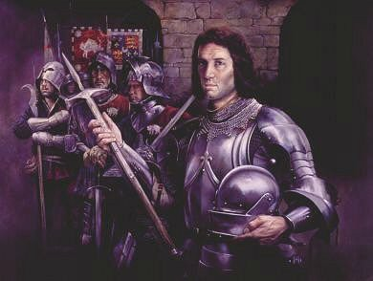
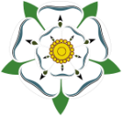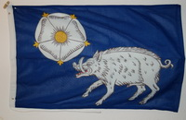

Symbols of the House of York (Richard III)

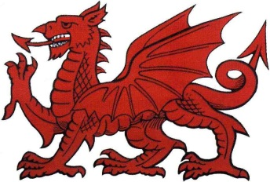
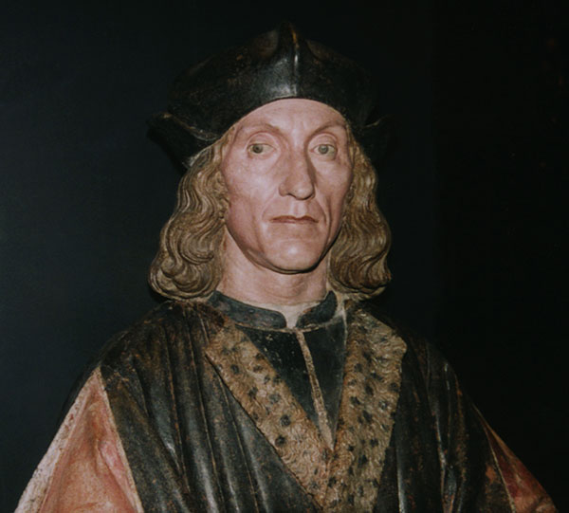
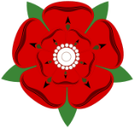
Symbols of the House of Lancaster (Tudor)

In 1485 there was a huge battle between two armies in a field at Bosworth, near Leicester. On its flags one army showed the White Boar and White Rose of the York family, which was the symbol of King Richard III. The other army’s flags showed the symbols of the Red Dragon and the Red Rose of the Lancaster family. At the head of this family was Henry Tudor.
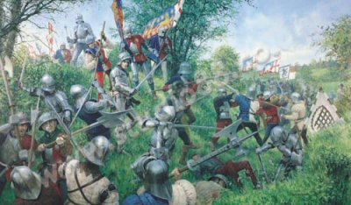
This battle was to end the War of the Roses which had been going on for 30 years! The House of York (Richard III’s family) and The House of Lancaster (Henry Tudor’s family) had been fighting for 30 years to decide which family was going to rule England as Kings and Queens.

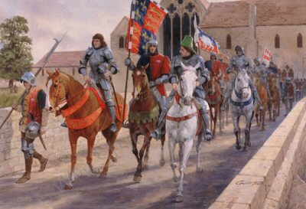
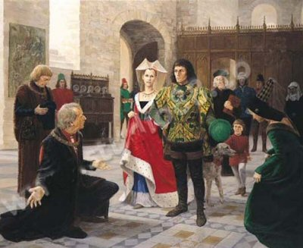
Richard III was worried because he did not know how many other armies he would get to help him fight Henry Tudor.
On 21 August 1485, Richard III rode out of Leicester to meet Henry Tudor’s army at the Field of Bosworth. Richard had 6000 men in his army with promise of another 3000 men from another Lord.

Henry Tudor, leading the House of Lancaster Army, only had 5000 soldiers and knights in all. Richard III seemed to have 4000 more men than Henry.
First the Longbow men shot their arrows across the field at the opposing army.
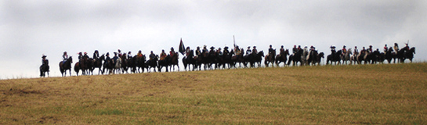
Then the Halberdiers and Pikemen of each army charged at each other, thrusting their long sharp, spiked and bladed weapons at each other.

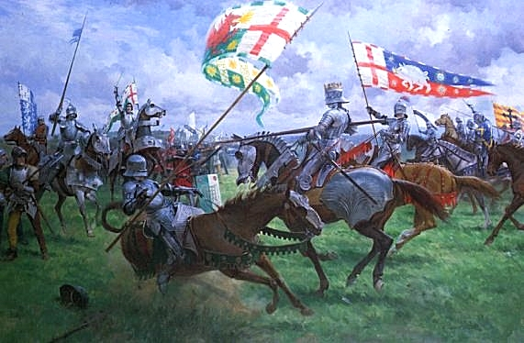
Then, finally, the knights in their shining armour, sitting on their armoured horses, charged at each other with their lances ready to push their enemy off his horse and hopefully kill him.
During the battle Richard III became impatient and charged at Henry Tudor himself. He hoped to kill Henry, but instead, Richard was pushed off his own horse by Henry’s knights.

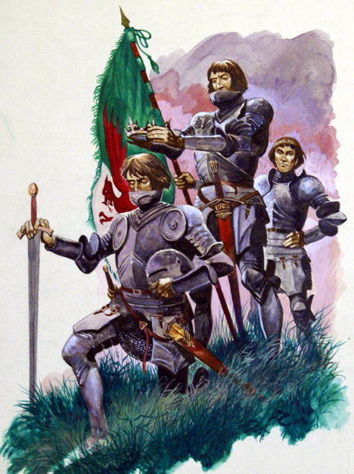
Richard III, off his horse, fought with his sword bravely, but he was soon surrounded by Henry’s knights, and they killed him.
The Battle was over, Richard III was dead. His body was taken back to Leicester on his horse.
Henry Tudor and the House of Lancaster had won the War of the Roses.

One of Henry’s knights found Richard’s crown lying on the grass under a thorn bush near where Richard had been killed in the battle.
The knight picked up the crown and placed it on Henry’s head shouting, “Hail, the new King of England!”
All Henry’s knights and soldiers cheered.

In 1485 Henry Tudor was properly crowned Henry Tudor King of England (Henry VII) at Westminster Abbey in London.
You can see here the Throne that he sat on for his crowning, and a Gold Coin that was made to show he was now the new King of England. All new coins would now have Henry’s image on them.
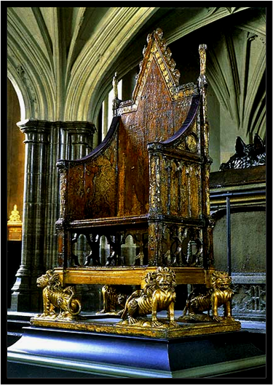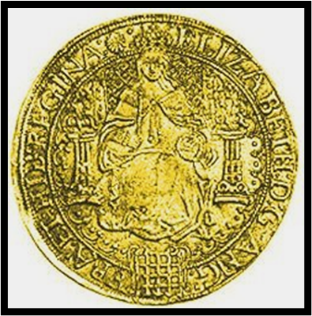

After Henry Tudor was crowned as King Henry VII he married Elizabeth of York, Richard III’s niece. Henry now brought together the houses of York and Lancaster (Tudor) into a peaceful time, with no more warring between them.
This started the reign of the Tudor family as Kings and Queens of England for the next 100 years.

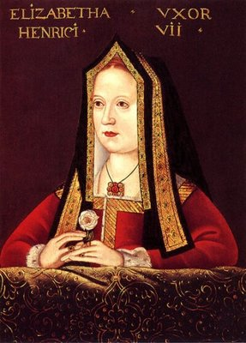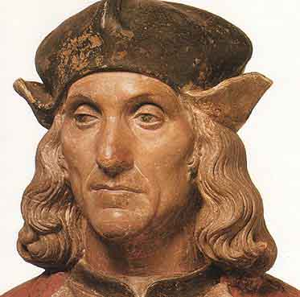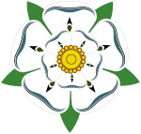
The House of York The House of Tudor

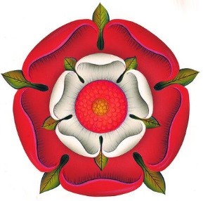
The new Tudor Rose

- Watch the following clips about the Battle of Bosworth
https://www.bing.com/videos/search?q=the+battle+of+bosword+you+tube&view=detail&mid=6D37306973538D04C2206D37306973538D04C220&FORM=VIRE

https://www.youtube.com/watch?v=JI8RvxEPJXs

- You will be draw boxes in a piece of paper for pictures and then writing the events of the Battle of Bosworth for each square. Use a ruler. Give the required detail for each part of the battle. Use colouring pencils to colour in pictures.
Plan your ideas your ideas first.

- Draw the Tudor rose and write an explanation underneath of how it was called the Tudor Rose.

Plan your ideas out on the bubble map below. Use the next sheet for your task.

THE
BATTLE OF
BOSWORTH

