LO: To be able to design your own insect mosaic.
HOM: Managing impulsivity

What is a mosaic?
A mosaic is a picture or pattern produced by arranging together small pieces of stone, tiles, glass, etc.

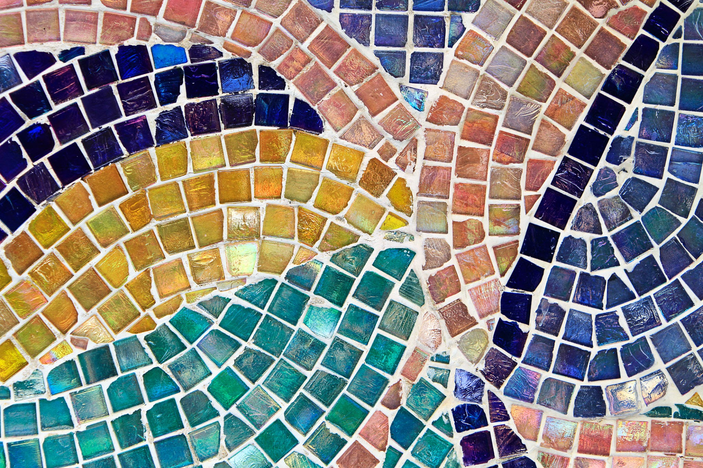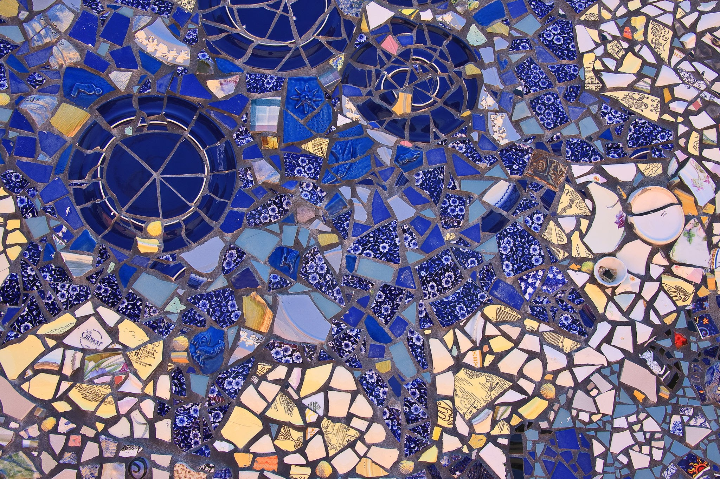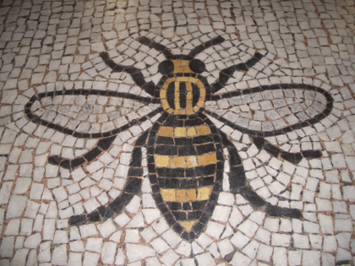

You are going to be making paper insect mosaics in pairs. For that you will need: paper squares, glue, sketchbooks/paper, and scissors.
- Decide which insect you will be drawing.
- Draw a large insect shape.
- Choose the colours of paper squares you will need for your insect. For example bee: black, yellow and white. If you do not have colour paper you can colour in white paper with the colours you will need.
- Lay the coloured squares on top of the insect design.
- Glue the coloured squares on the design.
- Fill in the background with another colour.
Look at the examples:

