LO: To learn about what people wore during Tudor’s time
HOM: Thinking flexibly

We are able to know what Tudor people wore thanks to all the paintings of Tudors, especially the Tudor kings and queens. By studying these painting we can study what clothes the Tudors wore.

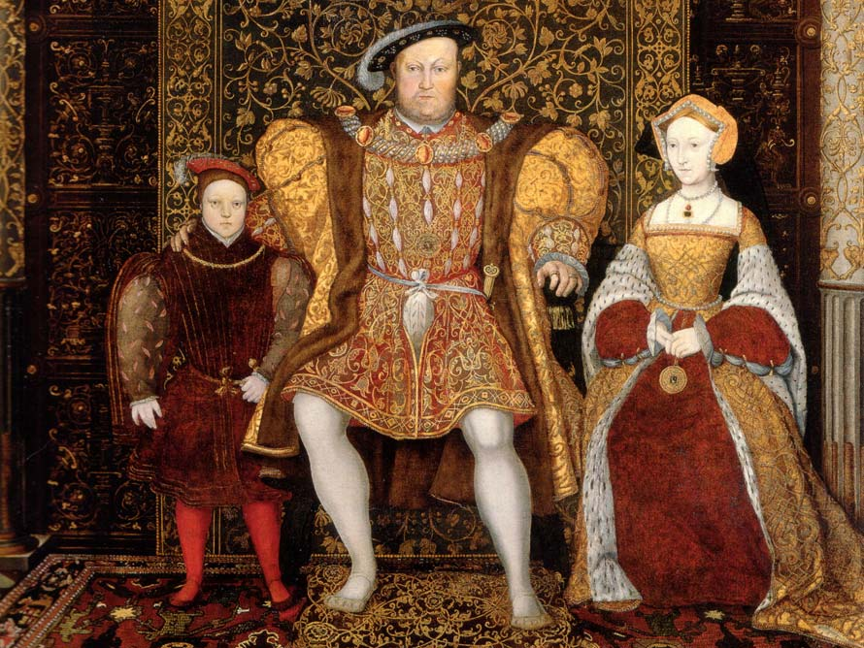
Tudor England is famous for its beautiful and ornate clothing. Elizabeth I was known for the 2000 beautiful dresses that she left behind.
Tudor England clothing was mostly quite lavish and rich.
There was a big different between what rich and poor people wore at Tudor times. For rich people, clothes were a way to show how rich and important you were. Rich Tudors loved to made their clothes as fancy as possible.
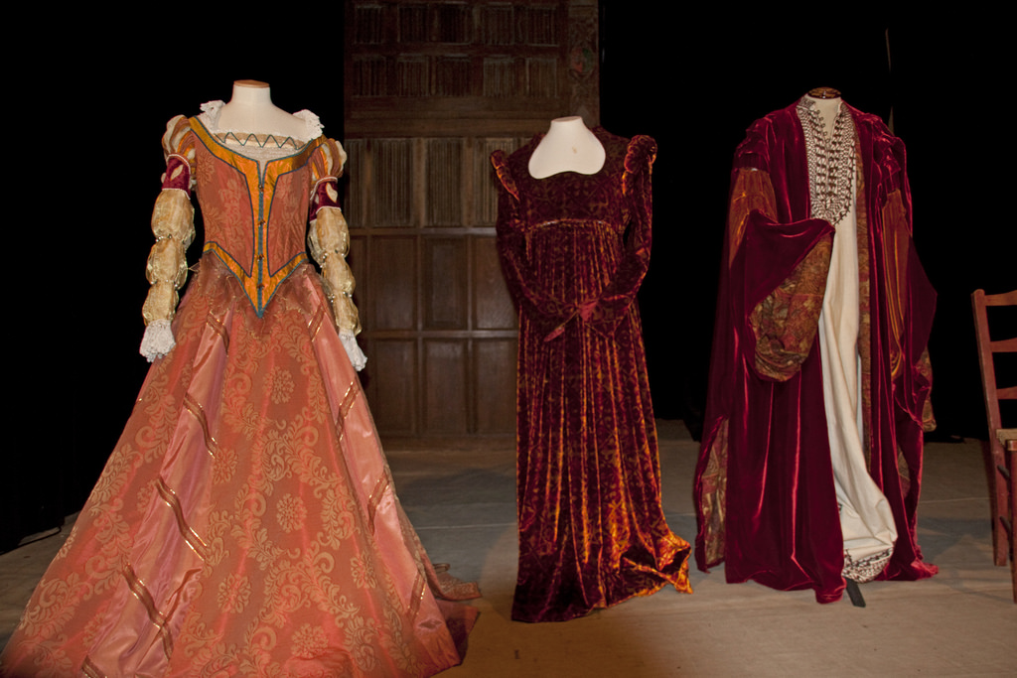
Rich ladies wore padded skirts held up with loops. Over these went bodices and colourful floor-length gowns. They had to wear lots of layers of clothing to show how rich and important their family was.
Rich men wore white silk shirts, frilled at the neck and wrists. Over this they wore a doublet (a bit like a tight-fitting jacket), and close-fitting striped trousers (called hose).
They wore clothes that were cut and sewn together very carefully into eye-catching shapes and designs.
Everyone wore their hair shoulder length.
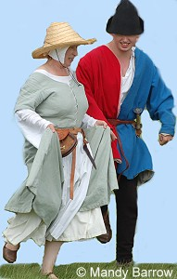
For poorer people, clothes needed to be practical and hard-wearing. Poor people wore simple, loose-fitting clothes made from woollen cloth. Most men wore trousers made from wool and a tunic which came down to just above their knee. Women wore a dress of wool that went down to the ground. They often wore an apron over this and a cloth bonnet on their heads.
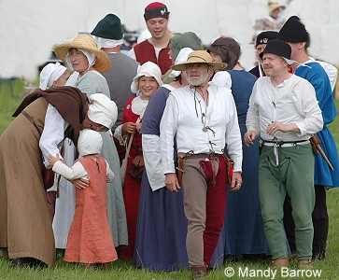
Their clothes were made mainly of wool, rough cotton and leather.
They would wear the same clothes all the time, every day, until they would make new clothes.

By the time Elizabeth I came to the throne, there had been some changes in what was fashionable. The ruff was made of a stiff fabric that ruffled at the neck. Both men and women wore ruffs. Women also started wearing bumrolls, which were tubes of fabric under the gown placed over the hips to make the waist appear smaller. Breeches or upper hose became fashionable for men. These were like puffed shorts that were worn with a shorter doublet.

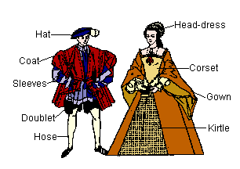

The clothes during that time were very different to what we have today. In Tudor times there were no synthetic fabrics. All Tudor clothes were made from only natural fabrics (fabrics that came from animals or plants). Some of these fabrics are: wool, leather, satin, silk, fur.
Have a look to the following links:

https://www.dkfindout.com/us/history/tudors/early-tudor-clothing/
https://www.bbc.co.uk/bitesize/clips/z3x6n39
http://www.primaryhomeworkhelp.co.uk/tudors/clothes.htm
https://www.historyonthenet.com/the-tudors-tudor-costume
https://tudorerafashion.weebly.com/the-poor.html
https://primaryfacts.com/1714/tudor-clothes-costumes-and-fashion/
https://gumroad.com/l/fnrLG

Name the features of Henry’s Clothes and then colour in the picture using the colours of rich Tudor clothing

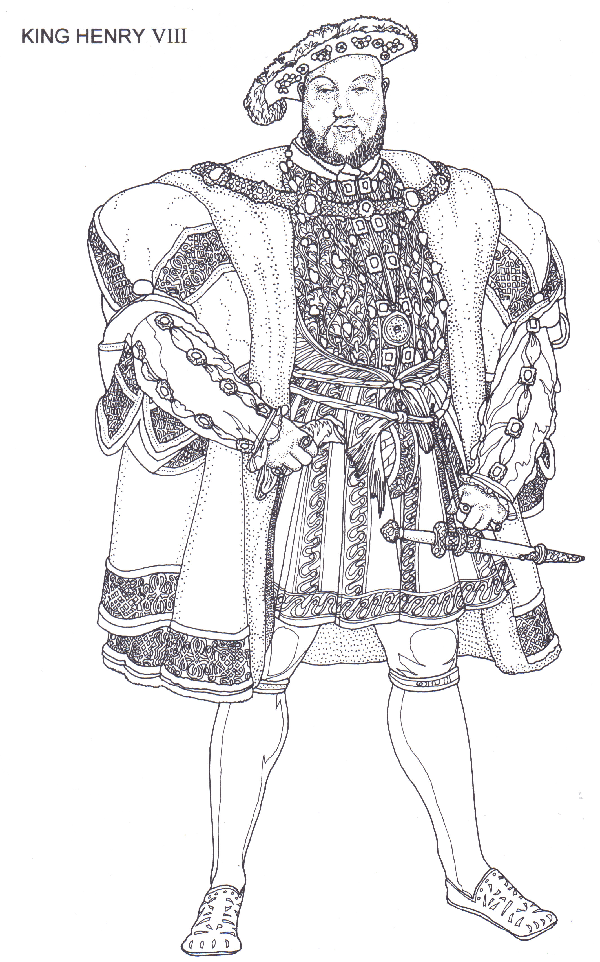

Why did Henry wear these rich and expensive clothes?
________________________________________________________________________________________________________________________________________________________________________________________________________________________________________________________________________________________________________________________________________________________________________________________________________________________________________________________________________________________________________________________________________________________________________________________________________________________________________________________________________________________________________________________________________________________________________________________________________________________________________________________________________________________________________________________________________________________________________________________________________________________________________________________________________________________________________________________________________________________________________________________________________________________________________________________________________________________________________________________________________________________________________________________________________________________________________________________________________________________________________________________________________________________________________________________________________________________________________________________________________________________________________________________________________________________________________________________________________________________________________________________________________________________________________________________________________________
Name the different clothes the Tudor peasant is wearing and then colour in the picture using accurate colours for Tudor peasant clothes.

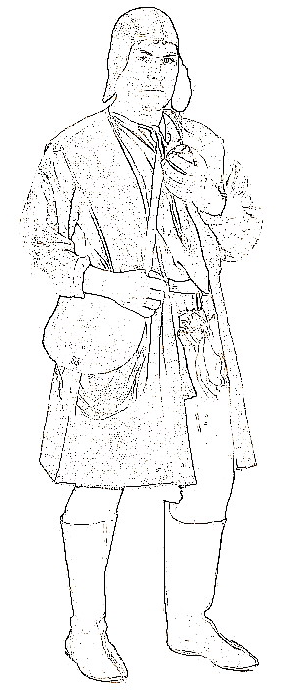

YOUR TASK:
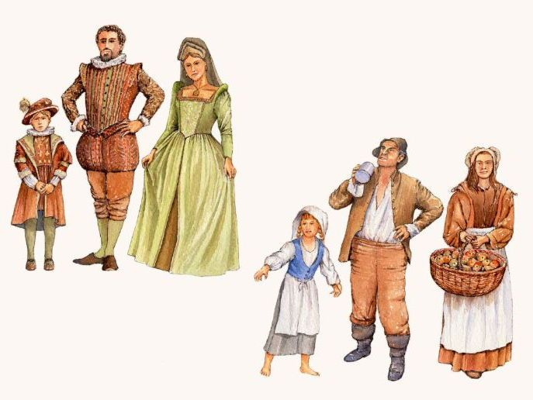

Looking at the picture, explain the differences between the clothes that rich and poor people wore during Tudor’s time
________________________________________________________________________________________________________________________________________________________________________________________________________________________________________________________________________________________________________________________________________________________________________________________________________________________________________________________________________________________________________________________________________________________________________________________________________________________________________________________________________________________________________________________________________________________________________________________________________________________________________________________________________________________________________________________________________________________________________
________________________________________________________________________________________________________________________________________________________________________________________________________________________________________________________________________________________________________________________________________________________________________________________________________________________________________________________________________________________________________________________________________________________________________________________________________________________________________________________________________________________________________________________________________________________________________________________________________________________________________________________________________________________________________________________________________________________________________
________________________________________________________________________________________________________________________________________________________________________________________________________________________________________________________________________________________________________________________________________________________________________________________________________________________________________________________________________________________________________________________________________________________________________________________________________________________________________________________________________________________________________________________________________________________________________________________________________________________________________________________________________________________________________________________________________________________________________
________________________________________________________________________________________________________________________________________________________________________________________________________________________________________________________________________________________________________________________________________________________________________________________________________________________________________________________________________________________________________________________________________________________________________________________________________________________________________________________________________________________________________________________________________________________________________________________________________________________________________________________________________________________________________________________________________________________________________________________________________________________________________________________________________________________________________________________________________________________________________________________________________________________________________________________________________________________________________________________________________________________________________________________________________________________________________________________________________________________________________________________________________________________________________________________________________________________________________________________________________________________________________________________________________________________________________________________________________________________________________________________________________________________________________________________________________________

