RE LESSON 7 WEEK 10
LO:
HOM:
INTRO
God has put many people on this earth who have served their community, their country and even the world in the way that God expected.
These men and women have, through their voices and their service, demonstrated very clearly to us, the teachings, and practices of God.
In our last topic we found out about our Holy Father, Pope Francis. In this topic we are going to find out about another great man, whose love for God, his forgiveness of others and his general humility, serves to remind us everyday of God’s love for us all and how we need to understand and prepare for the Kingdom of God.
TASK 1
White hat: Where is the name of this country ?
_____________________________________________________________________
Tip: The names of the provinces give you a little helping hand.
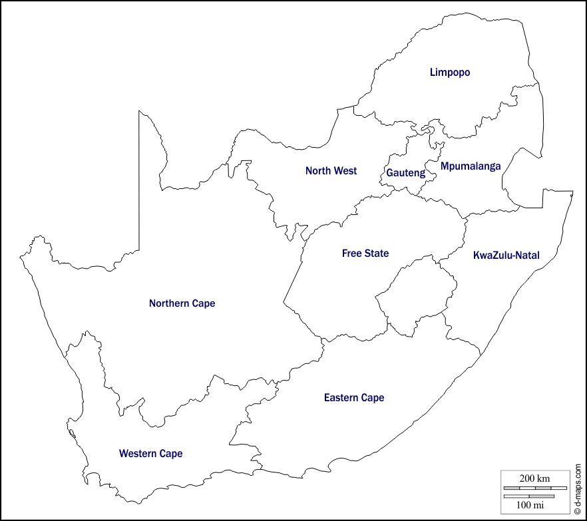
White hat: Where is it located?
____________________________________________________________________________________________________________________________________________
TASK 2
White hat: Can you name this man?
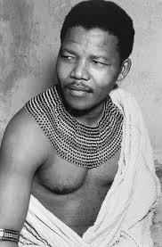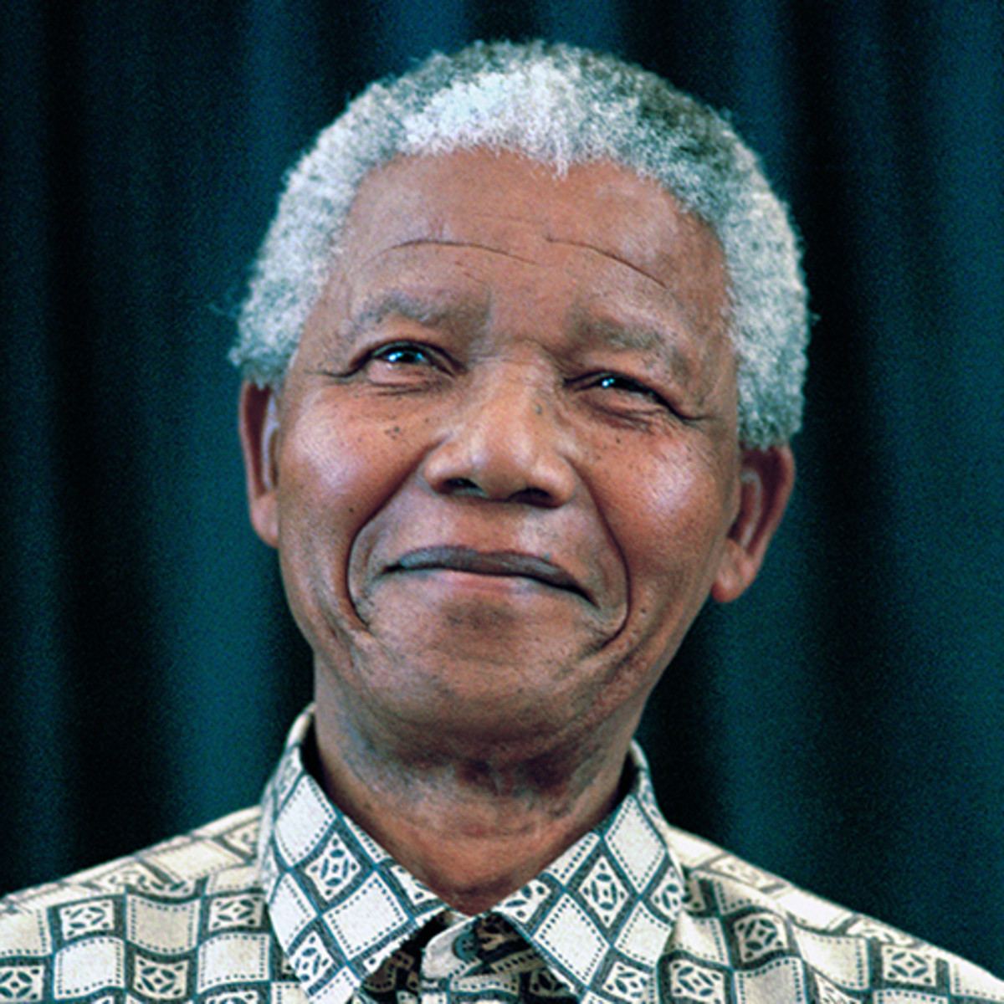
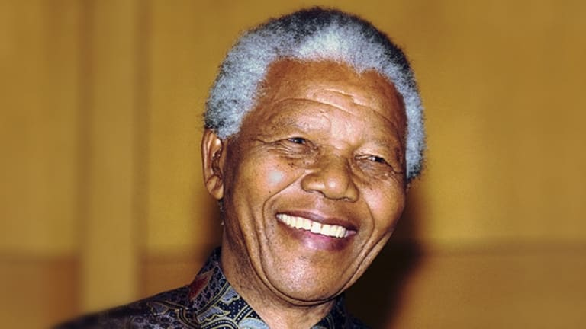
This man is ______________________________________________________
Blue hat: Can you record some things that you already know about him?

