RE LESSON 8 WEEK 10
LO: To learn and understand about the life of Nelson Mandela
HOM: Remaining open to continuous learning.
INTRO
In the last part of this topic our focus question is:
Nelson Mandela’s dream for the world.
(AT 1 Strand iii)
From the work that you completed in RE lesson 7, you came to know that Nelson Mandela is another person whom we are researching to find out and show how they lived their life worthy of example in the Kingdom of Heaven.
Nelson Mandela had a dream for the world and lived to bring it about. He was not treated well, he suffered under those who did not want to hear his voice and felt that he was too powerful. He was unfairly and unjustly treated. But through all this, he never lost faith in God and recognised that he was here to serve a purpose.
Mandela as a person who acted because he believed in God and this belief compelled him to act (behave) in particular ways.
Unlike Pope Francis, Nelson Mandela was not a Catholic, I need to make this quite clear here. He was still a Christian by Nelson Mandela was baptised and educated in the Methodist Church and as a Christian, a strong believer in Jesus Christ and his teachings, Mandela’s faith was an important influence on his life.
TASK
Your task is to create a BIOGRAPHY about Nelson Mandela. Your booklet must include information on the areas listed below
o Who he was
o What he did (ie some of the events of his life)
o Why he did these things (AT 1 (iii) Level 3)
o Explain how his faith was an important influence on his life choices. (AT 1 (iii) Level 4)
Remember although there may be some things that you find ‘not right and unfair’ about how Nelson Mandela was treated, you must remember
HIS FAITH GOT HIM THROUGH EVERYTHING HE FACED!
Pope Francis knew he wanted to be a priest and to be of service to people. Nelson Mandela knew that he had to be of service to his people and to help them overcome and overturn the injustices which they faced.
Below are some website pages that you may find quite helpful when researching. They are a starting point for you.
https://www.natgeokids.com/uk/discover/history/general-history/nelson-mandela/
https://www.ducksters.com/biography/nelson_mandela.php
https://www.bbc.co.uk/bitesize/topics/zjkj382/articles/zj3p8xs KS1 information but may still be useful.
I have provided you with a front cover for your BIOGRAPHY booklet. Use each of the bullet points above to be a chapter in your booklet and write a suitable heading for each.

A GREAT FIGHTER AGAINST THE OPPRESSION OF HUMAN KIND.
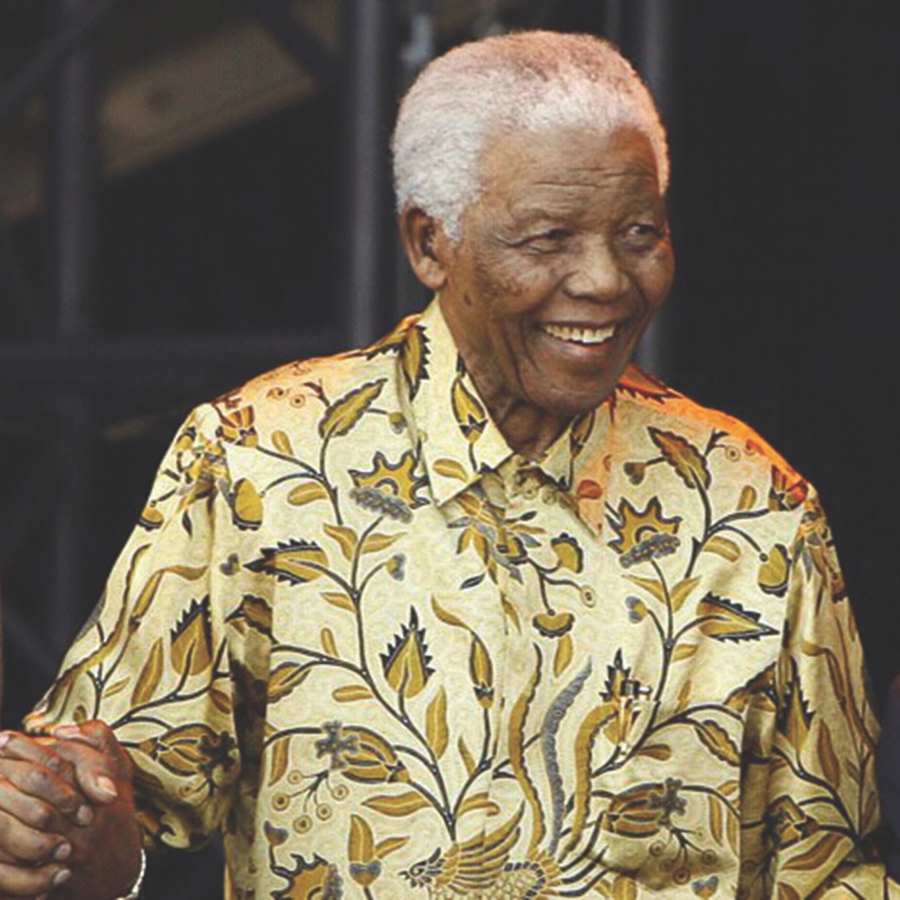
NELSON
ROLIHLAHLA
MANDELA
_____________________________________________________________

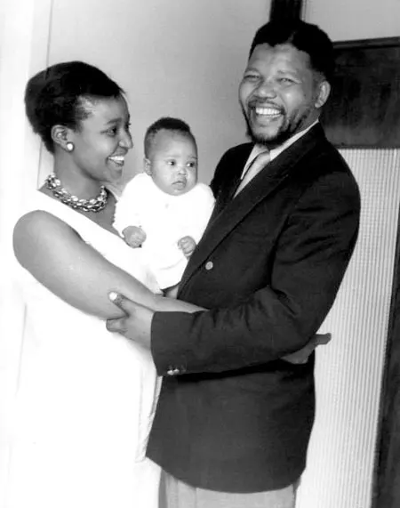

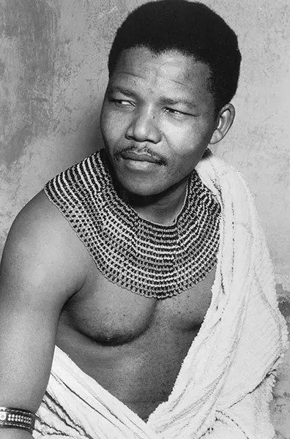
_________________________________________

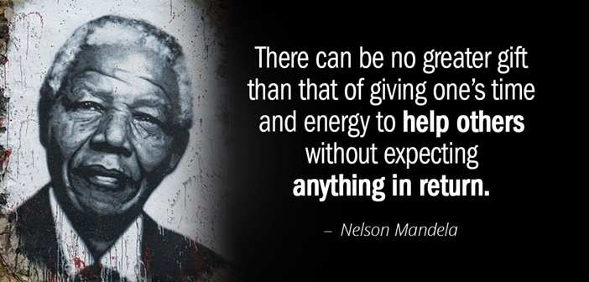

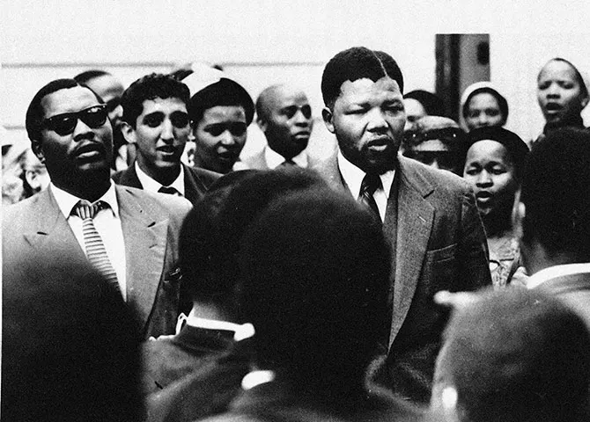
__________________________
__________________________

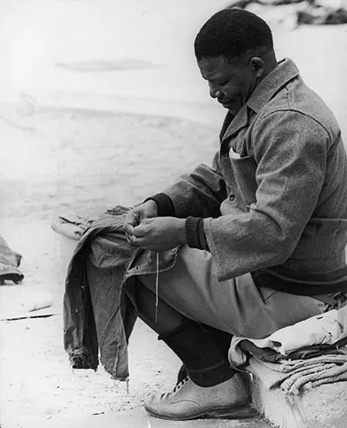

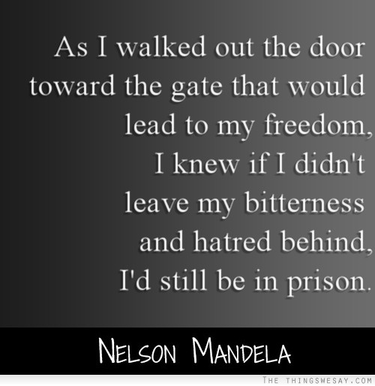

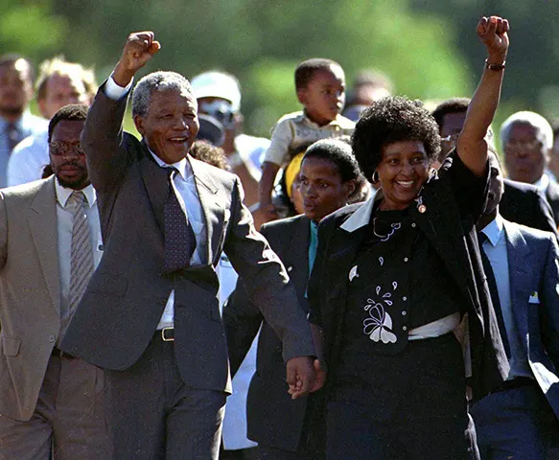
______________________________
______________________________

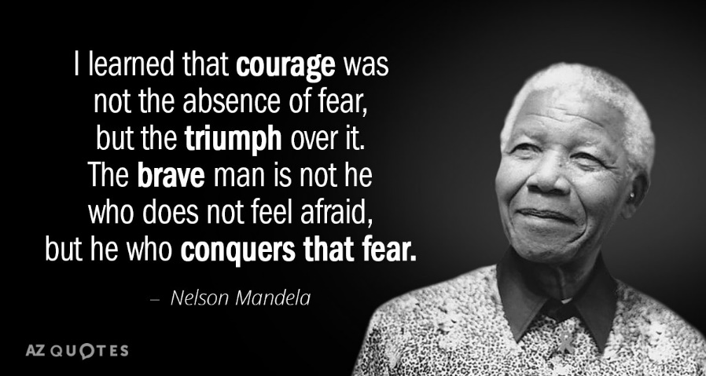

_______________________________________________________________
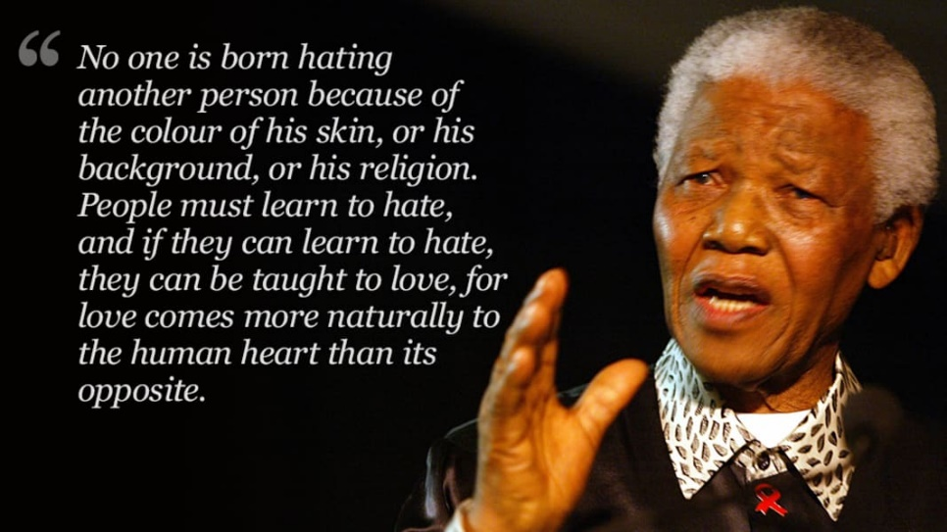

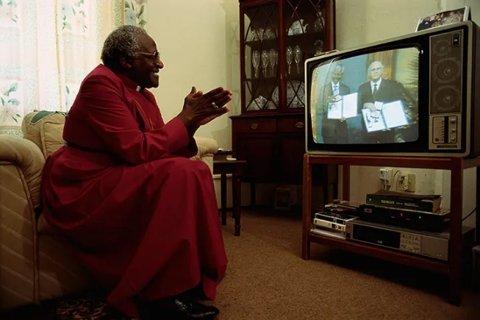

A MAN OF GREAT FAITH.
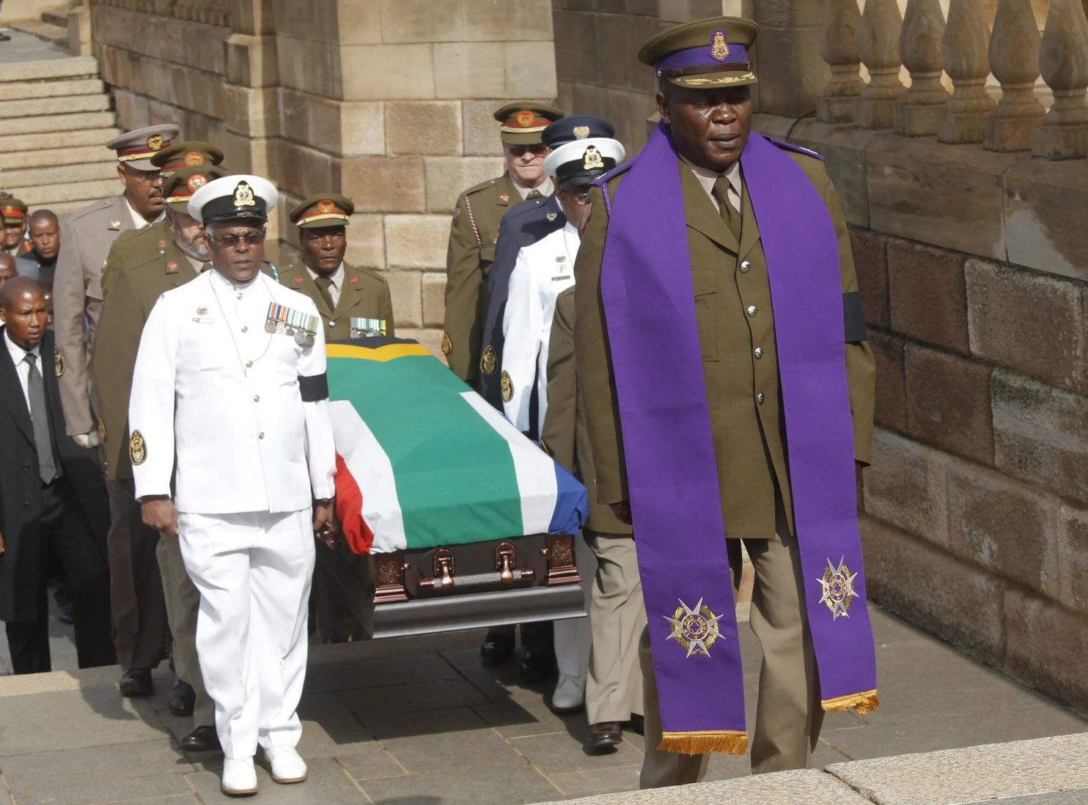
“I learned that courage was not the absence of fear, but the triumph over it. The
brave man is not he who does not feel afraid, but he who conquers that fear.” ~
Nelson Mandela

