WRITING LESSON WEEK 10
LO: To be able to make predictions.
HOM: Thinking with clarity and precision.
INTRO
All of our children are expected to make predictions while reading. Our curriculum objective reads simply:
KS2: Predict what might happen from details stated and implied
You have been doing this for a very long time now so, you clearly recognise that this can be as simple as asking the question, ‘What do you think is going to happen next?’, quickly followed with, ‘Why?’.
However, we need to make explicit the additional skills needed to be able to do this very successfully.
To be able to predict, you need to be able to read and understand what has happened and is currently happening. You need to be able to retrieve and infer (‘details stated and implied’), combine this with your knowledge of the world, weigh up probability, and make a sensible prediction of the next outcome. It might come naturally to some of us, but it’s worth breaking it down to look at what’s involved just as a little reminder because we haven’t been together for a while and you are usually reminded of this each time we read together.
Your writing task today is based on prediction. Although the questions may appear simple you really need to think ‘beyond’ what is stated (what you can actually see).

TASK 1
Look very carefully at the image below.
Blue hat: Do you recognise characters?
_____________________________________________________________________
White hat: Can you name them?
______________________________________________________________________

Read and answer the questions below the image. They may seem like very simple questions but you really need to focus then on ensuring that your answers are detailed, no words have been omitted, so your sentence makes complete sense, your handwriting is neat and words are easily readable and well formed and all necessary punctuation has been used correctly.

KITE-EATING TREE
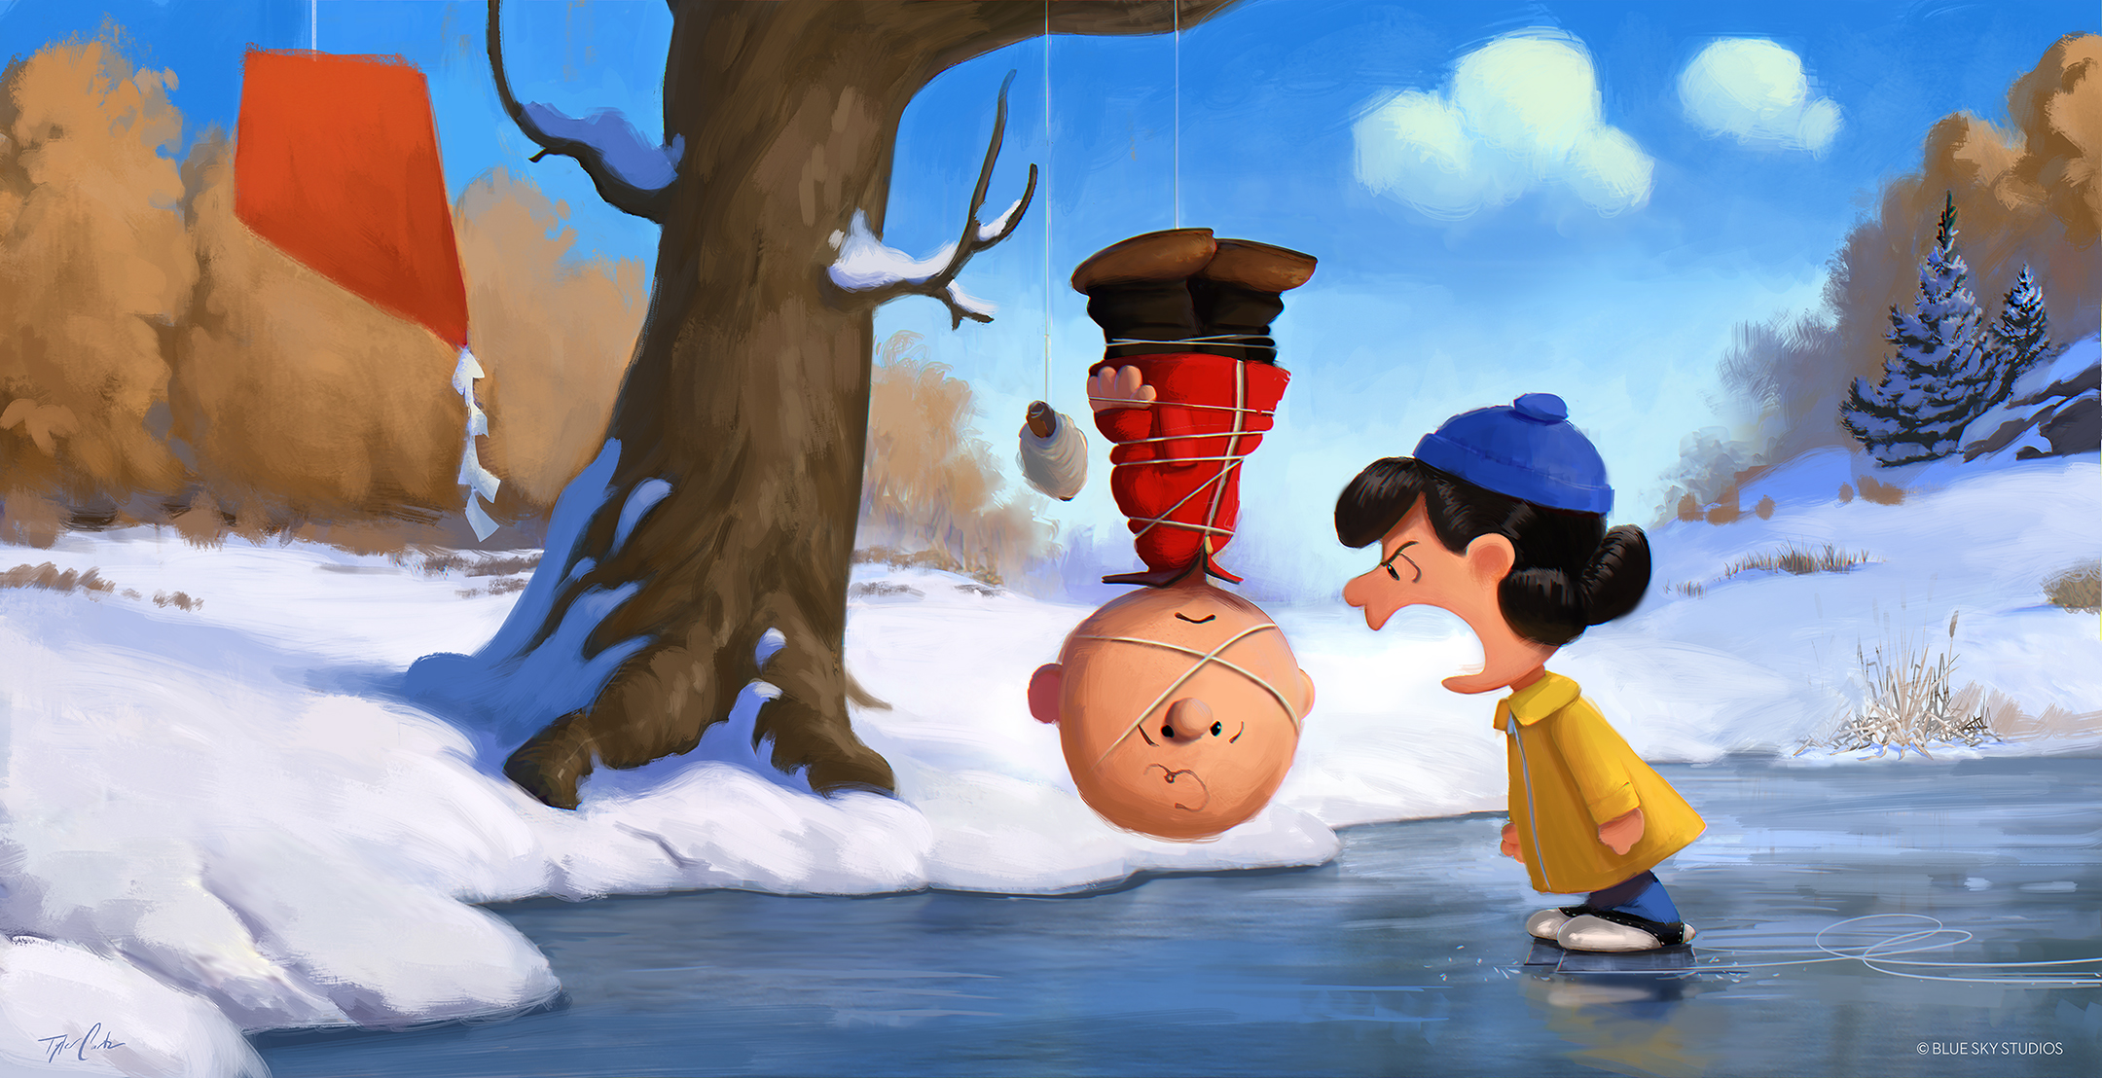
Blue hat: What has happened here?
____________________________________________________________________________________________________________________________________________
Blue hat: Why is the boy hanging from the tree?
__________________________________________________________________________________________________________________________________________________________________________________________________________________
Blue hat: Why is she wearing ice skates, but he is not?
____________________________________________________________________________________________________________________________________________
Blue hat: What might she be saying to him? Be creative!
__________________________________________________________________________________________________________________________________________________________________________________________________________________

Blue hat: How is he going to get down?
__________________________________________________________________________________________________________________________________________________________________________________________________________________
TASK 2
Your writing task today is quite simple, but we want you to think about all the skills that you have used, learnt, and understand how to apply to the writing up of these next two narrative pieces.
You are going to write two different narrative pieces that explain
What happened 5 minutes before this scene? What will happen 5 minutes after?
THERE IS A ‘CATCH YOU OUT HERE!!!!!!’
You must write the events in story form! So yes, you are still writing a short story but in two parts. Now each part of your story only needs to be a couple of paragraphs in length, but it is especially important that it is written as a narrative and not as an explanation piece.
SUCCESS CRITERIA
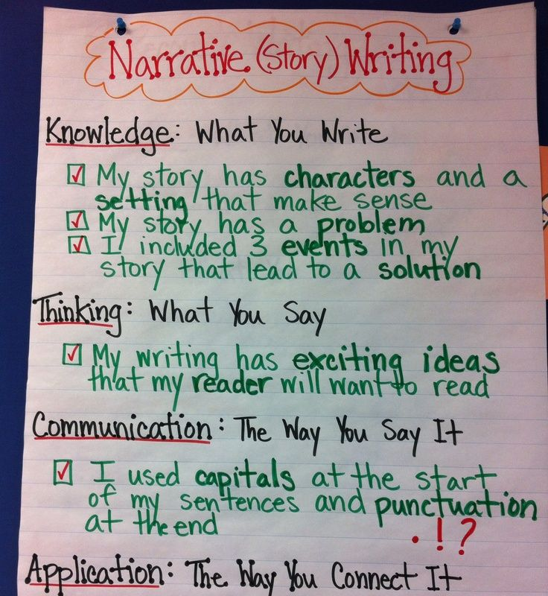
- Use adjectives, adverbs, and wow vocabulary to create detailed sentences.
- Use a variety of punctuation marks throughout your work with increased accuracy
- Use dialogue within your writing
- Use paragraphs to group your ideas, remembering that a paragraph should contain no less than 5-6 sentences and no more than 8…. Our year 4 advice because some of you were writing 2 sentence paragraphs.
- Writing stamina means that you must write an entire A4 page of writing for each scenario. Yes, Year 5 is just around the corner. Even though you have been at home during this time, your year 5 teacher will be expecting that you were writing at least an A4 page of writing ideas before school closed suddenly!
Mindmap your ideas below and then complete each narrative on the sheets that follow.
What happened 5 minutes before this scene? | What will happen 5 minutes after?
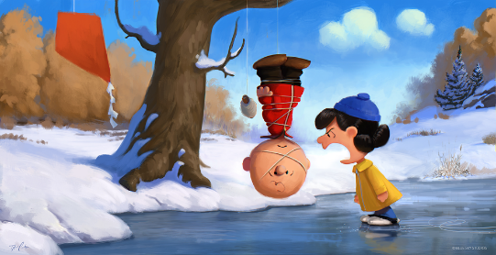
What happened 5 minutes before this scene.
________________________________________________________________________________________________________________________________________________________________________________________________________________________________________________________________________________________________________________________________________________________________________________________________________________________________________________________________________________________________________________________________________________________________________________________________________________________________________________________________________________________________________________________________________________________________________________________________________________________________________________________________________________________________________________________________________________________________________________________________________________________________________________________________________________________________________________________________________________________________________________________________________________________________________________________________________________________________________________________________________________________________________________________________________________________________________________________________________________________________________________________________________________________________________________________________________________________________________________________________________________________________________________________________________________________________________________________________________________________________________________________________________________________________________________________________________________________________________________________________________________________________________
Go back and use the success criteria to self assess your work.

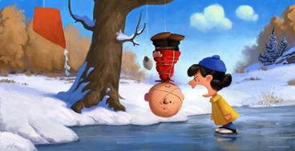
What will happen 5 minutes after this scene
________________________________________________________________________________________________________________________________________________________________________________________________________________________________________________________________________________________________________________________________________________________________________________________________________________________________________________________________________________________________________________________________________________________________________________________________________________________________________________________________________________________________________________________________________________________________________________________________________________________________________________________________________________________________________________________________________________________________________________________________________________________________________________________________________________________________________________________________________________________________________________________________________________________________________________________________________________________________________________________________________________________________________________________________________________________________________________________________________________________________________________________________________________________________________________________________________________________________________________________________________________________________________________________________________________________________________________________________________________________________________________________________________________________________________________________________________________________________________________________________________________________________________
Go back and use the success criteria to self assess your work.
WELL DONE! You have worked hard and achieved the learning objective.

