LO: to create artwork influenced by Polish Folk Art
HOM: Thinking flexibly
For this lesson you will need A4 black paper or card for the background, A4 white and brightly coloured paper for the main cut out, lots of scraps of white and brightly coloured paper for smaller cut outs, scissors and glue sticks.
In Poland over 100 years ago farm houses often didn’t have glass windows. Farmers would hang sheep skins at the window openings. To let in the light they would snip little patterns into the skins. This cutting became a popular art form and the patterns were used as decorations. ‘Wycinanki’ (pronounced vee-chee-non-kee) is the word for Paper- cut designs. Wycinanki is now a well known traditional folk art.
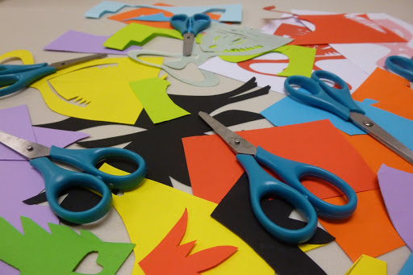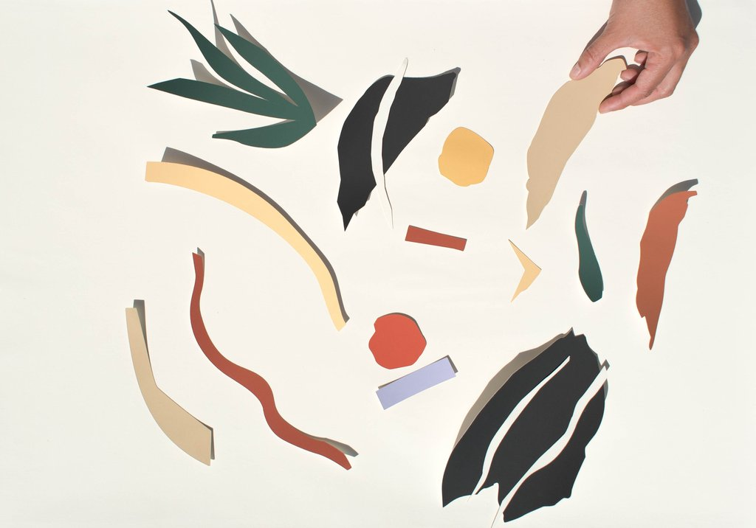
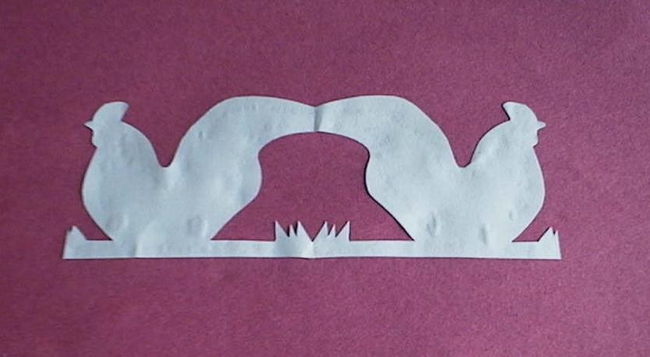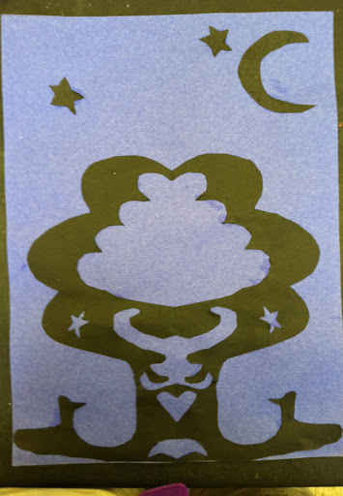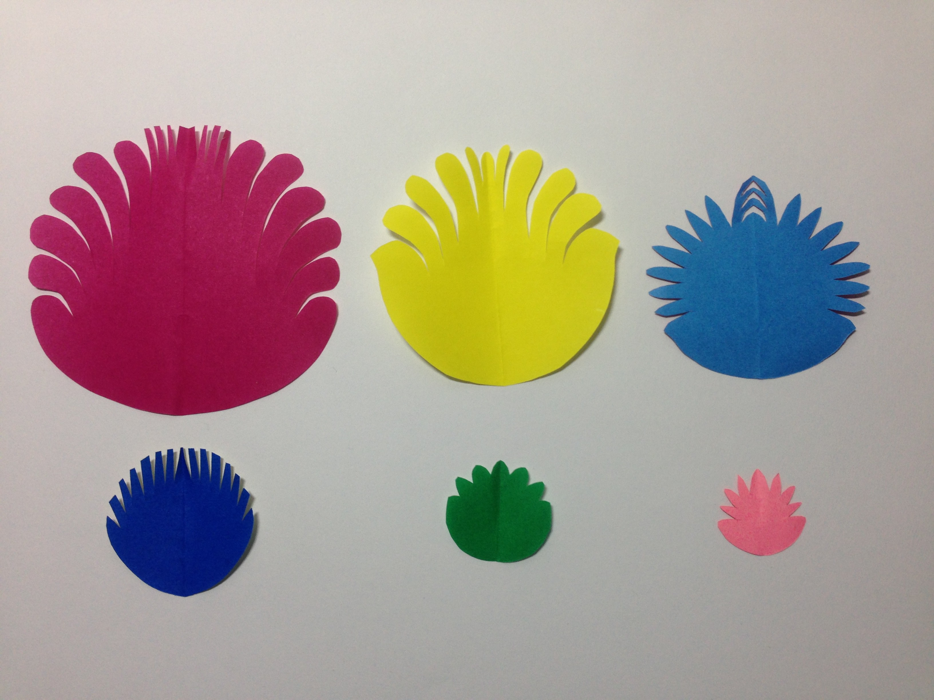
What is similar about the pieces? What do you like/ dislike? What do you notice about the colours? What do you notice about the subject matter of the paper cuts? Are all of the paper cuts symmetrical?
_________________________________________________________________________________________________________________________________________________________________________________________________________________________________________________________________________________________________________________________________________________________________________________________________________________________________________________________________________________________________________________

You are going to create some wycinanki.
Watch the following videos:

https://www.youtube.com/watch?v=TX_c7FEIVrc
YOUR TASK:
You are going to use wycinanki to create a picture with different animals from the story Peter and the Wolf.

