**LO: To understand what life was like as a child living in Tudor times.  
  
HOM: Remain open to continuous learning**

Watch the following videos

**A child’s life in Tudor times**

[**http://10.75.20.200/espresso//modules/t2_tudors/life/video_life_child.html**](http://10.75.20.200/espresso//modules/t2_tudors/life/video_life_child.html)

Life for rich and poor people in Tudor times  
<http://10.75.20.200/espresso//modules/t2_tudors/life/video_life_rich_poor_1.html>



What do you think Tudor children wore?

Children wore smaller versions of their parents’ clothes.

A rich boy would wear doublet, breeches and stockings.

A rich girl wore a dress like her mother’s, with jewels in her hair.

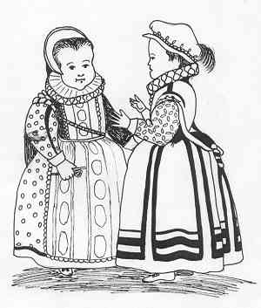

**<--Which of these two children is the boy?**

Young boys wore long dresses until they were about 4 years old.

The rich wore expensive clothing of velvet and silk.

Poor children wore clothes that were warm and practical, made of linen or wool, not the height of fashion.

During Elizabeth I reign ruffs around the neck became popular for men and women. Both wore hoods and hats.

Fun and games - outside.

* Both rich and poor tried archery and fishing.
* Rich children took part in hunting.
* The village youths played a very rough version of football… which was banned for a while by Henry VIII.
* Younger children played with tops and hoops.

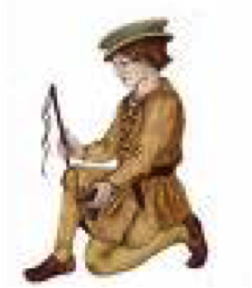

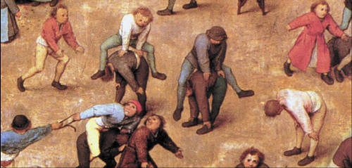**What game are these Tudor children playing?**

**[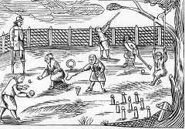](http://www.bvt.org.uk/sellymanor/tudors.html)**

What games can you see the children playing in this picture?

Are any similar to games we play today?

**Schools.**

At the start of the Tudor age, schools were in monasteries. The teachers were monks and priests.

However Henry VIII closed the monasteries during the Reformation in 1540.

**So what do you think happened to children and their education?**



**Children of ordinary families led a different life…**

* Most children worked each day tending the crops and animals.
* Boys worked in the fields, growing the various crops for food, and would hunt and keep animals to provide their meat.
* Boys of ordinary families were expected to learn a trade such as printing, carpentry or becoming a blacksmith.
* They often served a 7-year apprenticeship.
* Girls learned how to look after the home, cooking, washing, making clothes and candles, keeping bees for honey, milking the cows and growing herbs for medicines and cooking.
* When they were old enough, girls became servants.

**Those lucky enough to go to school…**

* Spent 3 years at a nursery school.
* At age 7 they went to grammar school.
* There were 2 holidays each year – 2 weeks at Christmas and at Easter.
* Only Sundays and Saints Days were free days.
* A typical day at school began at 6 or 7am.
* The most important subjects were Latin and Divinity (Religion).
* They also studied Greek, religious studies, arithmetic and music.
* They had to learn long passages by heart – and were beaten if they forgot anything.
* Lunch was at 11am.
* Afternoon lessons were 1pm to 5pm.
* On fine days they might be allowed outside to swim or practise archery.

[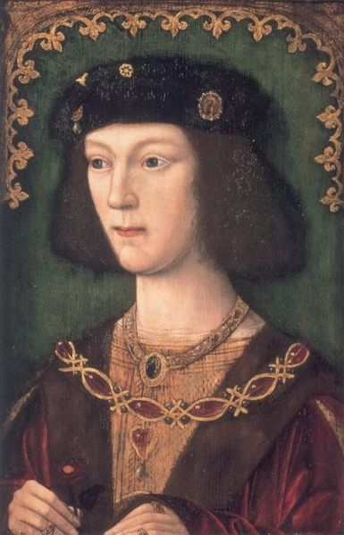](http://upload.wikimedia.org/wikipedia/commons/5/5a/HenryVIII_1509.jpg)

**Henry VIII as a teenager**

* Handsome
* Light glowing skin
* Short straight hair in the French style
* Beautiful face
* Spoke French, Latin and some Italian
* Played the lute and harpsichord
* Sang
* Good at archery
* Jousts ‘beautifully’

**What does this description tell us about Henry’s childhood?**

**Can you remember…**

* What were schools like at the beginning of Tudor times?
* What were they like at the end?
* Why did things change?

Have a look to the following websites:

<https://www.dkfindout.com/uk/history/tudors/tudor-toys-and-games/>

<https://primaryfacts.com/497/tudor-games-and-sports-facts-and-information/>

<https://www.dkfindout.com/uk/history/tudors/tudor-childhood/>

<https://www.bbc.co.uk/bitesize/clips/zqvb4wx>

<http://www.primaryhomeworkhelp.co.uk/tudors/schools.htm>

**TASK**

**Create a Tudors History Information web page to give information about what life was like for children (rich and poor) living in Tudor times.**

**On the web page include information about:**

* **The kind of food they ate (rich and poor)**
* **The clothes children wore (rich and poor)**
* **The games children played**
* **School and education (boys and girls)**
* **The life of children from ordinary families**
* **The life of children from rich families**
* **What it was like for those who were lucky enough to go to school**
* **What Henry VIII’s childhood might have been like and what he was like as a teenager from descriptions given**