WRITING LESSON WEEK 11
LO: To be able to write a descriptive story.
HOM: Creating, imagining, innovating.
INTRO
Look closely at the images below.
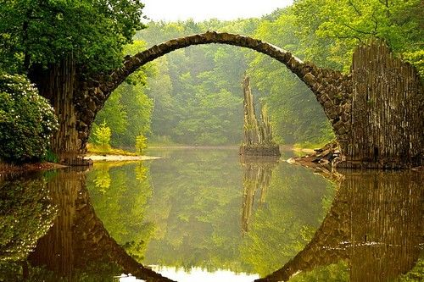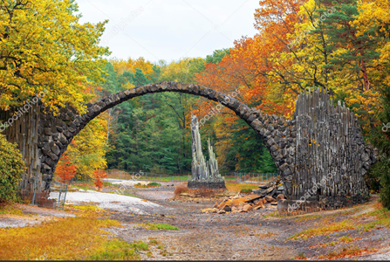
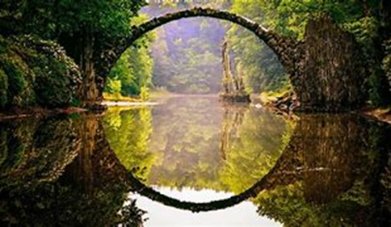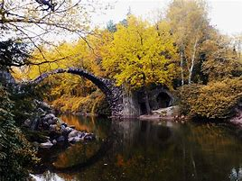
These images are of a beautiful place called the Azalea and Rhododendron Park in Kromlau.
The Azalea and Rhododendron Park Kromlau is a 200 acres landscaped park in Gablenz, Germany. It was built in the 19th century. The park is an example of an English landscape garden, and it contains many small ponds and lakes.
Rakotzbrücke is the name given to the bridge within the park that you can see in this picture. It is indeed very enchanting.
The Rakotzbrücke (also known as Teufelsbrücke, is a bridge especially built to create a circle when it is reflected in the waters beneath it. The bridge's artificially formed basalt columns were selected and shipped from distant quarries.

Task 1
Use a dictionary and find the meaning of these two words:
basalt____________________________________________________________________________________________________________________________________________________________________________________________________________
quarry _______________________________________________________________
____________________________________________________________________________________________________________________________________________
Task 2
Now look very closely at the image again
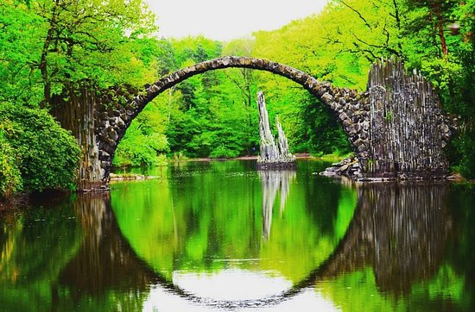
Imagine that you are standing on the riverbed looking out at this beautiful sight.
- What can see?
- What can you hear?
- What can you smell?
- What can you touch?
Let your imagination wander and then record some ideas. To help you with this watch this video on YouTube which should help you with your ideas.
https://www.youtube.com/watch?v=4daLthYFAVA
Use the chart below to organise your ideas.
What can see?
What can you hear?
What can you smell?
What can you touch?

Record your ideas neatly as you will be using them in your writing.
Now its story writing time. You have completed several writing tasks during the lockdown as well as in school. This is your chance to apply everything you have learnt to this task. You can complete this writing task as a slow write-meaning you can complete a little everyday, or if you want to challenge yourself, you can complete it in one sitting, read it and then edit it by making improvements. This will mean that you will need to rewrite your piece.
Editing is not just about changing spelling and checking grammar.
Improving writing includes revising sentence structure, improving vocabulary, ensuring it is effective and interesting to the audience/reader.

If you are not too sure about the editing skills, take a look at these videos on Youtube. The first is an American guidance so watch out for any of those words that may pop up that we spell differently here in England. In the second video you may find his ideas for writing and editing a paragraph very useful too.
https://www.youtube.com/watch?v=XP5yWz-MNpM
https://www.youtube.com/watch?v=CUScPnDwzPU

Good luck with writing your amazing story. Start writing on the lined sheets below.

PS. Remember to give your story a title. I have left a space for this. You may have a great idea for the title at the start, or you may have an idea of what your story should be titled at the end. No problem! Just remember to write it in.

_____________________________________________________________________________________________________________________________

_______________________________________________________________________________________________________________________________________________________________________________________________________________________________________________________________________________________________________________________________________________________________________________________________________________________________________________________________________________________________________________________________________________________________________________________________________________________________________________________________________________________________________________________________________________________________________________________________________________________________________________________________________________________________________________________________________________________________________________________________________________________________________________________________________________________________________________________________________________________________________________________________________________________________________________________________________________________________________________________________________________________________________________________________________________________________________________________________________________________________________________________________________________________________________________________________________________________________________________________________________________________________________________________________________________________________________________________________________________________________________________________________________________________________________________________________________________________________________________________________________________________________________________________________________________________________________________________________________________________________________________________________________________________________________________________________________________________________________________________________________________________________________________________________________________________________________________________________________________________________________________________________________________________________________________________________________________________________________________________________________________________________________________________________________________________________________________________________________________________________________________________________________________________________________________________________________________________________________________________________________________________________________________________________________________________________________________________________________________________________________________________________________________________________________________________________________________________________________________________________________________________________________________________________________________________________________________________________________________________________________________________________________________________________________________________________________________________________________________________________________________________________________________________________________________________________________________________________________________________________________________________________________________________________________________________________________________________________________________________________________________________________________________________________________________________________________________________________________________________________________________________________________________________________________________________

