LO: To create a comic about a story you read
HOM: Thinking flexibly

Today you are going to create a comic about a story you recently read.
You will need a piece of paper and colouring pencils.

Look at the following examples of comic

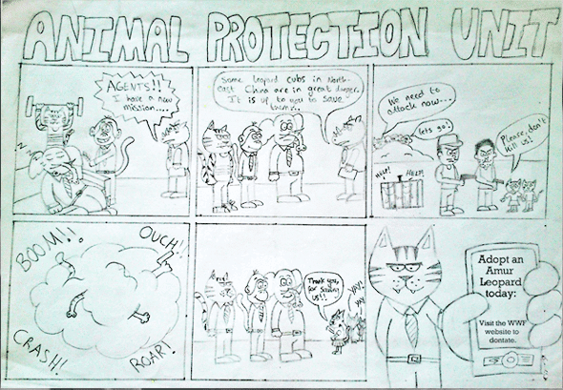

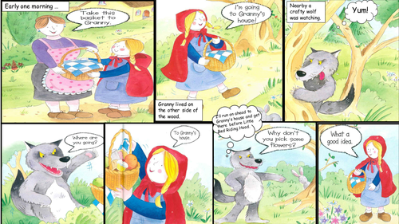

To create a comic you need to follow the next steps:

Step 1: Write your ideas for your comic. A comic strip is no different from writing a short story. ...
Step 2: Draw the three-frames. ...
Step 3: Use basic shapes to draw. ...
Step 4: Add in the speech and lettering. ...
Step 5: Add detail to your cartoon. ...
Step 6: Go over your comic in pen.

Watch the following websites to help you to create your comic:

https://www.bbc.co.uk/bitesize/topics/zkgcwmn/articles/zbk47nb
https://www.mykidsadventures.com/create-comic-strip-kids/

Remember to use different shapes for the speech bubbles for example:

