RE LESSON 10 WEEK 12
LO: To create a poster
To explain how Nelson Mandela lived a life of faith in God.
HOM: Thinking interdependently.
Attainment level descriptor
Recognise, describe and/or give reasons for the actions of Nelson Mandela as a man who lived his whole life in response to his belief (AT 1 (iii) Levels 3-4)
INTRO
We recall the beautiful quotes that Mandela gave throughout his life, which demonstrated his understanding of how people should act and live towards each other, not just through their words but also by their actions, what they do and to understand and explain why they
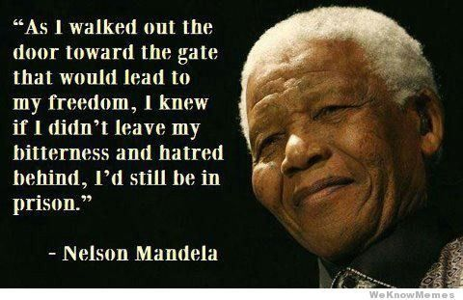
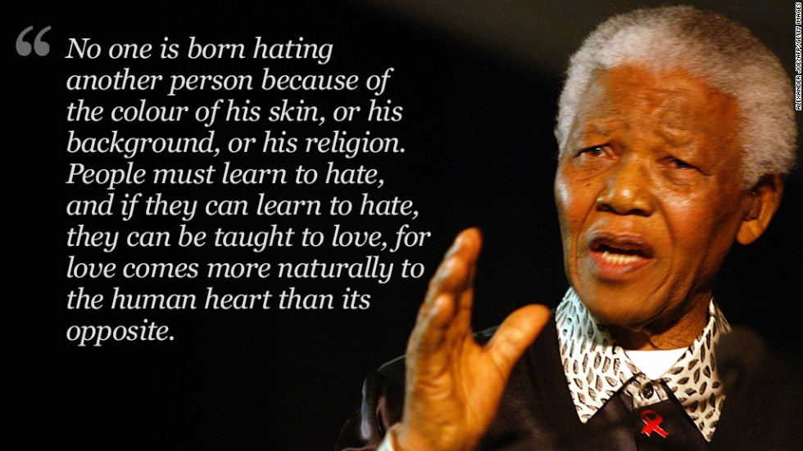
behave and act in a particular way.
On his death, the Methodist Church said that Mandela ‘lived a life of faith in God and lived in service to others’.
TASK 1
Your first task today is to create a powerful word poster
- From the selection of pictures of Nelson Mandela choose one
- Use the ‘tongue of fire’ template and stick your chosen picture into the middle.
- Can you now think of powerful words that describe Nelson Mandela? How he behaved, how he spoke etc. For example: powerful, strong, fearful, full of love, avoided hatred, courageous, fair, loved etc. These are just a few to get you going. Decorate all around the flame using these words. Write in a decorative font, e.g. bubble writing and colour the words in
TASK 2
Your next task is to write about Nelson Mandela as a man who lived his whole life in response to his belief:
- On the next page write a description of something that Nelson Mandela did (a simple summary of his life’s work) and why he worked as he did. This is a simple explanation booklet for a new child who missed the lesson when we completed it in class. Make sure you are detailed but clear.
You may want to include some of these quote within your writing that will help to further explain the points you will cover.
MORE QUOTES FROM NELSON MANDELA
During my lifetime I have dedicated myself to this struggle of the African people. I have fought against white domination, and I have fought against black domination. I have cherished the ideal of a democratic and free society in which all persons live together in harmony and with equal opportunities.

It is never my custom to use words lightly. If 27 years in prison have done anything to us, it was to use the silence of solitude to make us understand how precious words are and how real speech is in its impact upon the way people live or die.

Overcoming poverty is not a gesture of charity. It is an act of justice. It is the protection of a fundamental human right, the right to dignity and a decent life. While poverty persists, there is no true freedom.

[I stand for] countless human beings, both inside and outside our country, [who] had the nobility of spirit to stand in the path of tyranny and injustice, without seeking selfish gain. They recognized that an injury to one is an injury to all and therefore acted together in defence of justice and a common human decency.

PICTURES OF NELSON MANDELA FOR THE FLAME.
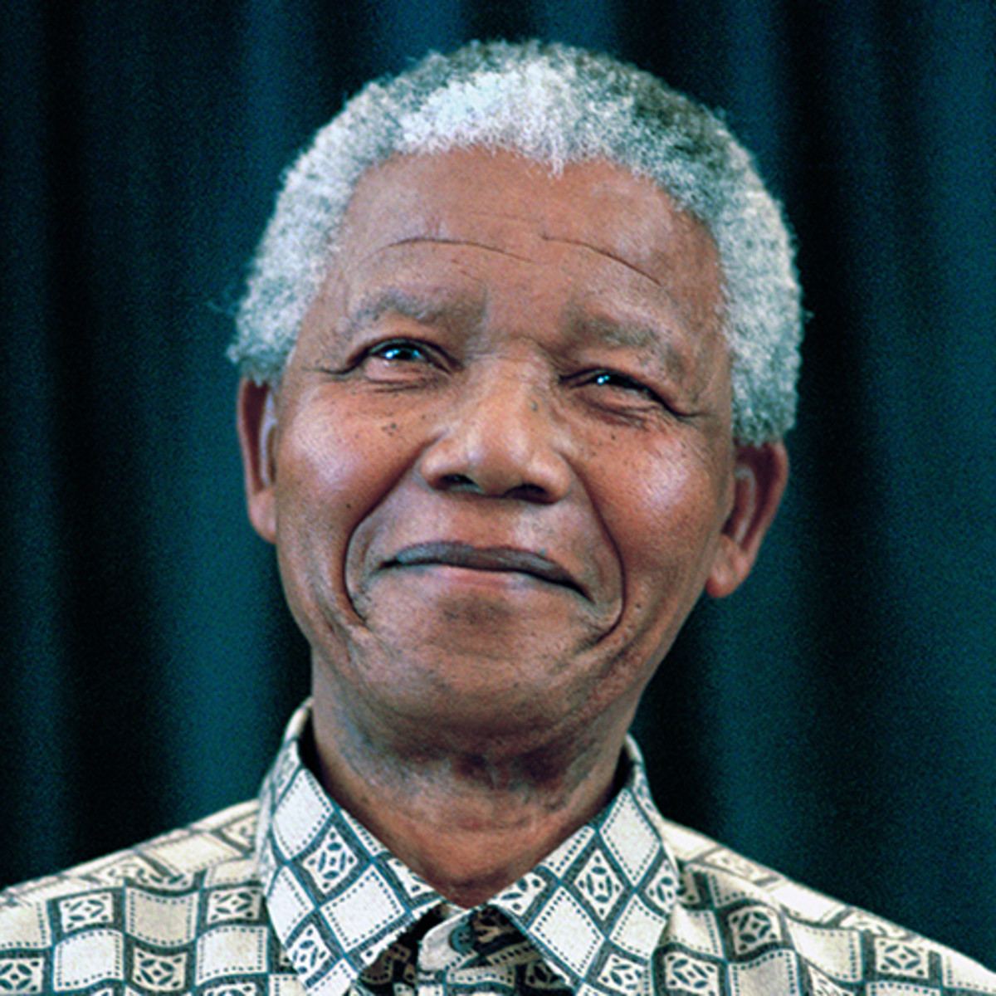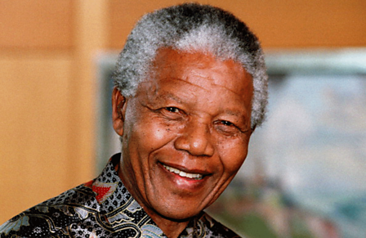

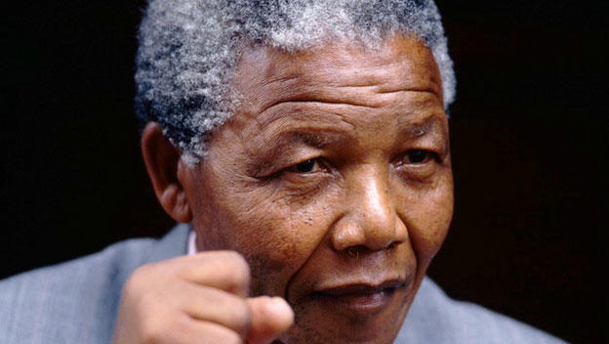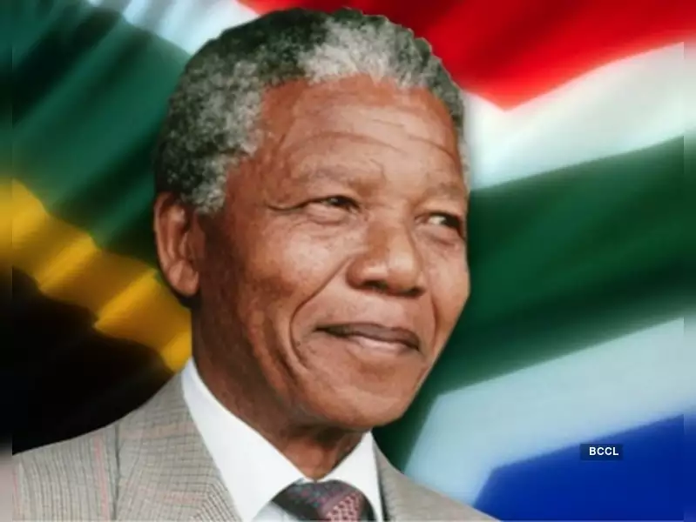
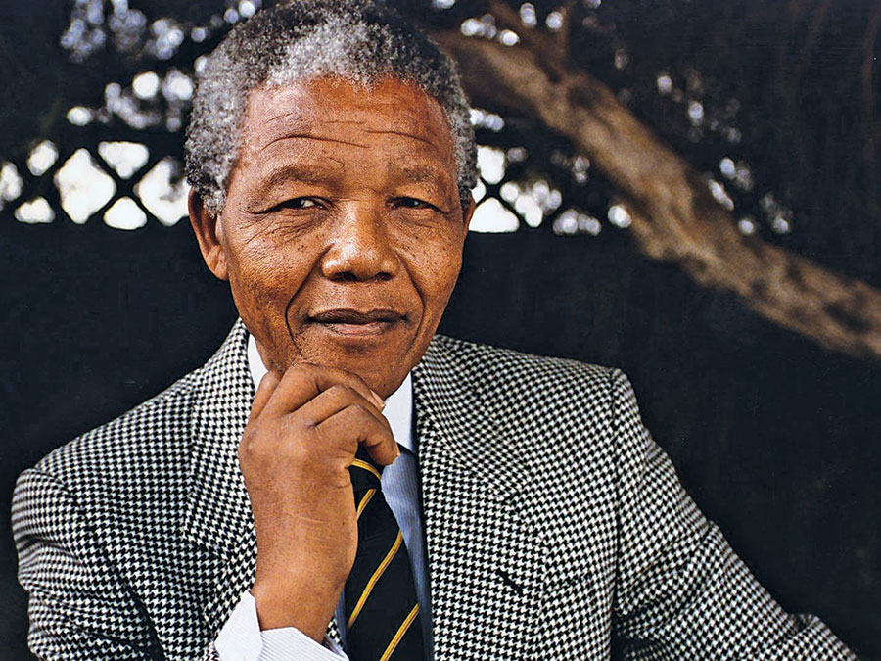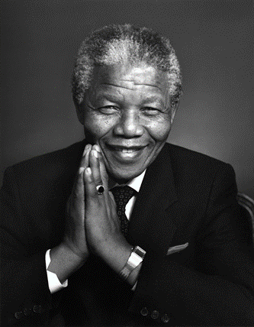

NELSON MANDELA LIVED A LIFE OF FAITH IN GOD AND SERVICE TO OTHERS.
______________________________________________________________________________________________________________________________________________________________________________________________________________________________________________________________________________________________________________________________________________________________________________________________________________________________________________________________________________________________________________________________________________________________________________________________________________________________________________________________________________________________________________________________________________________________________________________________________________________________________________________________________________________________________________________________________________________________________________________________________________________________________________________________________________________________________________________________________________________________________________________________________________________________________________________________________________________________________________________________________________________________________________________________________________________________________________________________________________________________________________________________________________________________________________________________________________________________________________________________________________________________________________________________________________________________________________________________________________________________________________________________________________________________________________________________________________________________________________________________________________________________________________________________________________________________________________________________________________________________________________________________________________________________
Here is a short biography of Nelson Mandela’s life which you may find useful in helping you to complete this work as well as some useful websites.
Nelson Mandela: A short biography
Mandela was born on 18 July 1918 in the village of Mvezo in Umtata. At the time it was part of South Africa's Cape Province. He was born into the Xhosa clan and given the name Madiba.
Madiba’s mother was a Methodist and Madiba was baptized in the Methodist Church in the village of Qunu.
Madiba’s family was ‘royalty’ within their clan, however he was still expected to help: when he was five Madiba’s first job was as a shepherd. He was seven when he started school and the first member of his family to ever go to school. On his first day at school he was given the name, Nelson.
Mandela wrote:
"No one in my family had ever attended school [...] On the first day of school my teacher, Miss Mdingane, gave each of us an English name. This was the custom among Africans in those days and was undoubtedly due to the British bias of our education. That day, Miss Mdingane told me that my new name was Nelson. Why this particular name, I have no idea!"

After he finished primary school he was sent to the Methodist school Clarkebury, 25 miles south-west of Umtata. The governor, the Rev Cecil Harris, was the first white man he ever shook hands with. His first day in class was also the first time he wore shoes. When he was 19, Nelson moved to another Methodist school, Healdtown, in Fort Beaufort. In 1951 he began a law degree but did not complete it until he was in prison in 1989.

At the time Mandela grew up South Africa practiced a system of government that segregated people on the basis of their race. It was against the law for Black Africans to visit certain places (eg the beach or areas of towns) or use certain facilities (eg shops) that white people could, or to go to the same schools as white people. Black Africans could not even vote in an election.
As a young man Mandela found this very difficult and he became involved in politics and joined the African National Congress (ANC). After the South African National Party came to power in 1948, he called for a system of ‘non-compliance’ to the laws which kept black and white people apart – he called for black people to ignore the laws and to visit and use places reserved for white people.
Because he was breaking the law he was repeatedly arrested for what were called ‘disloyal’ or ‘seditious’ activities. In 1956 he and other members of the ANC leadership group were tried for treason (which means being disloyal to your government). They were found not guilty.

To begin with Mandela was committed to forms of non-violent protest. However, on 21 March 1960, at the police station in the South African township of Sharpeville, a crowd of about 5,000 black protesters went to the police station. Some people say the crowd was peaceful while others say they were throwing stones at the police. Either way, the South African police started shooting at the crowd and 69 people were killed.

Angered by what had happened, in 1961 Mandela co-founded a more aggressive group and threatened the government that if they did not take steps to break down the apartheid system they would damage and destroy government buildings. The group was classified as a terrorist organization by the South African government and banned. In 1962, Mandela was arrested, convicted of plotting to overthrow the government, and sentenced to life imprisonment.

Mandela served 27 years in prison on Robben Island. During this time countries around the world campaigned for his release. When he was finally released in 1990 Mandela joined with the then South African President F. W. de Klerk to abolish apartheid so that both black and white Africans had equal rights, and to allow black South Africans to vote for the first time. In the elections in 1994 Mandela led the ANC to victory and became South Africa's first black president.
Websites:
http://www.bbc.co.uk/history/people/nelson_mandela
http://www-cs-students.stanford.edu/~cale/cs201/apartheid.hist.html
http://www.worldreligionnews.com/religion-news/bahai-faith/religious-spiritual-beliefs-nelson-mandela

The guardian
http://www.theguardian.com/teacher-network/teacher-blog/2013/dec/08/nelson-mandela-apartheid-south-africa

Show racism the red card
http://www.srtrc.org

Posters of history of apartheid/interactive timeline
http://www.nytimes.com/interactive/2013/12/05/world/africa/Mandelas-Struggle-in-Posters.html?_r=0

