LO: To explore a habitat
HOM: Gathering data through all the senses

WHITE HAT
What is a habitat?
_________________________________________________________________________________________________________________________________________________________________________________________________________________________________________________________________________________________________________________________________________________________________________________________________________________________________________________________________________________________________________________________________________________________________________________________________________

WHITE HAT
What is an invertebrate?
_________________________________________________________________________________________________________________________________________________________________________________________________________________________________________________________________________________________________________________________________________________________________________________________________________________________________________________________________________________________________________________________________________________________________________________________________________

GREEN HAT
What invertebrates can you name?
_________________________________________________________________________________________________________________________________________________________________________________________________________________________________________________________________________________________________________________________________________________________________________________________________________________________________________________________________________________________________________________________________________________________________________________________________________

These environments are different from each other because of their conditions.

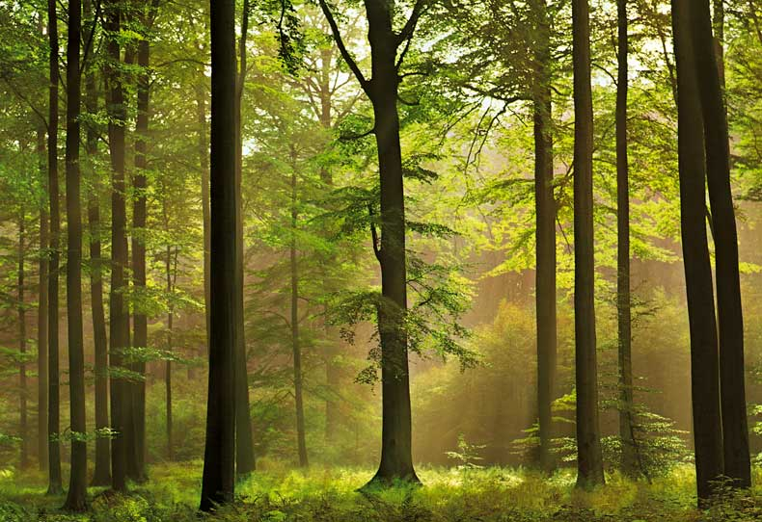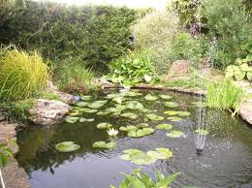
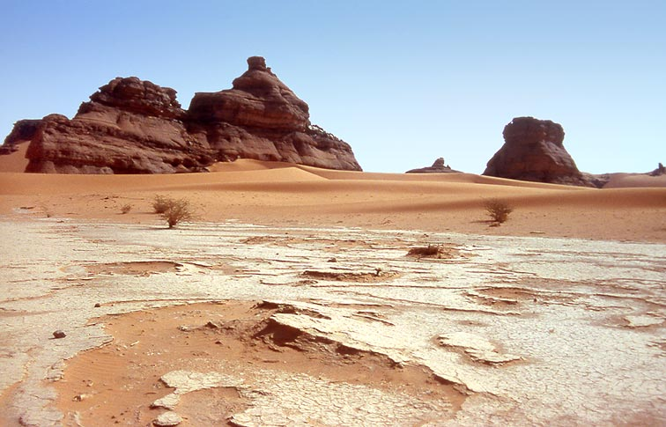
WHITE HAT
What would the conditions be like in each of these environments?
_________________________________________________________________________________________________________________________________________________________________________________________________________________________________________________________________________________________________________________________________________________________________________________________________________________________________________________________________________________________________________________________________________________________________________________________________________

WHITE HAT
What living organisms might you find in each of these environments?
_________________________________________________________________________________________________________________________________________________________________________________________________________________________________________________________________________________________________________________________________________________________________________________________________________________________________________________________________________________________________________________________________________________________________________________________________________

GREEN HAT
What living organisms might you find in each of these environments?
_________________________________________________________________________________________________________________________________________________________________________________________________________________________________________________________________________________________________________________________________________________________________________________________________________________________________________________________________________________________________________________________________________________________________________________________________________

Your task
Look around your area, in your garden, in the park when you go for a walk, in your road when you are looking through the window… Look for different animals or insects, look at them carefully and complete the following table. You can look for animals over a week or two. As the more you record the better.
Complete the following table
Invertebrate | Where do you find it? | Describe the habitats conditions
Now try to draw your own identification key about the invertebrates that you found,
Here you have an example to help you to create your identification key.

