LO: To understand the differences between the lives of rich and poor people in Tudor times
HOM: Applying past knowledge
Watch the following video about the life for rich and poor people in Tudor times
http://10.75.20.200/espresso/modules/t2_tudors/life/video_life_rich_poor_1.html

What was different about rich and poor people in
Tudor times?
Rich people would have lived in big houses.
Glass was very expensive, so rich people would often have a lot of windows in their houses to show how much money they had.
They could afford more expensive clothes and usually didn’t have to go to work.
They would make money from selling crops from land, which they owned.
Farmers who were allowed to live on the land in exchange would grow the crops.
Poor people had to work for a living. If they were farmers, they wouldn’t get paid, but the owner of the land would allow them to live there for free.
They had to grow or hunt all their own food.
They had to begin work at sunrise and work until sunset.
Poor people lived in small cramped houses often with damp inside.
Their houses belonged to the landowner so if they lost their job they would also become homeless.

Can you match the people to their houses?
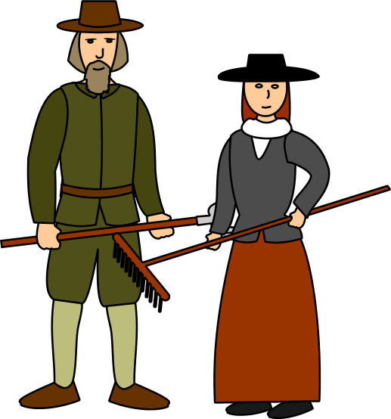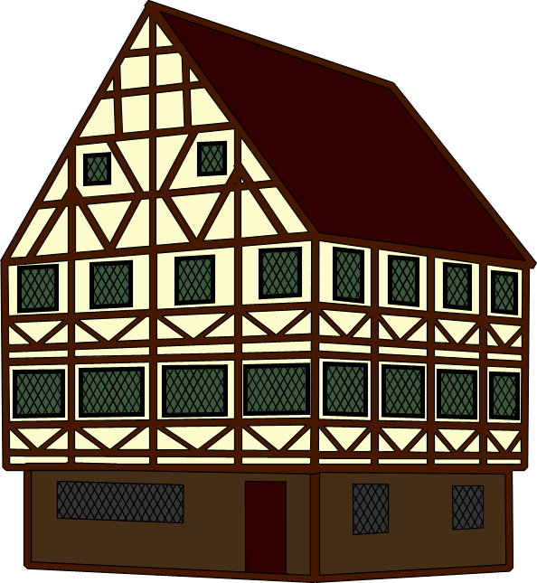
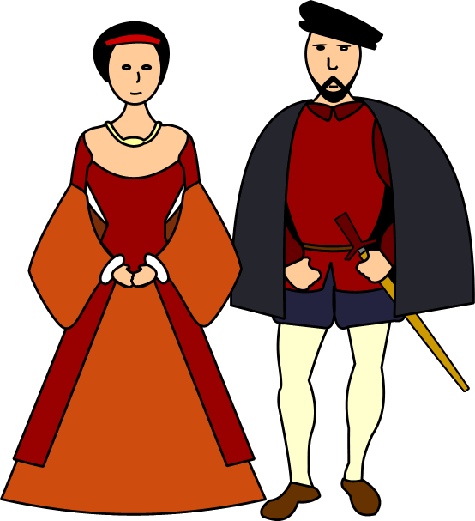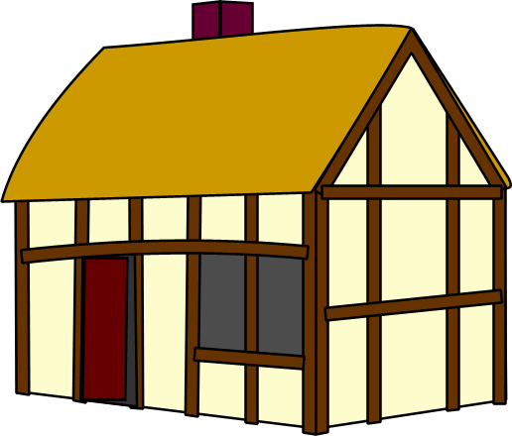

Explain why you made the choices you did
____________________________________________________________________________________________________________________________________________________________________________________________________________________________________________________________________________________________________________________________________________________________________________________________________________________________________________________________________________________
____________________________________________________________________________________________________________________________________________________________________________________________________________________________________________________________________________________________________________________________________________________________________________________________________________________________________________________________________________________

Which of these pictures show rich people? Which show poor people? Explain why you made the choices you did.

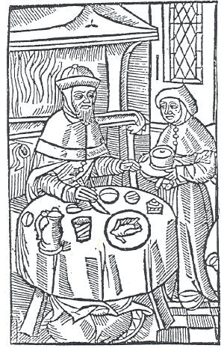

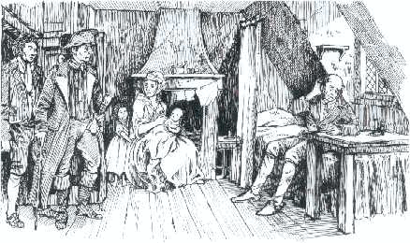

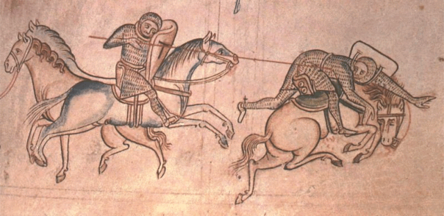

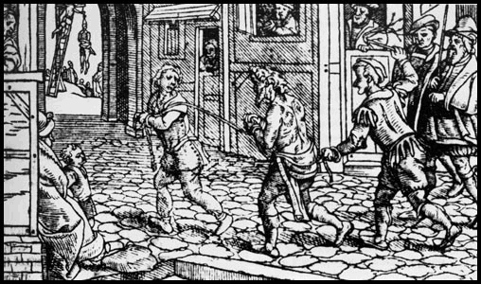

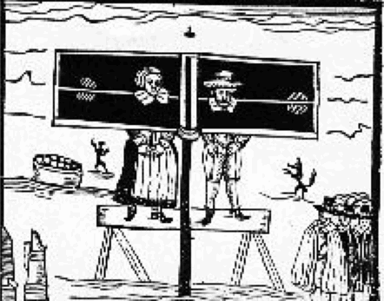

WHITE HAT
What is an inventory? (it is list to record different items or objects)
What can inventories tell us about the lives of people at this time?

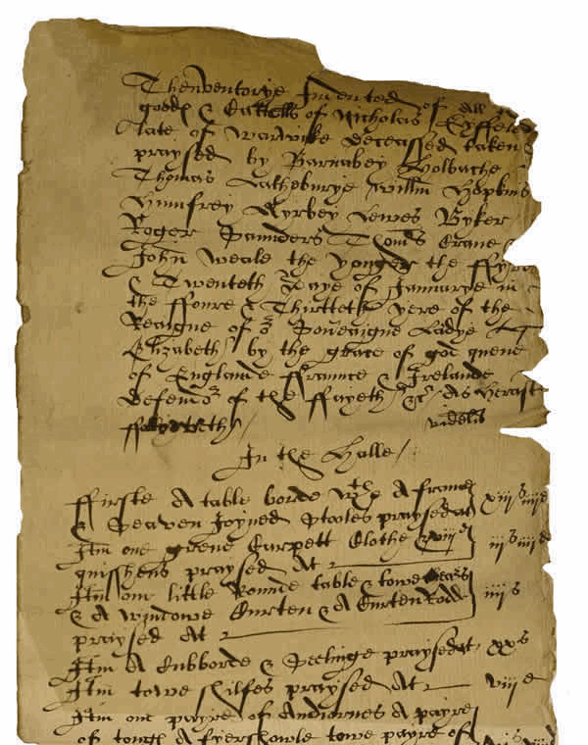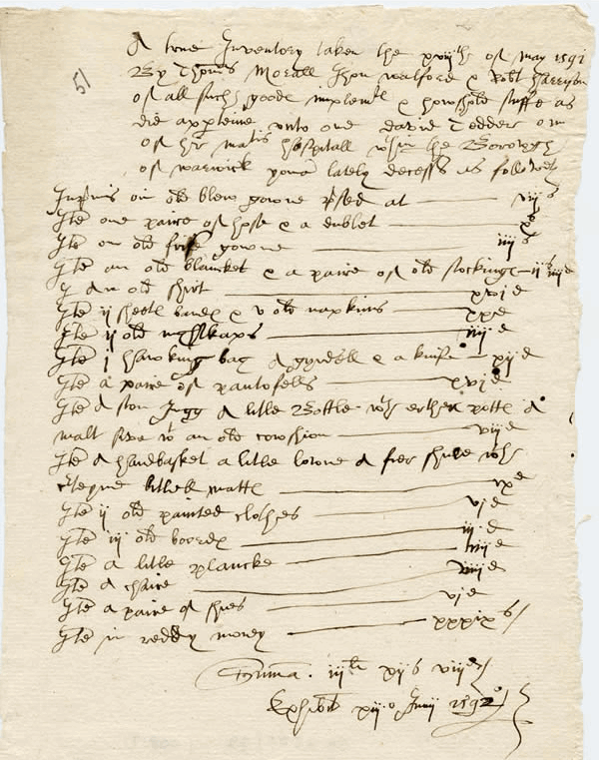

Pictures of inventories during Tudor times.

HERE IS PART OF ONE OF THE INVENTORIES. THIS LISTS THE ITEMS IN THE HALL.
- First a table board with a frame and seven joined stools
- Item one green carpet cloth and 8 cushions
- Item one little round table and two chairs and a window curtain and curtain rod
- Item one pair of andirons, a pair of tongs, a fire shovel, two pairs of pot hangings, a pair of bellows
- Item ten chargers of pewter, 12 pewter plates, nine counterfeit dishes, two pewter flagons, three quarter pots of pewter, one half pint pot, three salts, a little brass mortar and a pestle, six brass candlesticks, one plate candlestick, a plate to set a platter on, two latten basons
- Item two stories, the Ten Commandments, one arms and two pictures
- Item eleven panes of glass and a looking glass and a casement

WHAT DOES IT TELL US ABOUT THE TYPE OF PEOPLE WHO LIVED HERE?

What was life like for poor people in Tudor times?
Homeless people or beggars could be punished by being whipped or put in the stocks.

In the past, poor people who had no way of making a living were looked after by nuns or monks.

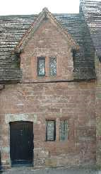
However, after the monasteries had been closed by Henry VIII people had nowhere to go. Some rich people donated money to build almshouses where poor people in need of help could go.

WHITE HAT
What are almshouses? (Houses for the poor people so that they had somewhere to live)

The poor should get jobs so that they can earn their keep. If they choose not to work then they should be punished. It’s not safe to have vagrants and beggars wandering the streets.

GREEN HAT
Do you think the rich people might have been afraid of the poor? Why might this be the case?

Have a look to the following links:

https://simplebooklet.com/adRJOwNJblnxOyPFYEuqjM#page=6

http://www.primaryhomeworkhelp.co.uk/tudors/poor.htm

https://es.slideshare.net/princesssaso7359/rich-and-poor-during-tudor-times

https://www.bbc.co.uk/teach/school-radio/history-tudors-rich-and-poor/z64gf4j

Your task: Complete the following table considering the differences between poor and rich people during Tudor times.
Use all the information above and the information you can gather from the links.
In your table you need to include detailed information about:
- The kind of food they ate (rich and poor)
- The clothes children wore (rich and poor)
- The games children played
- School and education (boys and girls)
- The life of children from ordinary families and from rich families

Look an example of how you can set up your work. You can support your statements with drawings of the different things you are describing.

 | RICH | POOR
Houses
Food
Clothes
Leisure
Health

