WRITING TASK WEEK
LO: To be able to write an adventure story.
HOM: Thinking, creating, imagining , innovating
INTRO
As we approach the end of our science topics on ‘Habitats’, I thought it would be really nice for you to write a little magical adventure story.
Throughout this science topic you have developed a deeper understanding about animals and their habitats. You have learnt why they live in specific habitats and not in others, how they cultivate their habitats, dangers encountered in their habitats and the general life cycle of specified animals.
In our present-day modern world, many animals are losing their natural habitats because of the actions of human beings. Humans are cutting down and building upon many of the earth’s natural habitats to make way for the building of new roads, cities and towns and houses.
Although we do need all these things, we do need to remember that God created all these animals including man saying that they needed to be able to live together side by side. When we destroy the habitats of animals, we make it exceedingly difficult for them to be able to continue to live and breed and exist as a species. Therefore, many animals, birds and insects are becoming extinct.
In your writing task today you need to think creatively and imaginatively, as you construct your piece of writing you may want to carry out some personal research, so that the dialogue that you could present between characters in your story are based on facts. When we cut down trees to make way for ‘other things’, it is called deforestation.
TASK 1
Click on the website links below to find out some facts about deforestation and jot down some facts and ideas that you might use in your story on the sheet titled ‘ DEFORESTATION FACTS’ below.
https://www.theworldcounts.com/stories/Deforestation-Facts-for-Kids
https://onetreeplanted.org/blogs/stories/deforestation-facts-kids

DEFORESTATION FACTS
Facts that I found out about deforestation.
FACT | INFORMATION
FACT 1
FACT 2
FACT 3
FACT 4
FACT 5
FACT 6
FACT 7
FACT 8
FACT 9
FACT 10

Well done! You have completed your research. I bet you found out some pretty amazing things that you did not know before.
TASK 2
Have a good look at this image below and let your imagination work wonders.
Question time!
What do you think has caused the destruction all around the tree?
_________________________________________________________________________________________________________________________________________________________________________________________________________________
Why has this one tree survived?
__________________________________________________________________________________________________________________________________________________________________________________________________________________
If you walked through the portal, what would happen to you? What would you see?
____________________________________________________________________________________________________________________________________________________________________________________________________________________________________________________________________________________________________________________________________________________________________________________________________________________________________
THE MAGIC TREE
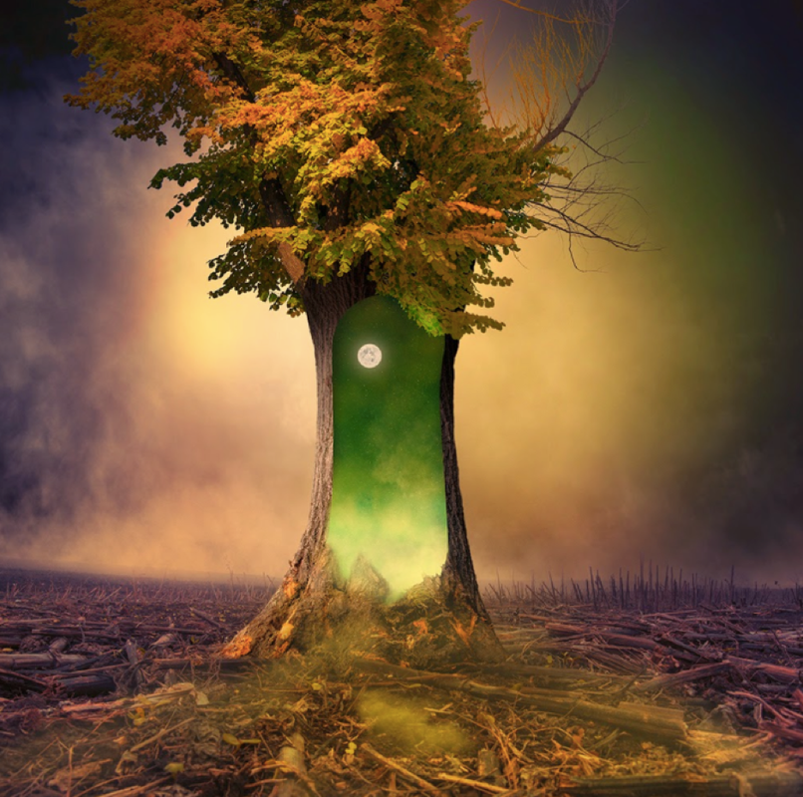
Perfect picture!
Imagine you have just walked through the open portal and into the world inside the tree. Draw/describe what you can see.
Complete this task on the sheet below.

THROUGH THE OPEN PORTAL I CAN SEE…

TASK 3
Now for your story writing.
Story starter!
The tree was all that remained. A solitary figure, it stood there in defiance of the destruction surrounding it. The bark had begun to peel away, one piece at a time, joining the wreckage of other trees that lay scattered across the scorched earth.

This tree was different to the other trees. It contained magic. It contained hope…

Can you continue the story?
What is so different about this tree?
What has happened to the other trees around it?
If you would like to write your own story opening, please go ahead and do just that. This story starter is to help those of you who may be stuck with a good idea of how to start this story.
Notice the bold red words. You may find it useful to use a dictionary to find the correct meaning, so that you fully understand why I have used these particular words in my story opening in the places in which I have used them.
Good luck and remember to be as imaginative as possible.
SUCCESS CRITERIA
I will use paragraphs around a theme within my writing
I will use a range of increasingly complex conjunctions within my writing
I will use adventurous vocabulary within my writing
I will use expanded noun phrases
I will use dialogue within my writing for effect
Remember: You also need to check that you have:
Correct use of punctation throughout your work
Consistent agreement of verb tenses/ agreement throughout you work

THE MAGIC TREE
__________________________________________________________________________________________________________________________________________________________________________________________________________________________________________________________________________________________________________________________________________________________________________________________________________________________________________________________________________________________________________________________________________________________________________________________________________________________________________________________________________________________________________________________________________________________________________________________________________________________________________________________________________________________________________________________________________________________________________________________________________________________________________________________________________________________________________________________________________________________________________________________________________________________________________________________________________________________________________________________________________________________________________________________________________________________________________________________________________________________________________________________________________________________________________________________________________________________________________________________________________________________________________________________________________________________________________________________________________________________________________________________________________________________________________________________________________________________________________________________________________________________________________________________________________________________________________________________________________________________________________________________________________________________________________________________________________________________________________________________________________________________________________________________________________________________________________________________________________________________________________________________________________________________________________________________________________________________________________________________________________________________________________________________________________________________________________________________________________________________________________________________________________________________________________________________________________________________________________________________________________________________________________________________________________________________________________________________________________________________________________________________________________________________________________________________________________________________________________________________________________________________________________________________________________________________________________________________________________________________________________________________________________________________________________________________________________________________________________________________________________________________________________________________________________________________________________________________________________________________________________________________________________________________________________________________________________________________________________________________________________________________________________________________________________________________________________________________________________________________________________________________________________________________________________________________________________________________________________________________________________________________________________________________________________________________________________________________________________________________________________________________________________________________________________________________________________________________________________________________________________________________________________________________________________________________________________________________________________________________________________________________________________________________________________________________________________________________________________________________________________________________________________________________________________________________________________________________________________________________________________
TASK 4
Sentence challenge!
A preposition is a word that shows the relationship between one thing and another.

It may tell you where a thing is in relation to something else. E.g. The green, shining door appeared inside the tree.

It may tell you when something is in relation to another event. E.g. The portal would not close until the electrical storm had ended.

Can you find any prepositions in your writing? Can you write 3 sentences that contain prepositions?

