ART LESSON 3
LO: To create a drawing in the style of an artist
HOM: Thinking and creating
White hat? Who is Andy Warhol?
Click on the link below to discover who this famous artist was and what his style of art was.
https://www.tate.org.uk/kids/explore/who-is/who-andy-warhol
His style of art is called Pop Art and today you are going to create your own interpretation of this famous style using your own ideas.
The idea is to take your time and to enjoy the experience and what you are trying to recreate.
POP ART CONTOUR LINE DRAWING
What you will need:
A4 white paper x 2 sheets
Pencil
Black felt tip pen or a black colouring pencil
Coloured pencils
Scissors
Mirror
Glue stick
Below is an example of what you are aiming to achieve. Of course, yours will be different because it will be you, but this helps you to visualise what you are aiming for.
Take your time as you complete this task, it can be complete over the course of two days. Don’t rush it!
An artist takes their time and creates a masterpiece over a great deal of time.
You are now that artist. You are now following the style of a great artist in order to complete your own masterpiece.
Enjoy as you create.

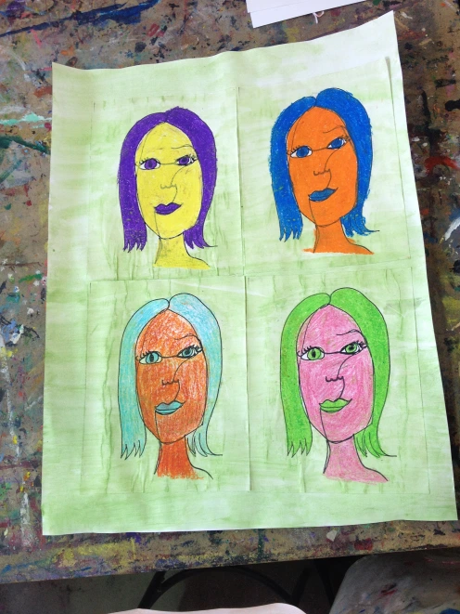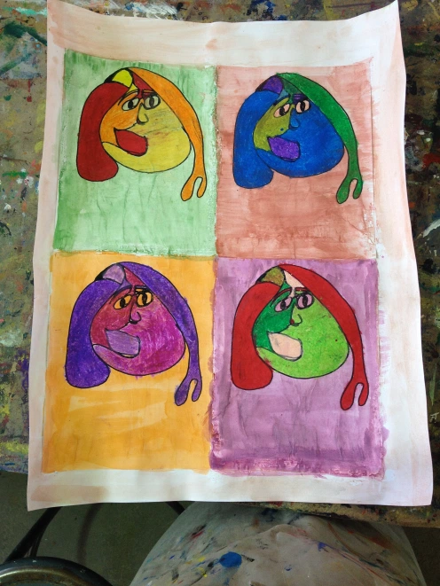
STEPS TO FOLLOW
- Take one piece of the A4 white paper, fold it in half and then fold it in half again. Your paper is now in quarters.
- Cut very carefully along the fold and set 3 of your 4 pieces aside.
- Taking your mirror, look very carefully at your face. Note the position of all your features, but most importantly the shape of your face. Look at the image below to help you decide.
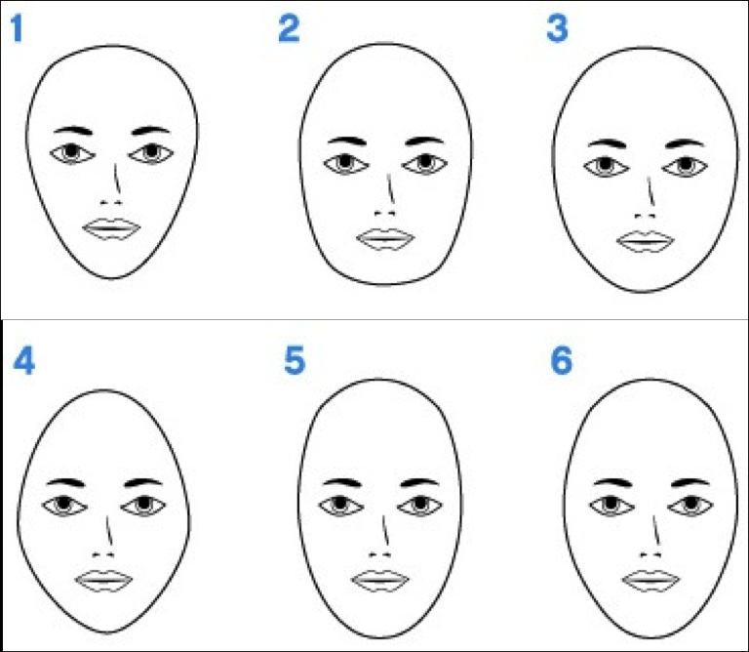
- On your first piece of paper very lightly sketch the shape of your face. When you are satisfied with the shape you have created go over it very carefully with a black felt tip pen or a black colouring pencil.
- Now in the same way very carefully sketch all your features into your face shape. Once you are satisfied with what you have created go over all the features with your black colouring pencil or black felt tip. Remember to add your hair!
- Now, you are going to use your other 3 rectangles of paper as tracing paper. You are going to place each rectangle over the image of your face that you have created and recreate your face by tracing over your image, very carefully, using your black colouring pencil or felt tip pen. Take your time!
- From your research you will have noticed how Warhol used colour to create his images. Below you will find 2 colour wheels that give you tips that will help you select the best colours to use to colour in your images.
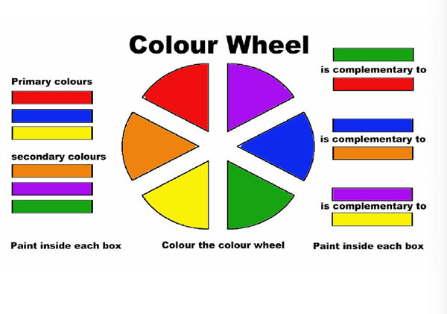
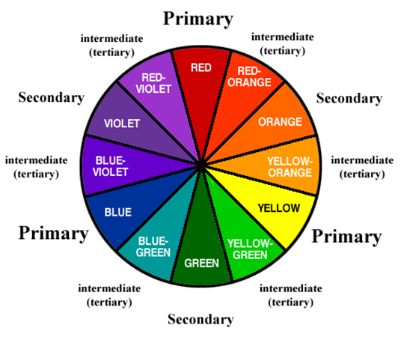
- Colour in one picture at a time, Take your time. Make sure no white paper is visible through your colouring in. You need to do what we call ‘solid colouring’.
- Decide on a colour that you will use for the background. You may find a colouring pencil more useful for this. Colour in the background carefully.
- Lay your four pictures side by side onto your other blank piece of A4 paper (you may find folding this other sheet into four will help you to lay out and stick down your completed pictures more accurately)
- Move them around until you are happy with your layout and then carefully stick them down.
- VIOLA! You have created your very own Pop Art Drawing in the style of Andy Warhol.
WELL DONE!

