**LO:** **To learn about Henry VIII’s coat of arms and to design my own coat of arms to represent my family and myself**

**HOM: Creating, imagining, innovating**

Look for information about what is a coat of arms

___________________________________________________________________________________________________________________________________________________________________________________________________________________________________________________________________________________________________________________________________________________________________________________________________________________________________________________________________________________________________

**WHITE HAT**

What is a coat of arms and what it is for?

A coat of arms is a unique design that identifies a family, individual or organisation. Coats of arms were originally used in battle so that soldiers could identify other people on their side. They would be drawn on shields, flags and held up high on poles so that people could be easily identified. Eventually, all important families had their own coats of arms.

Coats of arms belong to individuals.   
For any person to have a right to a coat of arms they must either have had it granted to them or be descended in the legitimate male line from a person to whom arms were granted or confirmed in the past.   
  
There is no such thing as a 'coat of arms for a surname'.   
Many people of the same surname will often be entitled to completely different coats of arms, and many of that surnames will be entitled to no coat of arms.

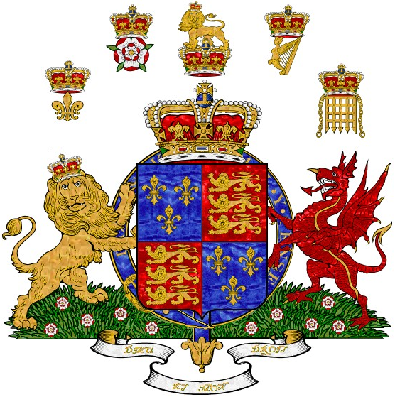

This is Tudor Coat of Arms.

Tudor Coat of Arms consists of a shield of arms, usually with the addition of a crest borne upon a helmet (upon which rests on a wreath) and frequently with a motto beneath.



This is the Tudor coat of arms.

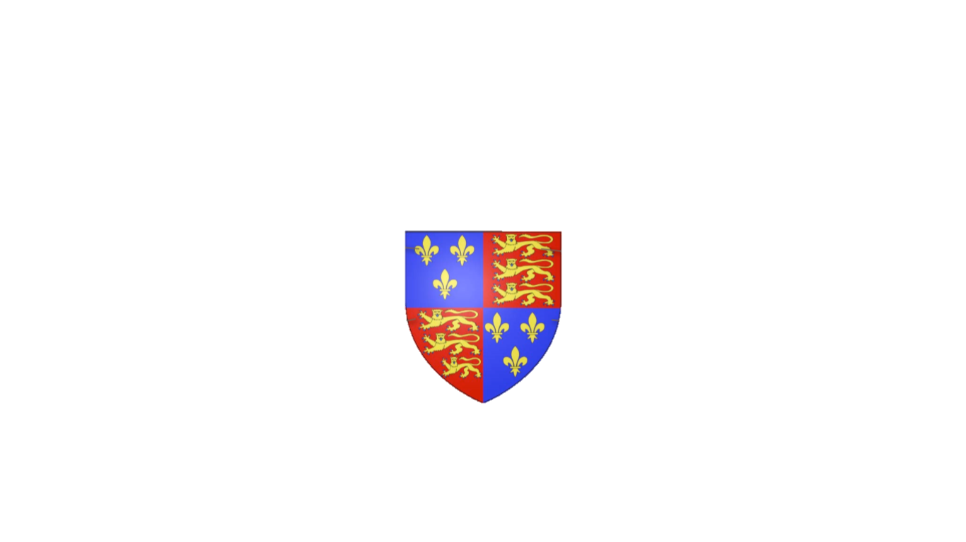

Red

Strength in battle

Lions:

Bravery and strength

Blue

Truth and loyalty

Fleur- de-lis

Purity and light

All coats of arms have symbols that represent the things the family want to portray. In the Tudor coat of arms, the fleur-de-lis symbolises purity and light, while the lion represents bravery and strength. The colours of coat of arms are also important. Red represents strength in battle and blue represents truth and loyalty.

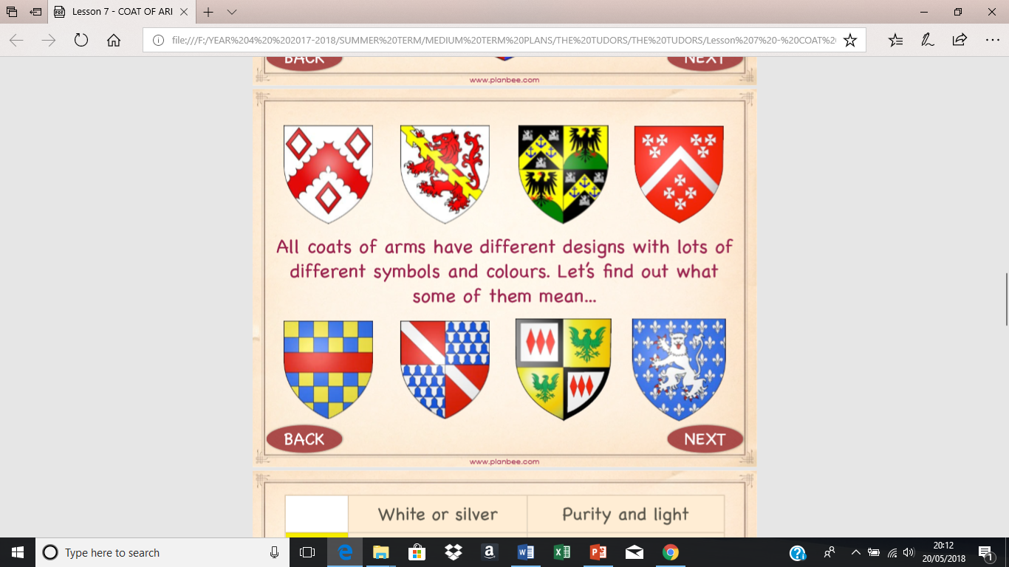

We will look at some symbols and colours that have been used on different coat of arms to show something about that person.

|  |  |
| --- | --- |
| White | Purity and light |
| Yellow or gold | Generosity |
| Red | Strength in battle |
| Green | Joe and hope |
| Blue | Truth and loyalty |
| Black | Grief and sadness |
| Purple | Royalty and justice |
| Orange | Ambition |

|  |  |  |  |
| --- | --- | --- | --- |
|  | **Anchor:** Hope and steadfastness |  | **Harp:** Person of fair judgement |
|  | **Arrow:** Ready for battle |  | **Dragon:** Defender of treasure |
|  | **Ring**: Faithfulness |  | **Griffin:** Death-defying bravery |
|  | **Cinquefoil:** Hope and joy |  | **Falcon:** Not stopping until you reach your goal |
|  | **Bear:** Protection of your family |  | **Heart:** Charity and love towards others |
|  | **Bee:** Hard work |  | **Lightning bolt:** Power and speed |
|  | **Castle:** Safety and protection |  | **Winged horse:** Poetic and full of inspiration |
|  | **Cross:** Faith in God |  | **Star:** A noble person, excellence |
|  | **Daffodil:** Sunshine and respect |  | **Snake:** Wisdom |
|  | **Deer:** Peace, not fighting unless provoked |  | **Unicorn:** Extreme and strength |
|  | Sword: Justice, honour in battle | |

**Now is your turn to design your own coat of arms to reflect who you are. Use the colours and symbols from last pages and the template below to do your work.**

**First plan your ideas**

**You will need to include:**

* **Something about your heritage/family**
* **What things you are interested in**
* **What sports you like**
* **A motto in the banner below which shows what you believe in**

**MY COAT OF ARMS**

