RE LESSON 4
LO: To understand that Jesus died and rose from the dead.
To be able to express the feeling of characters who witnessed the events.
To be able to recount an event.
HOM: Responding with wonderment and awe.
Intro
In the first part of today’s lesson we will be looking at the characters for the three stories of Palm Sunday, Holy Thursday and Good Friday.
To help you with your task re read the whole Passion story according to Matthew: from the entry into Jerusalem through the trials, to the crucifixion and death and to the resurrection. Use this link to read the story if you cannot easily access a bible: https://www.biblegateway.com/passage/?search=Matthew+26&version=NRSV

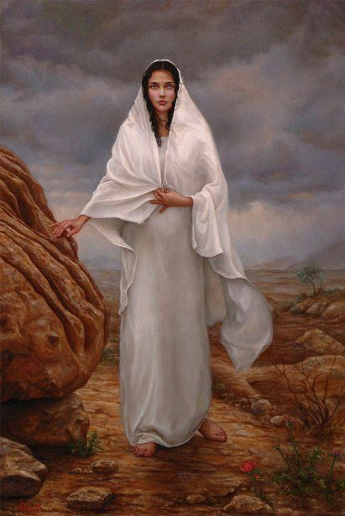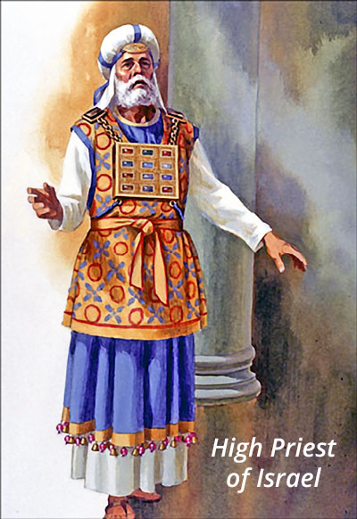
Above are the images of two people who played an important role during the events of Holy Week, namely Mary Magdalene and a High Priest.
As you know Mary Magdalene was a great believer in and a follower of Jesus, so for this activity we will say that she was FOR Jesus.
The High Priest was not a believer and would have had, very strong feelings and viewpoints AGAINST Jesus, his teachings and everything that Jesus stood for.
Below you are going to complete the chart to answer questions and express the emotions that each of these characters would have felt at the time of Jesus death and resurrection and explain why.

TASK 1
CHARACTER REFLECTIONS
QUESTIONS | MARY MAGDALENE | HIGH PRIEST
What did you think of Jesus?

How did you feel when you knew he was going to die?

Did you feel surprised when you knew he had risen from the dead? Why?

Did you feel happy when you knew he had risen from the dead? Why?

Did you feel cross when you knew he had risen from the dead? Why?

Did you feel embarrassed when you knew he had risen from the dead? Why?

Did you feel delighted when you knew he had risen from the dead? Why?

Did the resurrection of Jesus change your mind about who he was?

Brilliant, now you need to read Matthew 28
TASK 2
Your next part of this task is to read the summary of the Passion and to write the ending in your own words. You have previously read the entire events using the Bible.
Summary of the Passion according to Matthew
Jesus travels from around Lake Galilee, where he has been teaching and healing, to Jerusalem.

He arrives in Jerusalem and a huge crowd gather to meet him. He goes into Jerusalem on a donkey and the people wave branches to greet him.

Jesus goes to the Temple mount – an area around the Temple where people used to gather and meet. Some of the leaders of the Jewish people argue with Jesus about the things he has said: he is asked to explain what he has done and said. The Jewish leaders plot to arrest and kill him.

It is Passover time when Jews gather to celebrate their escape from Egypt. Jesus gathers with some of his disciples to celebrate the Passover meal.

After the meal is finished Jesus and some of the disciples go out to the Garden of Gethsemane to pray. Judas and some of the Jewish leaders and guards come to arrest Jesus. He is taken to the Jewish leader’s house and tried for ‘blasphemy’ – for misusing God’s name.

Next morning Jesus is taken to Pilate’s house where he is tried by Pilate for being a King – the King of the Jews.

Pilate sentences him to be crucified. He is taken out to a hill and killed. Jesus dies at 3 o’clock in the afternoon.

Joseph of Arimathea takes the body of Jesus down and places it in a tomb. The Romans place two guards in front of the stone entrance way to stop anyone stealing the body of Jesus.

Add the ending! You are to now retell the events of the resurrection in your own words. Be clear and concise.

