LO: To understand what kind of person Henry VIII was
HOM: Striving for accuracy

Even though Henry VII won the battle at Bosworth – there was still some worried people in England.
After all, civil war had being going on for 30 years.
How could Henry unite the two families and stop further fighting?
He married Elizabeth of York – and brought the two houses of York and Lancaster together.
He even created a new family emblem combining the two old ones. The Tudor Rose.

Henry VII died. His eldest son, Arthur was meant to be King, but he also died. Instead, Henry VIII, his younger son, came to the throne.

In this lesson we are going to see different pictures of Henry VIII, these pictures are going to show us how was Henry VIII, but because there were no cameras in those days, we can’t be sure which of the pictures is the closest to the truth.

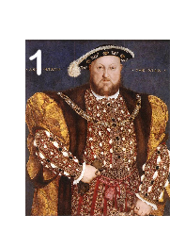
Look at this portrait.
What does Henry want people to think of him in this painting?
What does this painting say about the type of person he is?

Think about:
The clothes he is wearing and the material they are made from.
The way he is standing.
The jewellery he is wearing.
The way that he is looking straight at us.
Who might this painting be for?
What does Henry want people to think of him in this painting?

In this painting, Henry VIII wants us to see that he is powerful and rich.
He is looking straight at us to show that he has no fear.
He is dressed in very rich clothes made of silk, velvet and fur with jewels on them.
His hat has an ostrich feather on it. Only the very rich could afford this.
He has a chain round his chest to show how important he is.
One hand is on his waist, the other hangs down. This shows that he has strength and determination to rule.

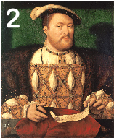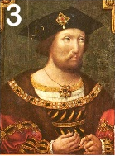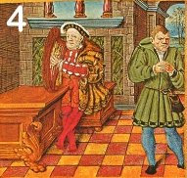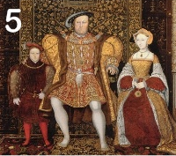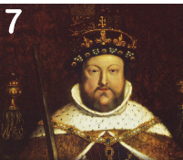
Choose two pictures from the page above. Do a research about Henry VIII, about his life and how was him using the links below. Think about: the clothes he is wearing, the way he looks at us, what is on his head, why is it there, what is round his shoulders, what is it for, what is in his hand, what is it for. Then, answer the following questions:
What does Henry want people to think of him in this painting? ________________________________________________________________________________________________________________________________________________________________________________________________________________________________________________________________________________________________________________________________________________________________________________________________________________________________________________________________
What does this painting say about the type of person he is?_________________________________________________________________________________________________________________________________________________________________________________________________________________________________________________________________________________________________________________________________________________________________________________________________________________________________________________________________________________________________
What does Henry want people to think of him in this painting? ________________________________________________________________________________________________________________________________________________________________________________________________________________________________________________________________________________________________________________________________________________________________________________________________________________________________________________________________
What does this painting say about the type of person he is?_________________________________________________________________________________________________________________________________________________________________________________________________________________________________________________________________________________________________________________________________________________________________________________________________________________________________________________________________________________________________

Links to find information about Henry VIII:

https://www.bbc.co.uk/bitesize/topics/zkrkscw/articles/zv2bmfr
https://www.youtube.com/watch?v=ltrTUGeK5DQ
https://kids.kiddle.co/Henry_VIII
https://www.natgeokids.com/za/discover/history/monarchy/henry-viii-facts/

