RE LESSON 6
LO: To explore the elements of the Pentecost story.
HOM: Remaining open to continuous learning.
INTRO
Lets do a little Pentecost quiz
- What Christian holiday does the Feast of Pentecost follow?
________________________________________________________________
- How many days after Jesus ascended into Heaven did the disciples celebrate Pentecost?
________________________________________________________________
- What is the Jewish name given to this feast?
________________________________________________________________
- While everyone was gathered together, as a family, in that room celebrating the Feast of Pentecost, what sound was heard all around them?
________________________________________________________________________________________________________________________________________________________________________________________________
- What happened to the disciples when the Holy Spirit touched/entered them?
________________________________________________________________________________________________________________________________________________________________________________________________
- Which one of the disciples was brave enough, stood up and went out and spoke to the crowds?
________________________________________________________________
- When Peter was speaking to the crowd why were the men in the crowd surprised or in shock?
________________________________________________________________________________________________________________________________________________________________________________________________
- What very important thing did Peter say to the men in the crowd?
________________________________________________________________________________________________________________________________________________________________________________________________
NOW YOUR NEXT TASK
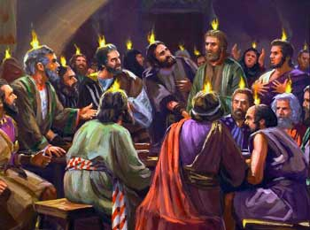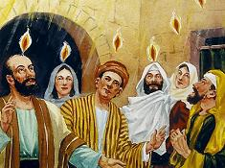
When the Holy Spirit came to Jesus’ disciples on the first Pentecost, it gave them courage and empowered them share and spread the Good News with others from all nations. Courage is one of the gifts of the Holy Spirit.
Let’s explore two of the elements of this amazing and beautiful scripture passage. Our first element of focus is FIRE.
White hat: Look at the two images above. What do the ‘tongues of fire’ represent?
__________________________________________________________________________________________________________________________________________________________________________________________________________________
Blue hat: How do you think the disciples felt when the tongues of fire appeared amongst them?
_______________________________________________________________________________________________________________________________________________________________________________________________________________________________________________________________________________________
White hat: What might the tongues of fire tell us about the nature of God?
______________________________________________________________________________________________________________________________________________________________________________________________________________________________________________________________________________________________________________________________________________________________
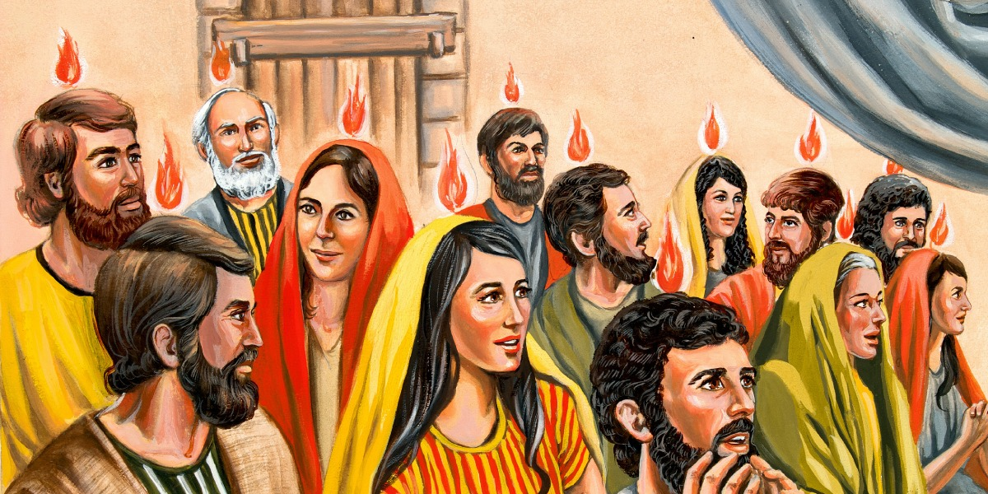
Imagine you are one of the people in this picture. Explain in a detailed way the emotions you felt and how your body felt when the tongues of flames touched you. What was it like speaking and then knowing and hearing the words coming out in a different language?
____________________________________________________________________________________________________________________________________________________________________________________________________________________________________________________________________________________________________________________________________________________________________________________________________________________________________________________________________________________________________________________________________________________________________________________________________________________________________________________________________________________________________________________________
Our next focus is on the element of WIND.
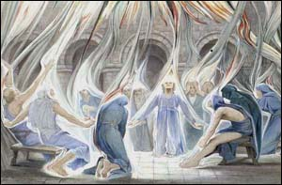
Our focus here is on the coming of the Spirit that comes ‘like the sound of a powerful wind from heaven’.
Click this link, close your eyes and listen: https://www.youtube.com/watch?v=98_ye60KVEo

White hat: What did you feel when you heard these wind noises?
__________________________________________________________________________________________________________________________________________________________________________________________________________________

Blue hat: What might these wind noises tell us about the nature of God?
__________________________________________________________________________________________________________________________________________________________________________________________________________________
Blue hat: How do you think the Disciples felt when they heard these wind noises?
__________________________________________________________________________________________________________________________________________________________________________________________________________________
EXTENDED WRITING PIECE
You are one of the men from one of the other nationalities name in the scripture (re-read the passage and select which place you will come from. You were so amazed by what happened that you have decided to write a family member or friend from your homeland to tell them about the events of the day.
  - Set the scene
  - Explain what happened when the Disciples began speaking in their language
  - What would they have wanted to hear about this marvellous God?
Start your writing below.
______________________________________________________________________________________________________________________________________________________________________________________________________________________________________________________________________________________________________________________________________________________________________________________________________________________________________________________________________________________________________________________________________________________________________________________________________________________________________________________________________________________________________________________________________________________________________________________________________________________________________________________________________________________________________________________________________________________________________________________________________________________________________________________________________________________________________________________________________________________________________________________________________________________________________________________________________________________________________________________________________________________________________________________________________________________________________________________________________________________________________________________________________________________________________________________________________________________________________________________________________________________________________________________________________________________________________________________________________________________________________________________________________________________________________________________________________________________________________________________________________________________________________________________________________________________________________________________________________________________________________________________________________________________________________________________________________________________________________________________________________________________________________________________________________________________________________________________________________________________________________________________________________________________________________________________________________________________________________________________________________________________________________________________________________________________________________________________________________________________________________________________________________________________________________________________________________________________________________________________
