SCIENCE LESSON 4
LO: To identify the basic parts of the digestive system and describe their purpose.
HOM: Remaining open to continuous learning.
Key vocabulary: Digestion, digestive system, teeth, mouth, saliva, oesophagus, stomach, duodenum, ileum, colon, intestine, rectum, anus

In today’s lesson you are going to learn about the ‘digestive system’ and how it works.
White hat: What do you think you already know about how the digestive system works?
________________________________________________________________________________________________________________________________________________________________________________________________________________________________________________________________________________________________________________________________
Now don’t cheat, White hat: Which words in the vocabulary box do you already know the meaning of? List them below:
________________________________________________________________________________________________________________________________
FACT CHECK: White hat: What does digestion mean?
In simple terms, it is the act of softening and changing food so that the body can absorb it for energy and growth.
Now do this, ask an adult to help you:
Ask your parents if you can have ONE cornflake (or maybe two). Chew it and swallow. As you swallow, trace a finger down your throat following the path you know the food is taking. Explain to an adult using the key vocabulary you know, how and where the food is travelling. Now pinpoint where in your body you think your stomach is. On the diagram below, mark a big cross where you think your stomach is:
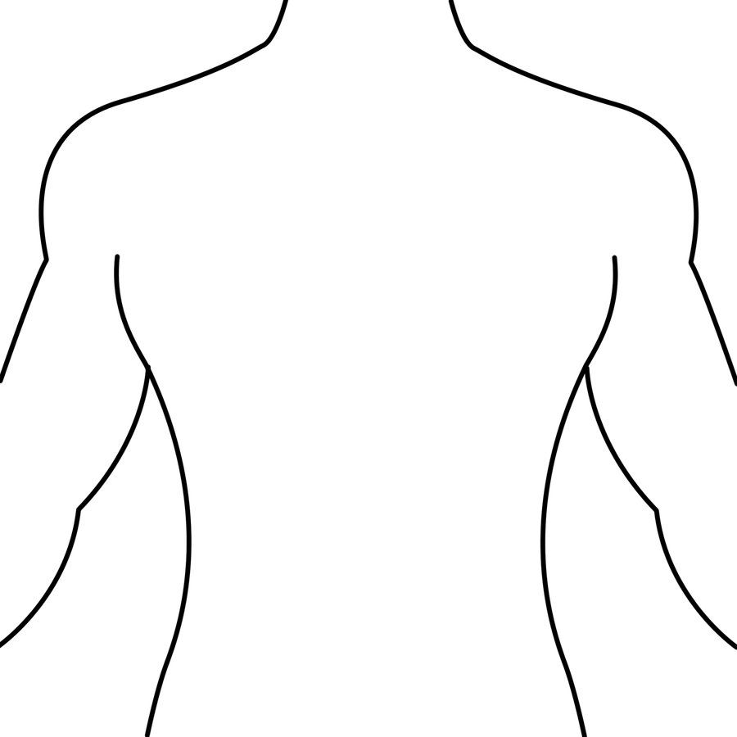
Well done!
It takes 10 seconds for food to reach your stomach after being swallowed. Blue hat: Do you think your cross is in the correct place?

Watch this short video clip

https://www.bbc.co.uk/bitesize/topics/z27kng8/articles/z9wk7p3

Complete the three questions given at the bottom of the video.
Did you get the correct? I am sure that you did because you listened and watched the video clip very carefully.

PRACTICAL TASK 1
A little note to your parents.
Dear Parents/Carers
Your child is now going to need to carry out a little practical task for which they will need your assistance and some simple items that you will find in and around your kitchen. We ask that you supervise your child, as this is a good opportunity to bring in some key questioning that will help to consolidate your child’s understanding of the digestive system. Thank you for your support.

Collect these items from the kitchen. Remember to ask your parent to help you.
A cracker or biscuit, a zip lock/freezer bag ( it could be as small as a snack size bag), 2 glasses- add a third of water to one and a third of orange juice to the other ( remember ‘little’, no wastage, we can always add more if needed), a tray (just to keep things tidy), a pair of old tights, kitchen roll.

Read the step by step instructions below. Follow them carefully

Step 1 [mouth]: put a cracker into their zip-lock bag. Start crushing it up to represent the teeth. What does our mouth produce to make food easier to swallow? Saliva: softens the food and starts breaking it down (add water to the bag). The food then travels down the oesophagus.

Step 2 [stomach]: what does the stomach have that helps break down food? Acid and digestive juices break down the food (add orange juice). Continue gently squeezing the bag to represent the stomach churning the food to break it down. This is completed in the duodenum.

Step 3 [ileum – small intestine]: proteins, fats and vitamins are absorbed from the food. The walls of the ileum are lined with tiny finger like villi expanding the surface area so it can absorb more.

Step 4 [colon – large intestine]: absorbs the water from the remaining waste to be used by the body before it is excreted through the anus. Pour the stomach contents into a pair of tights, lay to rest over kitchen roll. The liquid will pass through the tights and be absorbed by the kitchen roll, leaving only the waste.

How fascinating was that!
You have completed the practical task at home that we would have been carrying out in the classroom and you have had your parent at home to assist you completing this. Brilliant!

TASK 2
In this week’s lesson pack you will find a diagram of the digestive system, do you think you can label it on your own? If you are not sure, go back to this link and watch the other videos related to the digestive system, then label the diagram.

https://www.bbc.co.uk/bitesize/topics/z27kng8

There are 5 learner guides here that will help you to understand each part of the digestive system a little more.

TASK 3
Can you write out your practical task as an instruction piece?
I have included some prompts as a reminder. Aim to be as clear as possible as you record what you did in the practical task.

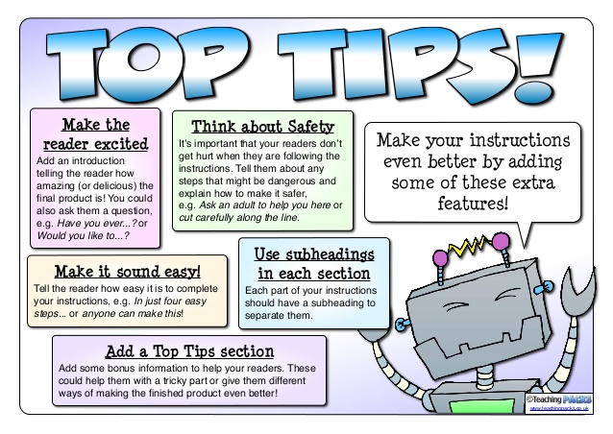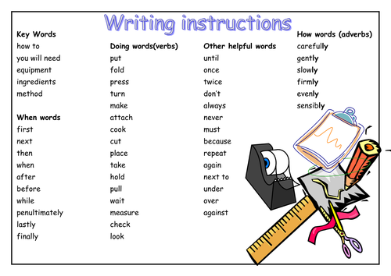

Use the sheet below to record your task.
HOW TO RECREATE THE DIGESTIVE SYSTEM
________________________________________________________________________________________________________________________________________________________________________________________________________________________________________________________________________________________________________________________________________________________________________________________________________________________________________________________________________________________________________________________________________________________________________________________________________________________________________________________________________________________________________________________________________________________________________________________________________________________________________________________________________________________________________________________________________________________________________________________________________________________________________________________________________________________________________________________________________________________________________________________________________________________________________________________________________________________________________________________________________________________________________________________________________________________________________________________________________________________________________________________________________________________________________________________________________________________________________________________________________________________________________________________________________________________________________________________________________________________________________________________________________________________________________________________________________________________________________________________________________________________________________________________________________________________________________________________________
EXTENSION
Can you explain how the digestive system works? Remember this is a different task to the task above.
Here you are explaining the journey the food takes from mouth to anus. You must explain what happens at each stage and the purpose of that organ. Go back and watch the 5 learner guides from the bbc bitesize website. (link above)
Remember to include all the important key vocabulary.
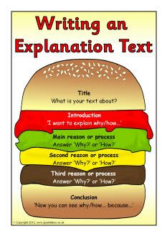
HOW THE DIGESTIVE SYSTEM WORKS
________________________________________________________________________________________________________________________________________________________________________________________________________________________________________________________________________________________________________________________________________________________________________________________________
___________________________________
___________________________________
___________________________________
__________________________________
___________________________________
________________________________________________________________________________________________________________________________________________________________________________________________________________________________________________________________________________________________________________________________________________________________________________________________________________________________________________________________________________________________________________________________________________________________________________________________________________________________________________________________________________________________________________________________________________________________________________________________________________________________________________________________________________________________________________________________________________________________________________________________________________________________________________________________________________________________________________________________________________________________________________________________
________________________________________________________________________________________________________________________________________________________________________________________________________________________________________________________________________________________________________________________________________________________________________________________________________________________________________________________________________________________________________________________________________________________________________________________________________________________________________________________________________________________________________________________________________________________________________________________________________________________________________________________________________________________________________________________________________________________________________________________________________________________________________________________________________________________________________________________________________________________________________________________________________________________________________________________________

