WRITING LESSON 1 WEEK 4
LO: To write an extended story
HOM: Thinking creatively and imaginatively.
Fancy writing a story this week. Bet you do!
This week I have included a task where you can keep up with your Big Writing skills. I know how so many of you love to use your imagination in a creative way, so this week here is your opportunity.
We start as always with a nice little image to get your creative juices going. Look closely at the image and then answer the questions.
GIRL ON A HOUSE ON A DRAGON
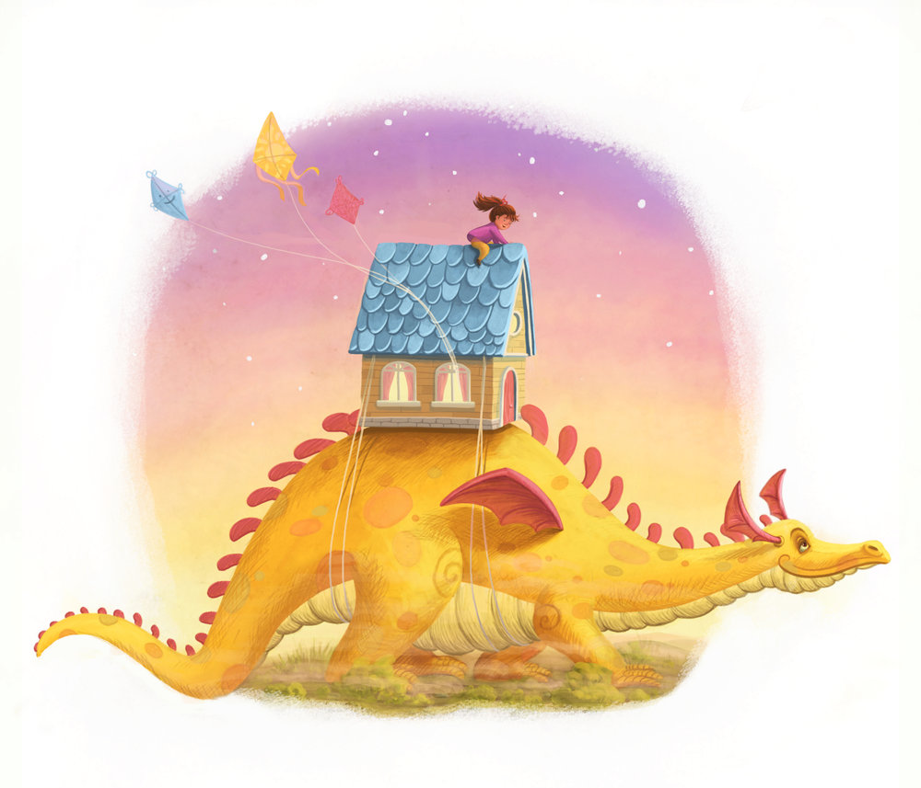
Image credit: https://www.ramonakaulitzkiart.com/
Give the image above a good visual overhaul then continue below.

Now answer these questions
- What happened before this picture?
___________________________________________________________________________________________________________________________________________________________________________
- How did the house get on top of the dragon? Who tied it onto the dragon’s back?
____________________________________________________________________________________________________________________________________________________________________________________________________________________________________
- Is the dragon happy about this? How do you know?
___________________________________________________________________________________________________________________________________________________________________________
- How do the girl and the dragon know one another?
____________________________________________________________________________________________________________________________________________________________________________________________________________________________________
- Why is the girl sitting on top of the house and not inside it?
____________________________________________________________________________________________________________________________________________________________________________________________________________________________________
- Is anyone else inside the house? Explain your answer
__________________________________________________________________________________________________________________
- Where did the kites come from?
____________________________________________________________________________________________________________________________________________________________________________________________________________________________________
- Where are the girl and the dragon going? Explain clearly.
___________________________________________________________________________________________________________________________________________________________________________
- Why are they travelling in this way?
____________________________________________________________________________________________________________________________________________________________________________________________________________________________________
- Give this picture a more interesting title or two!
  - ________________________________________________________________________________________________
  - ________________________________________________________________________________________________

- Compare this picture with Best Friends. What’s similar and what’s different? Sssh! Best Friends will be your next story!

Make a list of the similarities and differences.

Now take your time to complete a ‘slow write’. What is a slow write? A slow write is a method used by authors when writing their books.

First, they plan out their ideas for their story using a stimulus (you are using the picture as your stimulus)
Then, they take their time to make their ideas come alive and to ‘polish them up’. This means that they tend to write a paragraph or two at a time, read it through and then change ideas and words around in each paragraph, but they make sure to keep the theme the same as they make their changes.

So, this is what you will be doing with your ‘slow write’. You want to produce a piece of writing where you have been able to apply all that you have learnt at school in your English lessons up until this time, to produce a piece of writing where you confidently show case this.

You have learnt a lot and you know a lot!

Take your time to show this and produce a great piece.

Once you have completed the similarities and differences chart and planned your ideas on a separate piece of paper, you can then go on to start typing your story after the chart. Remember to keep saving your work as you type. Save it using one of the titles you created in one of the questions above.

HAVE FUN!

Tip- If you’re stuck for an opening to your story, you could use this one.
It was an usual day, when the dragon strolled into the village and Kasaw it for the first time. A usual day but one never to be forgotten.

EXTENSION- ART LINKS
You may decide to challenge yourself and create a few black line drawings to go with your writing, just as you would find in a published novel. Remember how we recreated Horrid Henry.

BEST FRIENDS
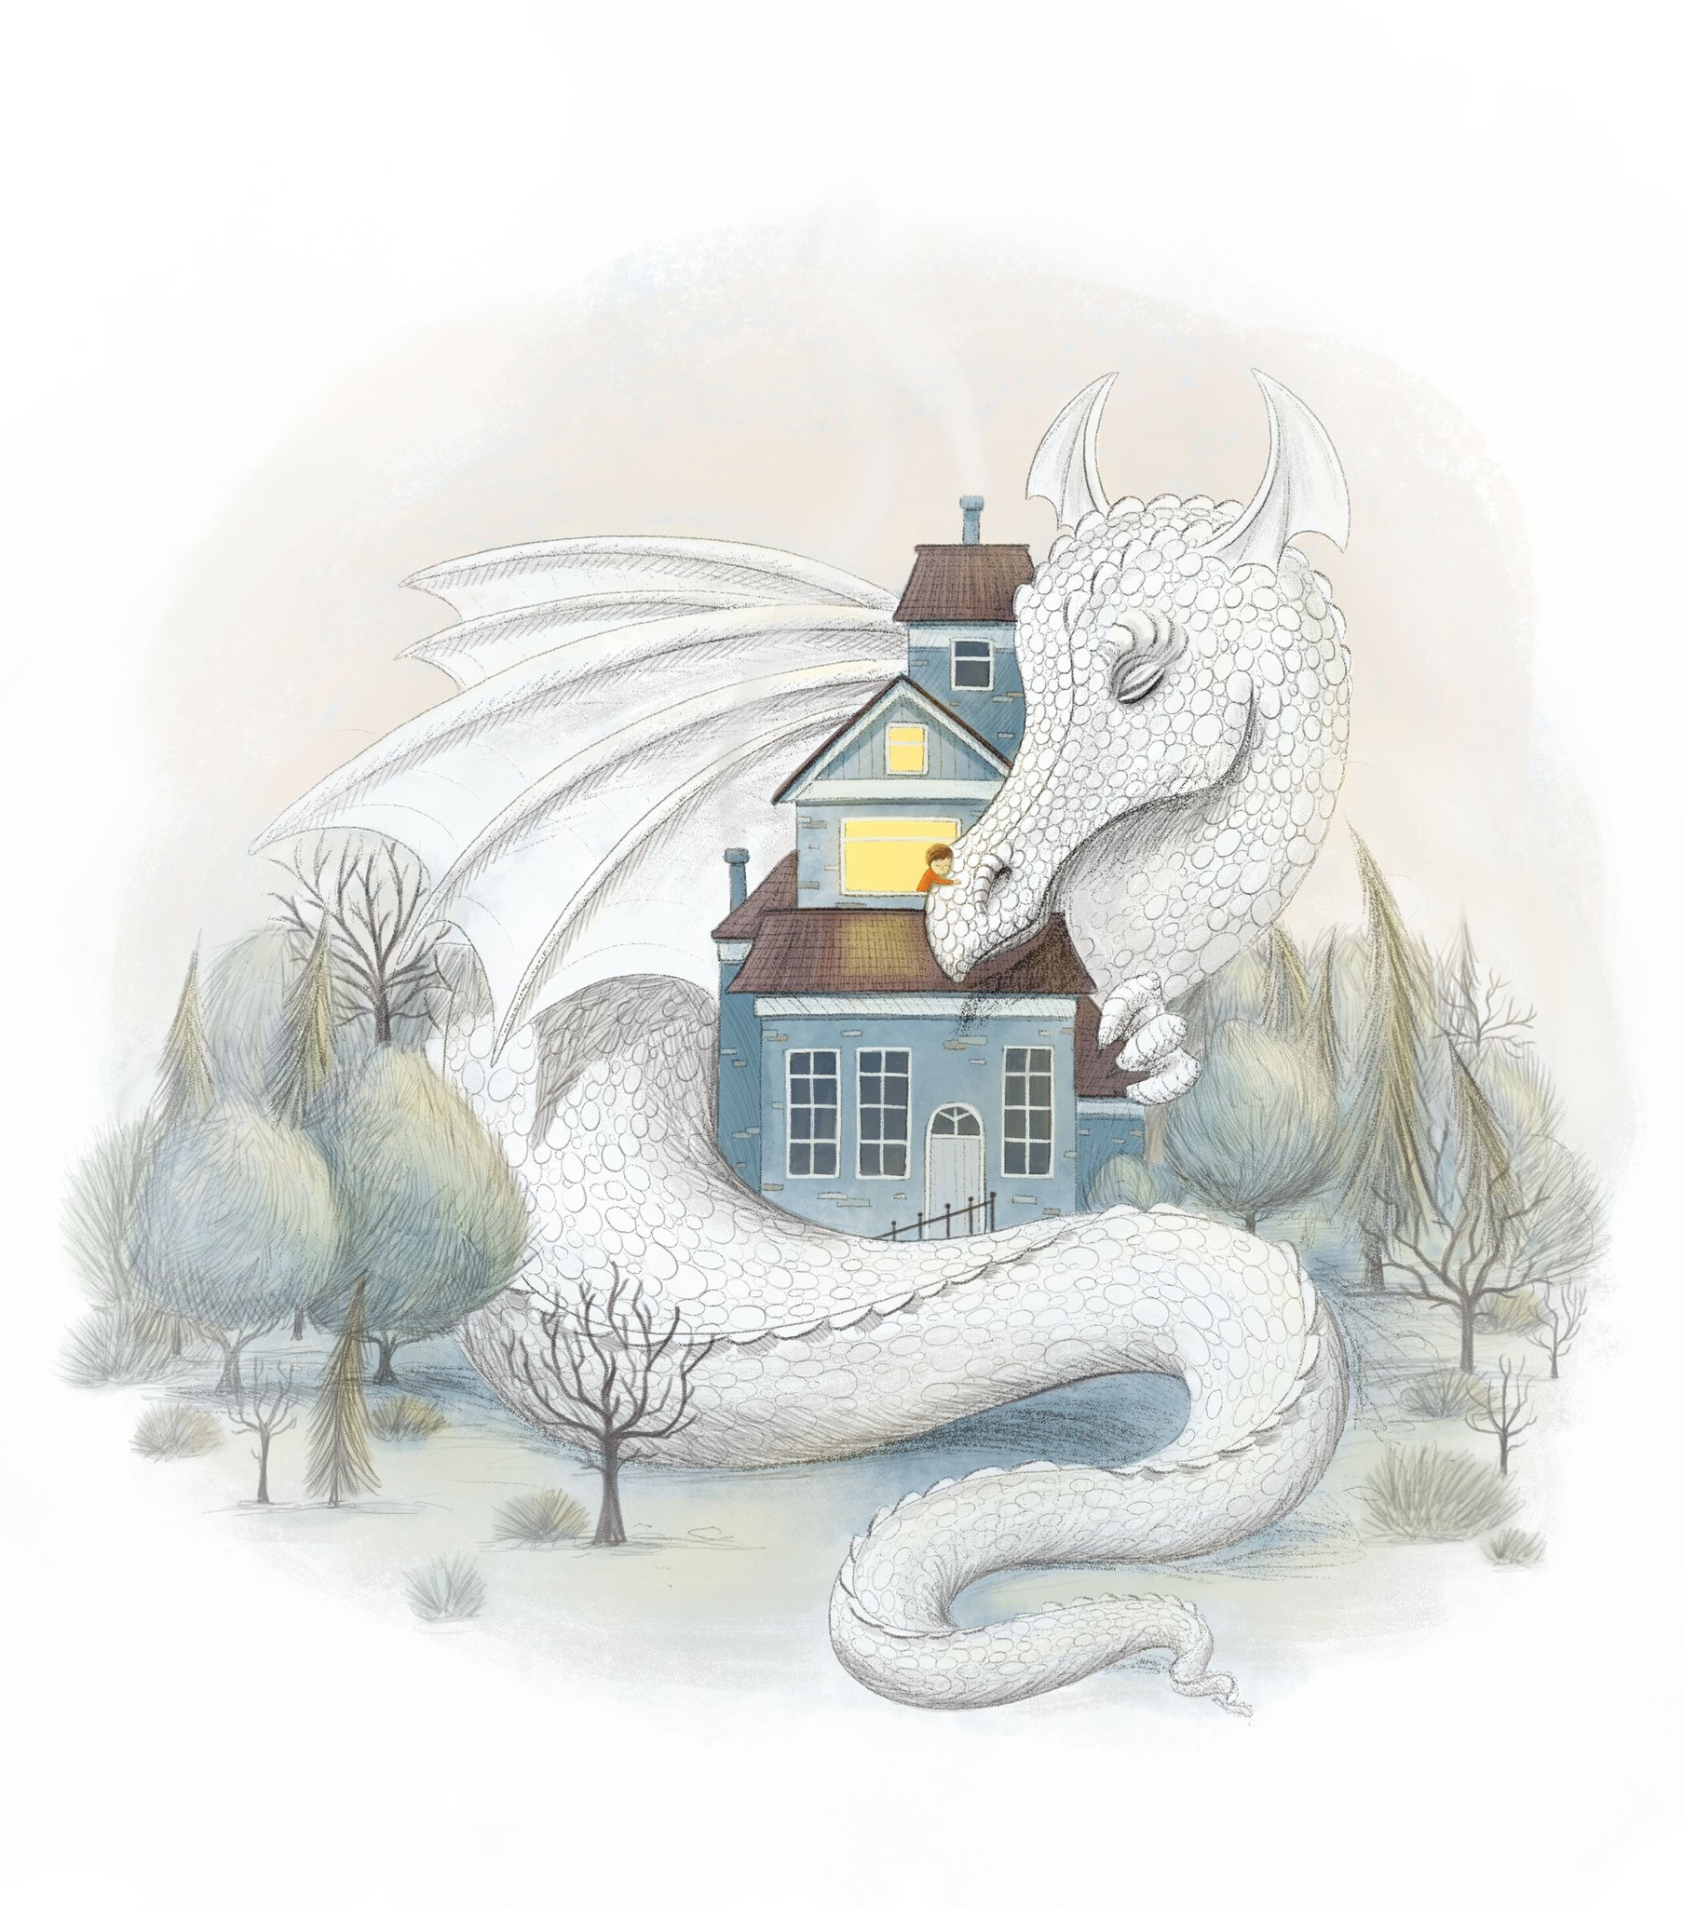
SIMILARITIES | DIFFERENCES
Start your story below. Remember your title!

