ART LESSON 5 WEEK 5
LO: To be able to combine different art techniques.
HOM: Thinking flexibly.
TASK
This is the last lesson where you will explore line, shape and colour
Euro 2020 should have taken place this year but our present situation has meant that it has been postponed.
The new dates are 11th June 2021 until 11th July 2021. For those super football fans amongst us, this is exciting news and something to look forward to.
To make it extra special, you are going to imagine that UEFA have designed a competition, where they are asking school children to use the skills that they have learnt about line and pattern in their art lessons at school, to design the brightest most detailed football, that could be used to kick off the Euro 2021 games.
Go back and use some of the ideas in the last two lesson and apply them to this lesson.
Each segment of the ball must be different. The colours used should be bright, vibrant and full of life, as though they want to jump off the page.
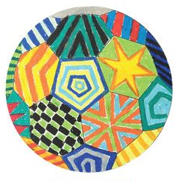
This is an example, but I know that you can do much better.
Below you will find a page with a football image. Print out and get creating.
What you will need: Football image print out. Colouring pencils
