LO: To understand what the job of a Tudor King would be
H.O.M: Thinking flexibly

White hat: What would you include in an advert to be a Tudor king? Think about the different task you will need to be a king in Tudor times.
_______________________________________________________________________________________________________________________________________________________________________________________________________________________________________________________________________________________________________________________________________________________________
_______________________________________________________________________________________________________________________________________________________________________________________________________________________________________________________________________________________________________________________________________________________________

A TUDOR KING’S JOB
A king had to rule. He would have meetings with his privy council, and they would discuss the passing of any new laws, the economic situation, relations with foreign countries etc.
While the privy council advised the monarch, he had the final word on any actions that were taken.
Sometimes a Tudor king might go to war, as Henry VIII did with King Francis I of France.
You could be a king at any age. Edward VI became king at the age of nine.
However, as he was not old enough to rule alone, a regent was appointed to govern in his stead until he was grown up.
Since the monarchy was hereditary, you did not have to have any particular character to be king, you just had to inherit the throne.
The three Tudor kings, King Henry VII, Henry VIII, and Edward VI all had quite different characters.

Income would vary depending on how prosperous your kingdom was.
Income of a monarch came from taxes etc. Some spent more than others, Henry VII was very careful with money, whereas Henry VIII was quite extravagant.
There were many church holidays during the course of the year, when everyone would celebrate.
Christmas was the longest, lasting thirteen days, from Christmas Day until Epiphany (6th January).

For royalty, celebrations would be extravagant. King Henry VIII did away with many of the holidays of the Catholic Church, but some, like Christmas, were retained.
The perks of being Tudor king were having power, wealth, and everyone submitting to you.
It helped to have a strong personality, and to be able to force your will on others.
You wanted to encourage people to respect you but also to fear you. That way you would have power and control.

Using the information above and the following links answer the following questions:

http://www.primaryhomeworkhelp.co.uk/tudors/kings.htm
https://www.planbee.com/blog/tudor-facts/
https://www.dkfindout.com/uk/history/tudors/
http://www.primaryhomeworkhelp.co.uk/Tudors.html
https://www.theschoolrun.com/homework-help/tudors

What do you think the King will have to do? What would be his duties, etc?
_______________________________________________________________________________________________________________________________________________________________________________________________________________________________________________________________________________________________________________________________________________________________
_______________________________________________________________________________________________________________________________________________________________________________________________________________________________________________________________________________________________________________________________________________________________

How old do you think a person should be to apply for the job of king?

_______________________________________________________________________________________________________________________________________________________________________________________________________________________________________________________________________________________________________________________________________________________________
_______________________________________________________________________________________________________________________________________________________________________________________________________________________________________________________________________________________________________________________________________________________________

What sort of character should the person to be a king be like?

_______________________________________________________________________________________________________________________________________________________________________________________________________________________________________________________________________________________________________________________________________________________________
_______________________________________________________________________________________________________________________________________________________________________________________________________________________________________________________________________________________________________________________________________________________________

How much pay will they get for the job of being a king?

_______________________________________________________________________________________________________________________________________________________________________________________________________________________________________________________________________________________________________________________________________________________________
_______________________________________________________________________________________________________________________________________________________________________________________________________________________________________________________________________________________________________________________________________________________________

What holidays they will have?

_______________________________________________________________________________________________________________________________________________________________________________________________________________________________________________________________________________________________________________________________________________________________
_______________________________________________________________________________________________________________________________________________________________________________________________________________________________________________________________________________________________________________________________________________________________

What perks or bonuses they will get?

_______________________________________________________________________________________________________________________________________________________________________________________________________________________________________________________________________________________________________________________________________________________________
_______________________________________________________________________________________________________________________________________________________________________________________________________________________________________________________________________________________________________________________________________________________________

What skills will they need to do the job?
_______________________________________________________________________________________________________________________________________________________________________________________________________________________________________________________________________________________________________________________________________________________________
_______________________________________________________________________________________________________________________________________________________________________________________________________________________________________________________________________________________________________________________________________________________________

Now look to the different examples of job adverts you can find around in newspapers or internet.
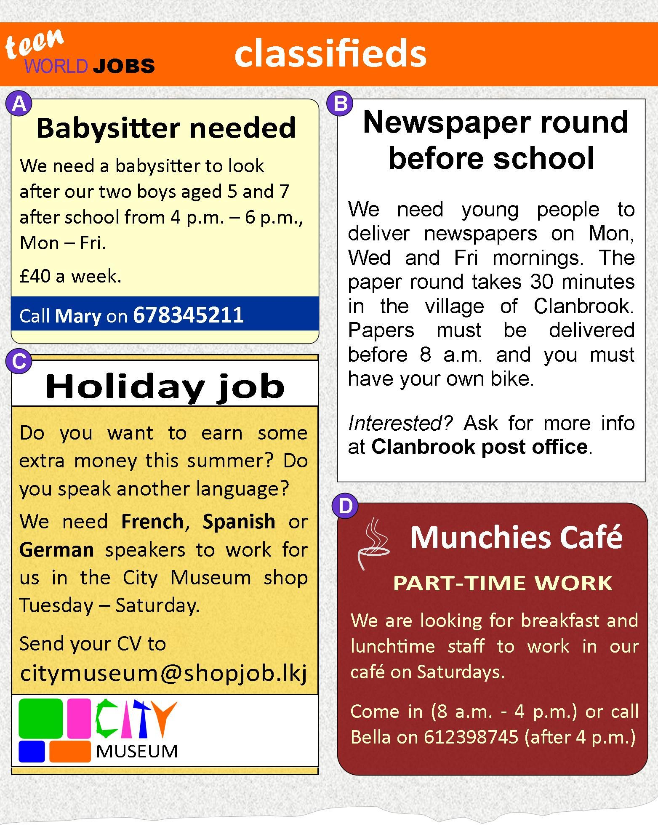

TASK:
You are going to create an eye catch poster for our display board to advertise the job of a Tudor King.
- Your information can be put inside different shapes e.g. a crown, bubble, sword etc
- Make sure your writing is written clearly and big enough to be seen
- Use colouring pencils and some felt tips to make the poster STAND OUT!

A JOB FOR A KING
Design a job advert for a Tudor King that would have been in a Tudor newspaper
It might include:
- A job description (what the King will have to do, his duties etc)
- Age range required to apply for the job
- What sort of character they will have to be
- What pay they will get
- What holidays they will have
- What perks or bonuses they will get
- The skills required to do the job
THINK CAREFULLY ABOUT THE PRESENTATION OF YOUR ADVERT

